A CALL FOR LEGALISATION
OF CANNABIS THROUGH THE NHS
Evidence, patient autonomy, product safety, illicit-market displacement and a proposed four-product NHS regulatory model
Research and policy analysis
28 September 2026
Purpose and status
This paper is a policy proposal and evidence synthesis. It is not individual medical advice, legal advice, or a claim that cannabis is harmless. It distinguishes established medical evidence from promising, limited and unsupported claims, and separates observed market changes from causal hypotheses about prohibition.

Executive summary
The United Kingdom already accepts the central medical proposition on which this paper rests: cannabis-derived medicines can have therapeutic value. Since 1 November 2018, qualifying cannabis-based products for medicinal use (CBPMs) have had a lawful Schedule 2 route. NICE recommends cannabidiol for defined severe epilepsies, THC:CBD spray for qualifying multiple-sclerosis spasticity, and nabilone for refractory chemotherapy-induced nausea and vomiting. The contested question is therefore no longer whether cannabinoid medicines can ever be medicine. It is how broadly, safely and equitably access should be organised (Home Office, 2018; NICE, 2019-2023; NHS England, 2026).
This paper proposes a regulated NHS-centred model in which adult cannabis supply is moved away from an untested illicit market and towards a small number of standardised, independently tested reference products. The proposal is intentionally simpler than the present private market: four NHS reference chemovars or formulations, defined by reproducible cannabinoid profiles rather than commercial strain names; explicit screening for synthetic cannabinoid receptor agonists (SCRAs/‘Spice’); full batch traceability; pharmaceutical contaminant controls; clinical recording; pharmacovigilance; and a non-judgemental pathway that allows patients to disclose use without routine criminal-enforcement consequences.
The argument is not that all cannabis use is medical, or that every reported benefit is clinically proven. Cannabis is also used for relaxation, pleasure, socialising and curiosity. EUDA survey data show that medical, social and recreational motives overlap: 78% of respondents reported stress reduction/relaxation, 70% getting high/fun, 51% sleep, 39% depression/anxiety, 35% socialising and 24% pain/inflammation (EUDA, 2022). A healthcare system that sees only ‘misuse’ can therefore miss genuine symptom management; a healthcare system that calls every use ‘treatment’ would make the opposite error.
The economic scale is material. The Home Office’s September 2026 estimate places annual illicit cannabis expenditure in England and Wales at about £2.3 billion, based on approximately 2.7 million users and 205 million use-days. The Home Office explicitly acknowledges this as an underestimate; substituting the Adult Psychiatric Morbidity Survey produces £3.6 billion. These figures are turnover, not profit and not money the NHS could simply collect. They nevertheless establish a multi-billion-pound existing demand from which a regulated market could potentially divert expenditure away from criminal suppliers and generate legitimate wages, taxation, testing capacity and healthcare-linked revenue (Home Office, 2026).
The product-safety case is equally important. Research using voluntarily submitted WEDINOS samples found synthetic cannabinoid receptor agonists in 435 of 1,635 cannabis-related submissions (26.61%). That sample is strongly selection-biased and must not be treated as prevalence in all UK street cannabis. It does, however, prove that people can acquire products believed to be cannabis that contain substantially different psychoactive chemicals. Older literature documents grit, glass, lead and other contaminants or adulterants in illicit cannabis. In contrast, UK prescribed cannabis has experienced real quality failures - including mould, excessive microbial counts and an out-of-specification THC concentration - but the regulated system could trace and recall affected batches (MHRA, 2021; MHRA, 2023; MHRA, 2026).
A further concern is substitution under prohibition. The strongest UK example is synthetic cannabinoids: after first-generation SCRAs were controlled, ACMD documents gaps in generic controls being exploited and further generations appearing. Comparable adaptive mechanisms exist in other drug markets, including methamphetamine precursor changes and some synthetic-opioid markets. This does not prove that every ban inevitably creates a deadlier drug, and cannabis did not chemically ‘turn into’ fentanyl. It does show that persistent demand plus enforcement pressure can reward compact, novel or legally evasive chemistry. Regulation should therefore be assessed not only by whether a prohibited product disappears, but by what replaces it.
International experience shows that a legal market can displace illegal purchasing when it competes on convenience, price and safety. In Canada, reported usual legal purchasing rose from 37% in 2019 to 72% in 2024 while illegal purchasing fell from 16% to 3%; convenience, price and safe supply were the three most commonly reported influences on source choice (Health Canada, 2024). The illicit market did not disappear, but the evidence contradicts the assumption that consumers inevitably prefer illegal suppliers.
The proposal is therefore a staged experiment in public health rather than a claim of zero risk: standardise products, make quality visible, allow trained GPs to participate within a defined formulary and specialist escalation pathway, protect confidentiality, collect outcomes, price the legal route competitively, and measure displacement of the illegal market, adverse events, NHS utilisation, prescribing patterns, road harm and mental-health outcomes. Where evidence shows harm, change the model. Where evidence shows benefit, expand it.
Core proposition
If a large adult population will obtain cannabis regardless of prohibition, a public-health system should test whether known composition, known dose, clinical visibility, non-judgemental access and regulated price produce less total harm than criminal-market supply. The burden is empirical: compare outcomes, not slogans.

Contents
1. Scope, method and evidential rules
2. Cannabis in context: ancient plant, modern control
3. THC, CBD, dronabinol, nabilone and Spice are not the same thing
4. What cannabis and cannabinoids are medically evidenced to do
5. What people actually use cannabis for
6. Current UK law, NHS access and the care-displacement problem
7. Product quality: regulated medical cannabis versus the illicit market
8. Prohibition, designer drugs and the substitution cycle
9. Economics: the £2.3-£3.6 billion cannabis market
10. Case studies: Canada, NHS diamorphine and regulated displacement
11. Commercialisation, private access and evidence incentives
12. Risks, contraindications and the schizophrenia/psychosis distinction
13. Proposal: four NHS reference cannabis products
14. Proposed clinical, confidentiality and monitoring pathway
15. Counterarguments, uncertainties and safeguards
16. Implementation and research programme
17. Conclusions
Appendices
References and legal authorities

1. Scope, method and evidential rules
This paper extends two earlier pieces of policy work recovered from the author’s research archive: From Punishment to Care (25 August 2026), which examined bodily autonomy, psychoactive drugs, public health and the cost of control; and Law and Policy in Medicine - Evidence Paper v1 (27 September 2026), which distinguished law, professional duties, NICE guidance, NHS commissioning, local policy, clinical judgment, private provision and care displacement. The present paper narrows those frameworks to cannabis and tests a concrete NHS-centred regulatory proposal.

Research questions
- What medical uses of cannabis or cannabinoid medicines are supported by randomised trials, systematic reviews, regulators or clinical guidelines?
- How should patient-reported symptom relief and social/recreational use be distinguished from proven clinical efficacy?
- What quality and adulteration risks exist in unregulated cannabis, and what does the regulated medical supply demonstrably prevent or detect?
- Does the history of synthetic cannabinoids provide evidence that prohibition can generate chemical substitution and greater uncertainty?
- How large is the existing cannabis market, and what proportion could plausibly move into a regulated legal channel?
- Could a deliberately small NHS formulary - four standard reference products - simplify prescribing, trials, procurement, quality assurance and pharmacovigilance?
- What safeguards are required for psychosis-spectrum vulnerability, pregnancy, cardiovascular disease, drug interactions, dependence and driving?

Evidence grading used in this paper
Grade | Meaning
Established / guideline-supported | Accepted licensed or guideline-supported use, or consistent higher-quality clinical evidence.
Supported but modest / conditional | Randomised evidence suggests benefit, but average effect is small, population-specific or limited by adverse effects.
Limited / emerging | Some controlled or consistent observational evidence, but sample size, bias, heterogeneity or replication limits routine claims.
Insufficient / conflicting | Evidence does not permit a reliable treatment claim.
Evidence of no meaningful benefit / not recommended | Controlled evidence or guidelines indicate lack of clinically useful benefit for the specified indication/product.

Causation rule
Chronology is not automatically causation. The paper labels direct market adaptation only where regulators, investigators or credible studies document it. Where multiple forces operated - price, global supply, technology, enforcement, prescribing change, fashion or availability - the paper describes those factors rather than asserting a single cause. Likewise, evidence that patients self-treat after unmet need supports a care-displacement risk model; it does not prove that a particular NHS refusal caused a particular illicit purchase.

Referencing
Documentary sources are referenced in ISO 690:2021 author-date style. UK legal cases use standard neutral citations and legislation is cited conventionally. Online sources were accessed 28 September 2026 unless otherwise stated.

2. Cannabis in context: ancient plant, modern control
Cannabis is an herbaceous flowering plant in the Cannabaceae family, closely related to hops (Humulus). A 2026 genomic study estimated that the cannabis and hop ancestral lineages began diverging approximately 33.9-41.4 million years ago. This does not mean modern cannabis was itself a tree; Cannabaceae contains woody and herbaceous members. Archaeogenomic work places human domestication of Cannabis in East Asia in the early Neolithic, with an association stretching back roughly twelve millennia (Ren et al., 2021; Nature Communications, 2026).
The historical depth matters only in a limited sense. Age does not establish safety or a right to medical efficacy; many natural substances are dangerous. It does establish that contemporary criminal prohibition is a very recent governance choice compared with the human-plant relationship. A serious policy analysis should therefore evaluate present harms and benefits rather than rely on the assumption that illegality itself demonstrates medical worthlessness.
In the UK, cannabis remains Class B for unauthorised possession and supply. In 2018, however, qualifying cannabis-based products for medicinal use in humans were moved into Schedule 2, creating a lawful prescribing route. The Government’s own circular states that the Chief Medical Officer found conclusive therapeutic evidence for certain conditions and reasonable evidence for several others, while ACMD recommended that cannabis-derived medicinal products of appropriate standard be moved out of Schedule 1 (Home Office, 2018).

3. THC, CBD, dronabinol, nabilone and Spice are not the same thing
A recurring source of confusion in drug policy is the word “cannabinoid”. It describes a pharmacological relationship, not one uniform substance. Natural plant cannabinoids, pharmaceutical synthetic THC, THC analogues and illicit synthetic cannabinoid receptor agonists can have radically different risk profiles.
Substance / group | What it is | UK medical/legal significance | Key distinction
Δ9-THC | Primary intoxicating cannabinoid naturally produced by cannabis. Partial agonist at CB1/CB2 receptors. | Present in Schedule 2 CBPMs; also in licensed THC:CBD spray. | Natural THC can impair, intoxicate and provoke anxiety/psychotic-like symptoms at sufficient exposure, but it is pharmacologically different from many SCRAs.
CBD | Cannabidiol, non-intoxicating at ordinary therapeutic doses. | Licensed purified CBD is used for defined severe epilepsies. | Does not reproduce the typical THC “high”; effects and interactions are dose- and indication-specific.
Dronabinol | Manufactured Δ9-THC. | Class B, Schedule 2; not a UK licensed medicine. | Chemically Δ9-THC, not “Spice”.
Nabilone | Synthetic THC-related cannabinoid medicine. | Licensed in the UK for refractory chemotherapy-induced nausea/vomiting; Schedule 2. | THC analogue; not street SCRA/Spice.
Spice / SCRAs | Large group of synthetic cannabinoid receptor agonists, often chemically unlike THC; many are high-efficacy/full agonists. | Many are Class B and Schedule 1; no recognised medicinal use for controlled street SCRAs. | Can produce substantially more severe and unpredictable toxicity than cannabis.

How Spice products entered the market
Historically, many commercial “Spice” products were made by applying a laboratory-manufactured SCRA to otherwise non-intoxicating herbal material. The active chemical could be dissolved, distributed over a carrier and allowed to dry. Modern SCRAs are also found on paper, in vape liquids, powders and other forms. The carrier is not what makes the product “Spice”; the synthetic receptor agonist is. Importantly, early UK Spice mixtures were sold openly in the legal-high/head-shop market before successive controls were introduced (ACMD, 2020).

Why the pharmacology matters
THC is generally described as a partial agonist at CB1 receptors. Many SCRAs have much higher efficacy at CB1 and may act as full agonists. Combined with uncertain dose, uneven application and rapidly changing molecular identity, this helps explain reports of severe agitation, delirium, seizures, cardiovascular toxicity, unconsciousness and acute psychiatric disturbance. “Synthetic cannabis” is therefore a potentially misleading label: many SCRAs are not synthetic THC and should not be treated as if they were merely stronger versions of the plant.

4. What cannabis and cannabinoids are medically evidenced to do
No single sentence such as “cannabis works” or “cannabis does not work” is scientifically adequate. Evidence depends on the cannabinoid, formulation, dose, route, condition and outcome. Much of the strongest evidence concerns purified or standardised cannabinoid products rather than smoked or unstandardised whole-plant material.
Condition / purpose | Product studied | Evidence grade | Evidence summary
Severe treatment-resistant epilepsy: Dravet syndrome | CBD + clobazam | Established / guideline-supported | NICE recommends cannabidiol with clobazam from age 2, with continuation linked to seizure reduction.
Severe treatment-resistant epilepsy: Lennox-Gastaut syndrome | CBD + clobazam | Established / guideline-supported | NICE recommends with response monitoring; RCTs demonstrate reduction in relevant seizure frequency.
Tuberous sclerosis complex seizures | Purified CBD | Established / guideline-supported | NICE TA873 supports add-on CBD in qualifying patients with response monitoring.
Multiple-sclerosis spasticity | THC:CBD oromucosal spray (nabiximols) | Established / guideline-supported | NICE offers a 4-week responder trial after failure of other pharmacological treatment; systematic reviews show improved patient-reported spasticity response.
Chemotherapy-induced nausea/vomiting refractory to standard antiemetics | Nabilone; dronabinol in some international guidance; standardised THC/CBD evidence | Established / conditional | NICE: consider nabilone as add-on in adults with persistent CINV. ASCO 2024 supports cannabinoids for refractory CINV, not as cancer treatment.
Chronic pain, especially neuropathic pain | Comparable THC:CBD extract; high-THC products | Supported but modest / conditional | AHRQ 2024: small short-term pain improvements for some products, with increased dizziness, sedation and nausea; evidence for whole-plant cannabis remains insufficient. NICE does not recommend these products for routine adult chronic pain.
Sleep disturbance / insomnia symptoms | Various THC/CBD preparations | Limited / emerging | Recent RCT syntheses report improvement in subjective sleep measures, but substantial heterogeneity and little consistent objective sleep-architecture evidence.
HIV/AIDS appetite and weight loss | Dronabinol / cannabinoids | Limited / older evidence | Older trials and NASEM found limited evidence for appetite/weight outcomes; modern antiretroviral care changes current relevance.
Tourette syndrome / tics | THC or THC/CBD | Limited / emerging | Small trials and reviews suggest possible benefit but evidence remains too small/uncertain for broad routine claims.
Crohn disease symptoms | Cannabis/cannabinoids | Limited / emerging | Small studies suggest symptomatic/clinical activity improvement in some Crohn populations; evidence is insufficient for maintenance or objective inflammatory control.
Cannabis use disorder / withdrawal | CBD or cannabinoid combinations | Limited / emerging | Recent psychiatric review reports low-quality signals for some outcomes; not established standard treatment.
Autism-related symptoms | CBD-rich/cannabinoid products | Limited / emerging | Small heterogeneous studies; insufficient for routine treatment claims.
Anxiety disorders | CBD/cannabis | Insufficient / conflicting | People commonly self-medicate, but a 2026 systematic review of randomised trials found no significant evidence supporting cannabinoids for anxiety disorders overall.
PTSD | Cannabinoids | Insufficient / conflicting | Current controlled evidence does not support routine efficacy; previous tiny studies were insufficient.
Depression | Cannabis/cannabinoids | Insufficient | No convincing RCT evidence for routine cannabinoid treatment of depressive disorders; observational relationships may include harm as well as perceived relief.
Schizophrenia / psychotic disorders | CBD investigated; THC generally risk-relevant | Not established; THC caution | THC can induce psychotic-like symptoms and cannabis exposure is associated with psychosis risk/relapse in susceptible people. CBD remains investigational rather than routine antipsychotic treatment.
Cancer itself | Cannabis/cannabinoids | Not supported as cancer treatment | ASCO recommends against using cannabis/cannabinoids instead of evidence-based cancer-directed treatment outside trials.
Cancer pain/cachexia/appetite | Cannabis/cannabinoids | Insufficient / condition-specific | Evidence does not justify broad claims; CINV is the clearest oncology indication.
Glaucoma | Cannabinoids | Not recommended / impractical | Transient intraocular-pressure effects do not make cannabis an effective long-term glaucoma treatment; cardiovascular/psychoactive effects and short duration limit utility.
Parkinson disease, Huntington disease, dystonia, ALS | Cannabinoids | Insufficient | Trials are small or inconsistent; no robust basis for routine disease-specific treatment.
Irritable bowel syndrome | Cannabinoids | Insufficient | Mechanistic interest exists, but reliable therapeutic evidence is inadequate.

4.1 Established UK uses
NICE NG144 provides the clearest current NHS benchmark. It recommends cannabidiol-based treatments for specific severe epilepsies, a responder trial of THC:CBD spray for moderate-to-severe MS spasticity after other treatment failure, and consideration of nabilone for chemotherapy-induced nausea/vomiting persisting despite optimised conventional antiemetics. Those recommendations alone establish that cannabinoid pharmacology is already part of ordinary evidence-based medicine in selected circumstances (NICE, 2019-2023).

4.2 Chronic pain: a genuine signal, but not a miracle
The 2024 AHRQ living systematic review included 26 RCTs (N=2,315) and 12 observational studies (N=48,468). In mainly neuropathic chronic pain, extracted products with comparable THC:CBD ratios produced small average short-term improvements in pain and function; high-THC products may also produce small improvements. Dizziness, sedation and nausea were more common. Evidence for whole-plant cannabis, opioid-sparing effects and several important long-term harms remained insufficient (AHRQ, 2024). This is a strong argument for better standardised trials, not for claiming that every chronic-pain patient will benefit.
NICE’s present recommendation not to offer THC, dronabinol, nabilone or THC:CBD combinations for chronic pain in adults reflects the committee’s assessment of evidence and cost effectiveness at population level. It is not equivalent to a statutory finding that cannabinoids have no analgesic effect. The distinction between clinical evidence, commissioning and law is central to the earlier Law and Policy in Medicine framework.

4.3 Mental health: self-medication is common, efficacy is not established
A 2026 systematic review in The Lancet Psychiatry synthesised 54 randomised trials involving 2,477 participants across mental health and substance-use disorders. It did not find significant overall benefit for anxiety disorders, PTSD, psychotic disorders or opioid-use disorder; no eligible randomised trials supported cannabinoids for depression. Low-quality signals existed for some other conditions. This is an important corrective to a simplistic medicalisation of every reported reason for cannabis use: people may genuinely experience relief, but population-level therapeutic efficacy requires separate evidence.

4.4 Social and subjective effects are health-relevant without automatically becoming diagnoses
Relaxation, pleasure, laughter, altered sensory experience, appetite, reduced salience of worry and social bonding are common reasons people seek THC. Those experiences are not automatically diseases requiring treatment, but wellbeing is not limited to disease eradication. A rights-based regulatory model can acknowledge adult pleasure and social use without pretending that recreational use is a medical prescription. The NHS role proposed here is therefore partly medicinal and partly public-health stewardship: safe supply, information, monitoring and a route into care when problems emerge.

5. What people actually use cannabis for
The European Web Survey on Drugs provides a useful empirical answer to the question “what is the person trying to achieve?” Among 33,718 respondents reporting herbal-cannabis use, motives crossed medical, emotional, social and recreational categories. Multiple motives can coexist in one person.
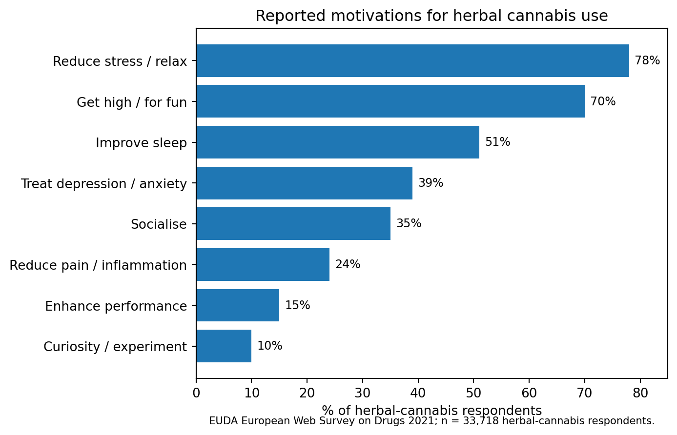
Figure 1. Reported motivations for herbal cannabis use in the European Web Survey on Drugs 2021 (EUDA, 2022).
The result undermines a rigid binary between “medical user” and “recreational user”. A person may use the same product because pain is lower, sleep is easier, social interaction is more comfortable and the experience is pleasurable. Clinical practice still needs to ask whether a symptom has another cause, whether cannabis is helping objectively and whether harms are emerging. But treating disclosure as a moral confession rather than clinically relevant information damages the quality of that assessment.

6. Current UK law, NHS access and the care-displacement problem
The UK changed the legal position in November 2018. Qualifying CBPMs moved to Schedule 2 and can be supplied through defined medical routes. Cannabis outside that definition remains controlled, and cultivation without appropriate authority remains unlawful. For unlicensed CBPMs, NHS England states that supply must be under the prescription or direction of a clinician on the GMC Specialist Register. A GP may legally continue prescribing in appropriate circumstances, but NHS England advises specialist initiation and highlights commissioning/shared-care constraints (Home Office, 2018; NHS England, 2026).
The result is an access paradox. A substance can be legally recognised as medicine while routine NHS access remains narrow. Private clinics can lawfully prescribe in a broader range of specialist circumstances, leaving some patients with a choice between private expense, continued symptoms, or unregulated self-treatment. NHS England’s 2019 review recorded barriers involving evidence, clinician confidence, commissioning and cost, along with families who had moved into private prescribing and reported substantial financial burden.
A 2024 UK cross-sectional study of 10,965 adults estimated that approximately 1.77 million adults were using illicit cannabis to self-treat diagnosed health conditions. The study cannot prove that NHS restriction caused that behaviour, and one author reported a Curaleaf affiliation. It nevertheless establishes a large population in which symptom management is occurring outside standard clinical visibility (Erridge, Troup and Sodergren, 2024).

Care displacement model
Route after unresolved need | Potential benefit | Principal risks / costs
Regulated NHS treatment | Clinical oversight, integrated record, regulated supply, equality of access. | May be unavailable, slow or limited by evidence/commissioning.
Regulated private treatment | Lawful access and some clinical oversight. | Cost, fragmented records, commercial incentives, unequal access.
Illicit/self-supplied cannabis | Immediate access, user control. | Unknown potency/composition, contaminants/adulterants, no mandatory interaction review, legal risk.
No treatment | Avoids medicine adverse effects. | Continuing pain/distress, loss of function, delayed diagnosis, loss of trust.

The proposed NHS model is designed to reduce the distance between the first and third rows: if a person is already using cannabis, clinicians should be able to know what they are taking, discuss risks and alternatives, and where clinically appropriate substitute a known product for an unknown one.

7. Product quality: regulated medical cannabis versus the illicit market
The central product-safety difference between a regulated medicine and an illicit product is not that regulated manufacturing never fails. It is that specifications, testing, traceability, recall and accountability exist.

7.1 What has been found in illicit cannabis
Adulterant / contaminant | Documented issue | Risk relevance
Glass / “grit” particles | UK “grit weed” reports and health warnings in the mid-2000s. | Weight/appearance manipulation; inhaled particulate injury.
Sand / mineral grit | Reported in adulterated cannabis. | Adds weight; inhaled particles.
Lead | Mass lead-poisoning outbreak linked to adulterated cannabis in Leipzig. | Systemic neurotoxicity, anaemia, renal and neurological harm.
Talc / silicates / aluminium | Reported in case or forensic literature. | Respiratory particulate exposure.
Rosin / colophony | Forensically identified in hashish. | Irritant fumes and adulteration.
Textile fibres / plastic / tape / plant debris | Found in forensic examinations of street hashish. | Foreign material; may reflect deliberate bulking or poor handling.
Mould / bacteria | Microbiological contamination occurs in poorly controlled plant products. | Respiratory/infectious risk, especially for vulnerable patients.
SCRAs / “Spice” | WEDINOS analysis found SCRAs in 435/1,635 submitted cannabis-related samples. | Unexpected high-efficacy cannabinoid exposure; severe toxicity can differ markedly from THC.
Other psychoactive compounds | WEDINOS submissions included small numbers containing cocaine, opiates or ketamine. | Unexpected drug interactions and diagnostic uncertainty.

Selection-bias warning
The WEDINOS figures must not be interpreted as “26.6% of all UK cannabis contains Spice”. WEDINOS submissions are voluntary and often occur because a product is suspected to be unusual. The finding proves adulteration occurs; it does not provide a representative national prevalence estimate (WEDINOS analysis, 2025).

7.2 What has gone wrong in prescribed UK cannabis
Year | Product | Regulatory defect | What the regulated system could do
2021 | NOIDECS T20/C4 cannabis flower | Two batches recalled because they might be contaminated with mould. | Identify affected batches, stop supply, quarantine stock and contact patients/pharmacies.
2023 | Canopy AKH 22 dried cannabis | Two batches exceeded specified total aerobic microbial count. | Full onward traceability; recall affected lots.
2026 | Curaleaf THC/CBD oil | Three batches recalled after stability testing found THC below specification. | Recall at wholesaler/pharmacy level; identify exact lots.

No confirmed UK prescribed-cannabis case was located in this review involving deliberate weighting with glass/sand/lead or deliberate SCRA/Spice adulteration. That is reassuring, but absence of a reported event is not the same as proof that every batch has undergone a broad SCRA screen.

7.3 The SCRA testing gap
The European Pharmacopoeia Cannabis Flower monograph was incorporated into the British Pharmacopoeia in 2024. Pharmaceutical cannabis quality control covers identity, cannabinoid assay and relevant impurity/contaminant specifications. However, a test designed to quantify THC and CBD does not automatically establish the absence of every synthetic cannabinoid receptor agonist. SCRAs can be identified with appropriate chromatographic/mass-spectrometric methods such as LC-MS/MS or high-resolution mass spectrometry, but this review did not locate a public UK requirement that every medicinal-cannabis batch undergo a universal broad SCRA panel.
The proposed NHS specification therefore adds an explicit requirement: **SCRA screen - none detected within validated analytical scope**, with the panel updated as new compounds emerge. This does not make adulteration impossible; it makes the analytical question explicit and auditable.

8. Prohibition, designer drugs and the substitution cycle
A central hypothesis of this paper is that prohibition can sometimes select for market features that are undesirable from a health perspective: high potency per unit mass, chemical novelty, concealability and rapid replacement. This is not a universal law. It is a mechanism to be tested against specific histories.
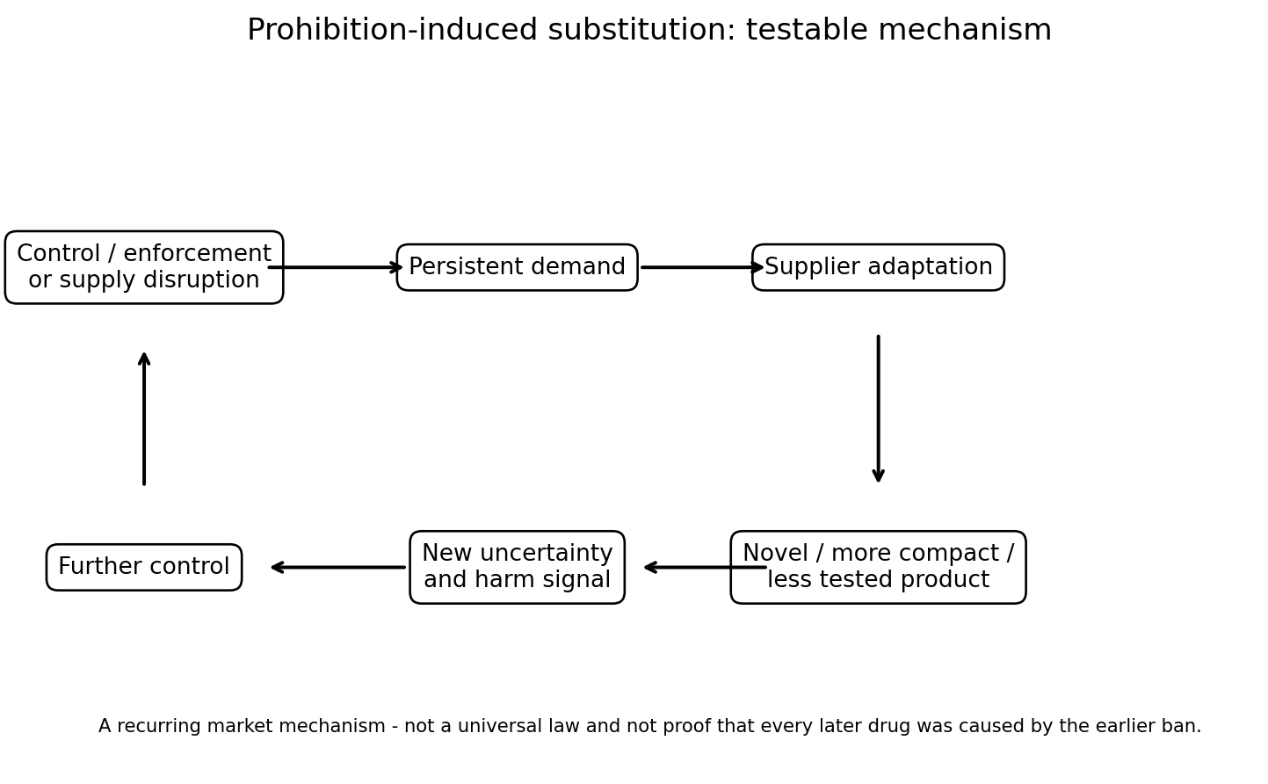
Figure 2. A testable substitution cycle. The arrows indicate a possible market mechanism, not an assertion that every control event causes the next drug.

8.1 The strongest UK example: synthetic cannabinoids
The UK SCRA record is unusually explicit. First-generation synthetic cannabinoids were controlled in 2009. ACMD subsequently recorded gaps in those definitions being exploited, followed by second-generation compounds and further controls in 2013; harmful compounds outside the second-generation definition then appeared, contributing to further generic controls. The Psychoactive Substances Act 2016 attacked the wider “legal high” retail model. The Government’s review found that visible head-shop supply reduced substantially, while some NPS supply - particularly Spice - moved into covert or street channels. This is direct evidence of regulatory evasion and market adaptation, even though it does not prove that prohibition was the only driver of harm.

8.2 Decade map: UK and USA
Decade | United Kingdom | United States
1960s | Cannabis, LSD, amphetamines and heroin present. 1967 legislation tightened heroin/cocaine prescribing; later heroin epidemic also reflected new international supply. Causal replacement not established. | Marijuana, LSD, heroin, prescription stimulants/depressants. Federal controls tightened; heroin epidemic expanded. No simple A→B causal chain.
1970s | Misuse of Drugs Act framework. 1977 generic chemical definitions were introduced partly to catch molecular variants rather than named compounds only. | Controlled Substances Act 1970. Designer fentanyl analogues appear by late decade as heroin substitutes; analogue-control problem becomes visible.
1980s | Heroin epidemic, cannabis, amphetamine, cocaine and MDMA/rave market. Diversification more than one-for-one substitution. | Crack/cocaine, heroin and clandestine designer drugs. Fentanyl analogues and 1986 analogue legislation illustrate chemical evasion.
1990s | Heroin, cannabis, amphetamine, ecstasy and rising cocaine. No single prohibition-driven replacement established. | Prescription opioid expansion begins; this is primarily a medical/commercial supply phenomenon rather than prohibition.
2000s | Commercial “legal high” market expands: Spice/SCRAs, piperazines, cathinones, mephedrone. Products exploit controlled/uncontrolled boundary. | Meth precursor restrictions reduce domestic labs; production shifts and Mexican producers adopt alternative precursor/P2P routes - a well-documented supply adaptation.
2010s | SCRA generations and generic controls; Psychoactive Substances Act closes head shops but some market moves to street/covert supply. | Prescription-opioid interventions plus market changes are followed by heroin substitution in some studies and then rapid illicit fentanyl expansion from 2013. Causality is multi-factorial.
2020s | Nitazenes and other synthetic opioids enter heroin/counterfeit medicine supply; international scheduling continues to trigger monitoring for new analogues. | Fentanyl dominates illicit opioid mortality; xylazine/medetomidine and new synthetic opioids demonstrate continuing adulterant/substitution dynamics.

The key inference is limited but important: **if demand persists, eliminating one molecule or supply route may not eliminate the desired effect.** Suppliers can change chemistry, geography or product form. Public-health evaluation should therefore ask not only “did use of the prohibited product fall?” but also “what did users receive instead, and was it safer?”

9. Economics: the £2.3-£3.6 billion cannabis market
The Home Office’s 2026 estimate for England and Wales combines approximately 2.7 million cannabis users, around 205 million cannabis-use days, assumptions about consumption per use-day and a £10-per-gram retail price. The result is £2.3 billion annual expenditure. The Home Office states that survey under-reporting and missing cohorts mean this is likely an underestimate; substituting APMS data generates £3.6 billion (Home Office, 2026).
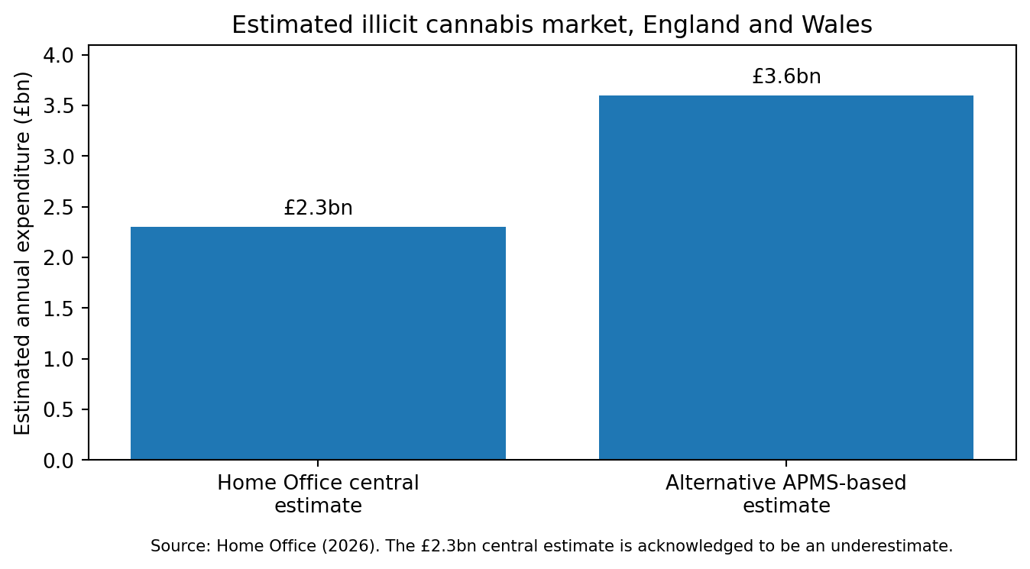
Figure 3. Home Office central and alternative estimates for annual illicit cannabis expenditure in England and Wales.
These are market-expenditure estimates, not dealer profit, and they are not automatically NHS revenue. Any legal system must pay for cultivation, energy, staff, laboratories, premises, pharmacy/dispensing, governance, waste, insurance and administration. Some illegal supply would remain. The economically defensible question is therefore how much existing expenditure can be moved into a lawful supply chain, and what public revenue or avoided costs result.

9.1 Illustrative regulated-market scenarios
Underlying market estimate | Legal-market capture (illustrative) | Gross spend moved into legal channel | 20% dedicated levy (illustrative)
£2.3bn | 50% | £1.150bn | £0.230bn
£2.3bn | 75% | £1.725bn | £0.345bn
£2.3bn | 90% | £2.070bn | £0.414bn
£3.6bn | 50% | £1.800bn | £0.360bn
£3.6bn | 75% | £2.700bn | £0.540bn
£3.6bn | 90% | £3.240bn | £0.648bn

These scenarios are arithmetic, not forecasts. A 20% dedicated levy is used only to show scale. VAT rules, excise design, NHS dispensing, producer margins, retail prices and public-health objectives would determine actual revenue. A high tax burden could itself preserve the illegal market by making legal supply uncompetitive. Canada’s survey evidence suggests price and convenience are central to consumer source choice.

9.2 Potential fiscal channels
- Cannabis-specific excise or public-health levy.
- VAT or other applicable consumption taxation depending on supply model and medicine status.
- Corporation tax, PAYE/NIC and legitimate employment generated through cultivation, testing and distribution.
- Direct NHS dispensing income if a public/self-pay route were chosen for non-medical adult supply.
- Potential avoided or reduced costs in policing, courts, incarceration, emergency treatment and diagnostics associated with unknown products - these require dedicated modelling and must not be assumed.
- Investment of a defined share into mental health, pain services, addiction care, toxicology, independent trials and drug checking.

10. Case studies: Canada, NHS diamorphine and regulated displacement

10.1 Canada: legal supply can displace illegal purchasing
Canada does not prove that one regulatory model will transfer directly to the UK, but it provides a large-scale natural experiment. Health Canada reports that among people consuming cannabis, usual legal purchasing rose from 37% in 2019 to 72% in 2024, while illegal purchasing fell from 16% to 3%. In 2024 the most common factors influencing where cannabis was obtained were convenience (30%), price (23%) and safe supply (22%).
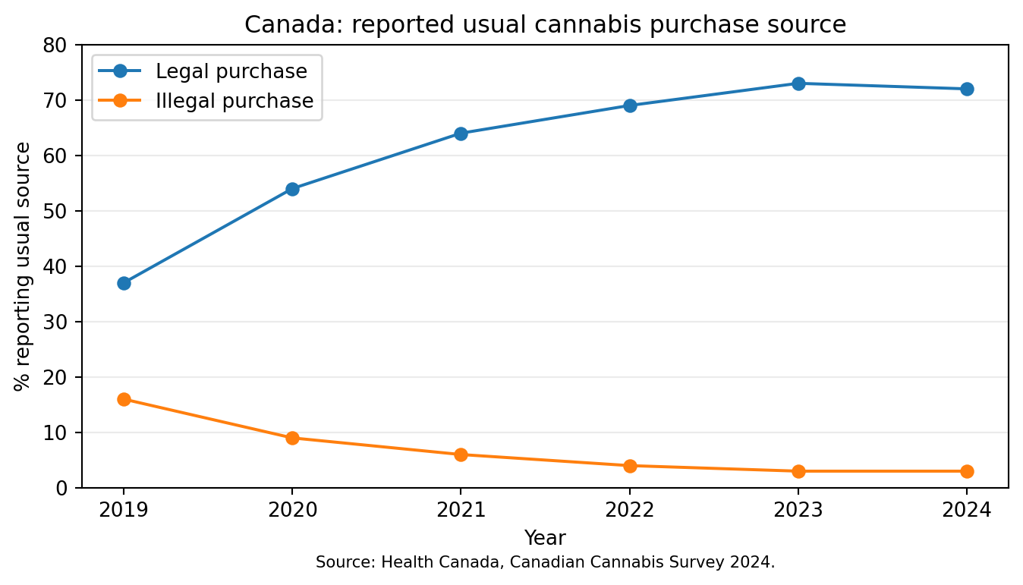
Figure 4. Canada: legal and illegal usual purchase sources, 2019-2024 (Health Canada, 2024).
The inference is not that illegal markets vanish after legalisation. The inference is that consumers can be moved toward regulated supply when it is easier, competitively priced and trusted. A UK NHS-centred model that is prohibitively expensive, slow or humiliating would fail that competitive test.

10.2 RIOTT: a UK example of known pharmaceutical supply reducing street supply
The Randomised Injectable Opiate Treatment Trial (RIOTT) is not a cannabis trial, but it demonstrates a broader public-health principle. In 127 chronic heroin-dependent patients who continued to inject street heroin despite conventional treatment, supervised injectable diamorphine produced substantially more participants meeting the trial’s reduction-in-street-heroin outcome than optimised oral methadone (adjusted 66% versus 19%; injectable methadone 30%). The treatment occurred in NHS supervised clinics in England (Strang et al., 2010).
This does not justify supplying every drug without restriction. It demonstrates that, in at least one high-risk drug market, providing the pharmaceutical substance under clinical supervision can reduce use of an unknown street product. That finding supports testing the analogous proposition for a lower-overdose-risk product such as cannabis.

11. Commercialisation, private access and evidence incentives
The UK already has a private medicinal-cannabis market. Ownership is mixed rather than simply “American or Israeli”: major operations include US/North-American, Australian, German-linked and UK-based businesses. This matters because a legal medicine that is practically accessible only through private payment creates a two-tier route: public prohibition for many, commercial access for those who can pay.
Private provision is not inherently improper. The policy concern is structural: fragmented records, commercial incentives, uneven prices and a research base partly dependent on firms with an interest in market expansion. The answer is not to reject private evidence automatically; it is independent replication, conflict disclosure and an NHS/public research capability strong enough to test claims itself.
Ketamine provides a parallel incentive problem. Generic ketamine is an old, inexpensive drug with established anaesthetic use and substantial evidence for rapid antidepressant effects in specialist settings, but the commercial incentive to fund a full new indication can be weaker when patent protection is limited. Oxford Health NHS Foundation Trust has operated a self-pay ketamine service and states that income supports NHS care. This illustrates the broader question: who pays to generate licensing-grade evidence for old, generic or naturally occurring medicines when exclusivity is weak?

12. Risks, contraindications and the schizophrenia/psychosis distinction
Legalisation through healthcare is not equivalent to declaring cannabis harmless. A credible system must make adverse effects visible and must be willing to recommend against THC for some people or circumstances.

12.1 Schizophrenia is not synonymous with psychosis
Psychosis is a syndrome - hallucinations, delusions or loss of reality testing can occur in schizophrenia, bipolar disorder, severe mood disorders, intoxication, neurological illness, sleep deprivation and other states. Schizophrenia is a specific disorder in which psychotic episodes may occur. This distinction matters because THC can produce transient psychotic-like symptoms even in people who do not have schizophrenia; a bad THC reaction is therefore not a diagnostic test for schizophrenia.
Experimental THC challenge studies show that THC can increase positive and negative psychotic-like symptoms in healthy volunteers. Deliberately administering THC to provoke an episode in a person suspected of schizophrenia would have poor specificity and could cause avoidable harm. It should not be proposed as routine diagnosis. Existing real-world reactions, however - especially reproducible paranoia, hallucinations or prolonged symptoms after cannabis - are clinically relevant history and should be recorded rather than dismissed as mere “drug misuse”.
A blanket lifetime ban on every cannabinoid for anyone with schizophrenia would also be pharmacologically crude. High-THC products present the clearest concern; CBD-dominant products have different pharmacology but remain investigational for psychotic disorders. Any use in this population should therefore occur only where a clinician with appropriate expertise judges the individual risk acceptable, with explicit monitoring and stopping criteria.

12.2 Other safeguards
- Age: adolescent exposure deserves stricter controls because brain development, dependence risk and educational impact differ from mature adult use.
- Pregnancy and breastfeeding: avoid routine cannabinoid exposure unless a specialist risk-benefit decision clearly justifies it.
- Driving and safety-critical work: impairment rules must remain enforceable; legal access is not permission to drive impaired.
- Cardiovascular disease: THC can increase heart rate and alter blood pressure; high-risk patients need individual assessment.
- Drug interactions: CBD and THC can interact with other medicines through pharmacodynamic and metabolic mechanisms; medication review remains necessary.
- Dependence: cannabis-use disorder exists. Treatment should be available without loss of dignity or automatic criminal consequences.
- Route of administration: smoking introduces combustion products. A health service should preferentially support vapourisation or oral/oromucosal formulations where appropriate while recognising differences in onset and dose control.

13. Proposal: four NHS reference cannabis products
The current private market often communicates through commercial cultivar or “strain” names. Those labels are poorly suited to an NHS formulary because they can drift across producers and do not reliably communicate pharmacology. The proposed alternative is four reproducible reference products selected and maintained to specification.
Reference product | Illustrative chemical specification | Purpose | Qualification
NHS-C1: THC dominant | Illustrative: THC 15-20%; CBD <1% | Conditions/individuals where THC-driven effects are clinically intended; highest psychiatric/impairment caution. | Not a final dose recommendation; MHRA/NICE trials set exact range.
NHS-C2: CBD dominant | Illustrative: CBD 10-15%; THC <1% | CBD-dominant therapeutic/research applications with minimal intoxication. | CBD still has interactions and dose-dependent adverse effects.
NHS-C3: Balanced | Illustrative: THC 8-12%; CBD 8-12% | Balanced THC/CBD response; analogous conceptually to 1:1 pharmaceutical products. | Allows direct comparative trials against C1/C2.
NHS-C4: Moderate balanced | Illustrative: THC 4-8%; CBD 4-8% | Lower-potency starting/reference option; potentially easier titration for some adults. | Exact specification requires clinical/pharmaceutical development.

The percentages above are policy-development examples, not clinical prescriptions. The central proposal is the four-class architecture. Exact cannabinoid ranges, minor-cannabinoid specifications and dose forms should be set through trials and regulatory science.

13.1 Cultivation and product rules
- Use stable, reproducible genetics or validated production methods rather than marketing-led strain proliferation.
- Organic-first or pesticide-minimising cultivation is desirable, but “organic” must never substitute for pharmaceutical testing: plants can still carry mould, mycotoxins, metals and environmental contaminants.
- Permit multiple licensed producers to manufacture to the same NHS reference specification, preventing dependence on one private company.
- Require representative batch sampling and independent laboratories separated from commercial sales incentives.
- Publish batch Certificates of Analysis in a patient-readable format and retain machine-readable records for pharmacovigilance.
- Explicitly include broad SCRA/NPS screening using validated mass-spectrometric methods, updated as new synthetic cannabinoids emerge.
- Keep a research/exception pathway for rare conditions or formulations outside the four-product routine formulary.

13.2 Proposed minimum batch certificate
Field | Requirement
Identity | Confirmed Cannabis material / validated formulation identity.
THC / THCA | Quantified with validated method; within product specification.
CBD / CBDA | Quantified with validated method; within product specification.
Minor cannabinoids | Defined panel where clinically/research relevant (e.g., CBG, CBC, CBN).
Microbiology | Pharmacopoeial inhalation/oral limits as applicable.
Mould / mycotoxins | Within defined limits; no unacceptable fungal contamination.
Pesticides / growth regulators | Within pharmaceutical limits; prohibited agents absent.
Heavy metals | Lead, cadmium, mercury, arsenic etc. below limits.
Foreign material | No glass, grit, fibres, plastic or other unacceptable foreign matter.
SCRA / NPS screen | No synthetic cannabinoid receptor agonist detected within validated scope; current panel/version stated.
Batch traceability | Grow lot, processing lot, laboratory, date, distribution chain, recall contact.

14. Proposed clinical, confidentiality and monitoring pathway
The proposal is not “GPs hand out cannabis without assessment”. It is a move from specialist-gated unlicensed prescribing toward a small, licensed/formulary system in which appropriately trained GPs can initiate or continue standard products within competence, with clear specialist escalation.

14.1 Consultation model
- Ask what outcome the person is seeking: pain relief, sleep, nausea control, spasticity relief, appetite, relaxation, social/recreational effect, or several at once.
- Record current cannabis use without judgement: product type, route, approximate dose/strength, frequency, perceived benefits, unwanted effects and source reliability.
- Review diagnoses, previous treatments, interactions and contraindications rather than treating cannabis disclosure as proof of non-compliance.
- Where the use is recreational rather than medical, provide risk information and safer-product access without inventing a diagnosis.
- Where a clinical indication exists, choose among standard products, use a defined trial period and record patient-reported and objective outcomes where possible.
- Escalate psychosis-spectrum, complex cardiovascular, pregnancy, severe dependence or uncertain diagnostic cases to appropriate specialists.
- Use the NHS medicinal-cannabis registry or successor system for longitudinal outcomes and Yellow Card reporting for suspected adverse reactions.

14.2 Confidentiality and non-enforcement
The clinical value of the model depends on honesty. If a patient believes that telling a GP about drug use will routinely trigger police action, they have an incentive to conceal information that may be essential to diagnosis and interaction safety. Existing GMC confidentiality principles already recognise that patients must be able to trust doctors with sensitive information, subject to legal duties, court orders and exceptional public-interest disclosures. The proposed system should explicitly separate health records used for care from routine criminal enforcement.
Population surveillance can still be strong without identifying individuals. Laboratories can report anonymised trends in potency, contamination, SCRAs, geographic clusters and adverse events. Public-health intelligence needs “what is circulating?” far more often than it needs “which named adult consumed it?”

14.3 Home-grown cannabis
Home cultivation is analytically different from commercial NHS supply because mandatory batch testing is impractical for every gardener. If home cultivation were separately legalised, a harm-reduction model could offer low-cost voluntary testing and clear cultivation safety guidance. Commercial and NHS-supplied cannabis should nevertheless meet mandatory standards because regulators have the power to impose them on sellers.

15. Counterarguments, uncertainties and safeguards
Counterargument | Assessment | Safeguard / test
Legalisation could increase use | Possible. Availability and normalisation can increase use in some populations. | Measure prevalence by age; restrict youth access; no lifestyle advertising; adjust retail density/price if harms rise.
High-THC products can worsen psychiatric risk | Supported for susceptible users; risk is dose/potency dependent. | Potency tiers, warning labels, GP screening, avoid/limit THC in high-risk patients, rapid specialist access.
Cannabis can cause dependence | Yes. Risk is not zero. | Routine screening, non-punitive treatment, dose review, taper/support when requested.
Driving risk may increase | Cannabis can impair driving. | Retain and enforce impairment rules; clear waiting/safety advice; study collision rates.
NHS should not become a recreational-drug retailer | A legitimate governance objection. | Separate medical prescribing from an adult regulated/public-health supply arm if needed; keep clinical care non-coercive.
The black market will undercut taxes | Likely if legal price is high or access inconvenient. | Price monitoring, modest tax, quality advantage, legal convenience, enforcement focused on unsafe/unlicensed commercial supply.
Evidence for many conditions is weak | Correct. | Four-product formulary enables better RCTs and registry evidence; do not advertise unproven indications.
A universal SCRA screen cannot detect every future molecule | Correct. | Use broad high-resolution methods, versioned libraries, non-targeted alerts and rapid panel updates; no test provides absolute zero-risk proof.
Organic-only rules may reduce supply or increase cost | Possible. | Use an “organic-first / low-pesticide” target while making validated safety specifications mandatory.
Cannabis revenue should not create NHS dependence on consumption | Important conflict risk. | Ring-fence only a capped health levy; do not set sales-growth targets; prohibit promotional incentives; publish independent governance.

16. Implementation and research programme
A staged programme can test the model without pretending uncertainty has disappeared.
Phase | Action
Phase 1 - Specification | MHRA/NICE/NHS pharmacy group defines four reference products, laboratory methods, SCRA panel, packaging and adverse-event standards. Commission independent baseline study of illicit market price/potency/adulteration.
Phase 2 - Pilot regions | Allow trained participating GPs and pharmacies to use the four products under protocol. Include adults already self-supplying cannabis and conventional clinical cohorts. Protect confidentiality.
Phase 3 - Comparative evidence | Run pragmatic trials and registry analyses by indication and user goal. Compare products C1-C4, dose, route, quality of life, function, sleep, pain, adverse effects and discontinuation.
Phase 4 - Market displacement | Measure legal versus illegal purchasing, prices, police cannabis workload, confiscations, WEDINOS composition, emergency presentations and organised-crime indicators.
Phase 5 - Economic evaluation | Publish NHS costs, tax/levy receipts, testing costs, enforcement changes, hospital/diagnostic costs and QALY/cost-effectiveness analyses. Separate gross sales from public revenue.
Phase 6 - Independent review | Independent academic/public-health review at 2, 5 and 10 years with authority to tighten, expand or terminate parts of the model.

Priority research questions
- Does legal NHS/public supply reduce the proportion of users buying cannabis from illegal suppliers?
- Does explicit SCRA screening reduce unexpected synthetic-cannabinoid exposure compared with illicit supply?
- What are the comparative outcomes of THC-dominant, CBD-dominant, balanced and moderate-balanced products by condition?
- Does integration into primary-care records reduce duplicated diagnostics, adverse drug interactions or emergency presentations?
- Which populations experience worsening anxiety, psychotic symptoms, dependence or functional impairment, and what early-warning markers predict this?
- What legal price and access conditions are necessary to outcompete illegal cannabis without encouraging unnecessary consumption?
- How much public revenue is generated after all production, testing, dispensing and governance costs, and where should it be spent?
- How do youth use, road collisions and workplace injuries change under the model?
- How many people currently using cannabis for symptoms transition to other diagnoses/treatments after a non-judgemental clinical review?
- Does standardising to four products materially improve the quality and comparability of clinical evidence?

17. Conclusions
Cannabis policy is often discussed as though society must choose between two caricatures: prohibition or a commercial free-for-all. The evidence supports a much more specific question. Can a regulated health-centred supply system produce safer products, better clinical information, less criminal-market revenue and better evidence than the present combination of narrow NHS access, private prescribing and illicit supply?
The UK already accepts cannabinoid medicine in law and in NICE guidance for several defined indications. The strongest expansion case is therefore not ideological. It is regulatory: standardise the product, test it properly, collect outcomes and let the evidence determine where use is useful, neutral or harmful. The four-reference-product proposal is designed to make that possible without importing the confusing commercial “strain” culture into the NHS.
The illicit market exposes users to uncertain potency, foreign material, microbes and - in documented submitted samples - synthetic cannabinoids. Prohibition has also repeatedly encountered chemically adaptive markets. The regulated medical market has had quality failures of its own, but the difference is traceability: affected batches can be identified, recalled and investigated. The appropriate response to imperfect regulation is better regulation, not an assumption that unregulated supply is safer.
The economic case remains a hypothesis to test, not a guaranteed windfall. England and Wales already contain an estimated £2.3 billion annual cannabis market, with an alternative Home Office methodology producing £3.6 billion. Redirecting even part of that expenditure into legal production would not make all of it NHS income, but it could create taxable legitimate activity and reduce the revenue available to criminal suppliers. The public-health model should be designed to compete on the factors consumers themselves report mattering: convenience, price and safe supply.
Finally, the paper rejects both stigma and romanticisation. Cannabis can help in some clinical circumstances, may help modestly in others, and is unproven or risky in still others. Adults can also seek it for pleasure or social reasons. A mature health system does not need to approve of every choice in order to reduce harm. It needs accurate products, honest information, confidential clinical relationships, proportionate safeguards and a willingness to revise policy when measured outcomes contradict expectations.
Proposed policy principle
Replace an unknown cannabis market with a known one: four standard products, independent testing, explicit SCRA screening, competitive legal pricing, informed adult choice, GP-accessible clinical oversight, specialist safeguards where risk is high, and continuous public reporting of outcomes.

Appendix A. Evidence matrix - interpretation notes
The medical evidence table in section 4 deliberately combines licensed medicines, purified cannabinoids and extracted cannabis products while identifying the product studied. This prevents evidence for one formulation being silently transferred to another. For example, evidence for purified CBD in Dravet syndrome does not prove that smoked high-THC flower treats epilepsy; evidence for nabiximols in MS spasticity does not prove all cannabis products have the same effect.

Appendix B. Financial scenario mathematics
For a base illicit-market estimate M, assumed regulated-market capture c and dedicated public-health levy l, illustrative levy revenue is M × c × l. The calculation does not include VAT, corporation tax, payroll taxes, production costs, behavioural price elasticity, administration, displacement to home cultivation, or continued illegal supply. It is therefore a scale illustration only.

Appendix C. Suggested minimum data fields for an NHS cannabis registry
Domain | Fields
Patient / consent | Age band, sex where clinically relevant, consent/opt-out, vulnerability flags; avoid unnecessary law-enforcement identifiers.
Clinical goal | Diagnosis where applicable; symptom/functional goal; recreational/social goal may be recorded separately without medicalising it.
Product | Reference product C1-C4; batch; THC/CBD profile; route; dose/frequency.
Baseline | Pain/function/sleep/spasticity/seizure or relevant validated outcome; other medicines; alcohol/tobacco/other drug use where clinically relevant.
Outcome | Benefit, adverse effects, discontinuation, dose change, quality of life, healthcare utilisation.
Safety | Psychiatric symptoms, cardiovascular effects, dependence indicators, driving/work incidents, pregnancy where relevant.
Supply displacement | Previous source, current legal/illegal purchasing mix, reason for source choice (price/convenience/safety).
Laboratory | Potency, contaminants, SCRA panel version, failures/recalls.

References
ADVISORY COUNCIL ON THE MISUSE OF DRUGS (ACMD). 2020, updated 2022. Synthetic cannabinoid receptor agonists. London: Home Office. Available at: https://www.gov.uk/government/publications/synthetic-cannabinoid-receptor-agonists
AGENCY FOR HEALTHCARE RESEARCH AND QUALITY (AHRQ). 2024. Living Systematic Review on Cannabis and Other Plant-Based Treatments for Chronic Pain: 2024 Update. Comparative Effectiveness Review No. 250. Rockville, MD: AHRQ. Available at: https://effectivehealthcare.ahrq.gov/products/plant-based-chronic-pain-treatment/living-review
ASCO. 2024. Cannabis and Cannabinoids in Adults With Cancer: ASCO Guideline. Journal of Clinical Oncology. Available via PubMed/ASCO.
BRITISH PHARMACOPOEIA. 2024. Ph. Eur. Supplement 11.5 incorporated into BP 2024, including Cannabis Flower and Cannabidiol monographs. London: MHRA. Available at: https://www.pharmacopoeia.com/content/html/479
ERRIDGE, S., TROUP, L. and SODERGREN, M.H. 2024. Illicit Cannabis Use to Self-Treat Chronic Health Conditions in the United Kingdom: Cross-Sectional Study. JMIR Public Health and Surveillance, 10, e57595. DOI: 10.2196/57595.
EUROPEAN UNION DRUGS AGENCY (EUDA). 2022. European Web Survey on Drugs 2021: top level findings, 21 EU countries and Switzerland. Lisbon: EUDA. Available at: https://www.euda.europa.eu/publications/data-fact-sheets/european-web-survey-drugs-2021-top-level-findings-eu-21-switzerland_en
HEALTH CANADA. 2024. Canadian Cannabis Survey 2024: Summary. Ottawa: Government of Canada. Available at: https://www.canada.ca/en/health-canada/services/drugs-medication/cannabis/research-data/canadian-cannabis-survey-2024-summary.html
HOME OFFICE. 2018. Rescheduling of cannabis-based products for medicinal use in humans. Circular 018/2018. London: Home Office. Available at: https://www.gov.uk/government/publications/circular-0182018-rescheduling-of-cannabis-based-products-for-medicinal-use-in-humans
HOME OFFICE. 2026. The proceeds of crime in England and Wales 2023 to 2024. London: Home Office. Published September 2026. Available at: https://www.gov.uk/government/publications/the-proceeds-of-crime-in-england-and-wales-2023-to-2024/the-proceeds-of-crime-in-england-and-wales-2023-to-2024
MEDICINES AND HEALTHCARE PRODUCTS REGULATORY AGENCY (MHRA). 2021. Company led medicines recall: NOIDECS T20/C4 cannabis flower. London: MHRA, 9 June 2021. Available at: https://www.gov.uk/drug-device-alerts/company-led-medicines-recall-noidecs-t20-slash-c4-thc-20-percent-cbd-4-percent-indica-cannabis-flower-unlicensed-medicine-and-noidecs-t20-slash-c4-thc-20-percent-cbd-4-percent-sativa-cannabis-flower-unlicensed-medicine
MEDICINES AND HEALTHCARE PRODUCTS REGULATORY AGENCY (MHRA). 2023. Company led medicines recall: Spectrum Therapeutics UK, Canopy AKH 22 dried cannabis. London: MHRA, 20 April 2023. Available at: https://www.gov.uk/drug-device-alerts/company-led-medicines-recall-spectrum-therapeutics-uk-canopy-akh-22-dried-cannabis-5g-unlicensed-medicine-clmr-23-a-slash-04
MEDICINES AND HEALTHCARE PRODUCTS REGULATORY AGENCY (MHRA). 2026. Class 2 Medicines Recall: Curaleaf Oil [FS] 10mg/ml THC, 10mg/ml CBD. London: MHRA, 12 March 2026. Available at: https://www.gov.uk/drug-device-alerts/class-2-medicines-recall-rokshaw-limited-trading-as-curaleaf-laboratories-curaleaf-oil-fs-10mg-slash-ml-thc-10mg-slash-ml-cbd-30ml-el-26-a-slash-13
NATIONAL ACADEMIES OF SCIENCES, ENGINEERING, AND MEDICINE. 2017. The Health Effects of Cannabis and Cannabinoids: The Current State of Evidence and Recommendations for Research. Washington, DC: National Academies Press. DOI: 10.17226/24625.
NATIONAL INSTITUTE FOR HEALTH AND CARE EXCELLENCE (NICE). 2019, updated. NG144: Cannabis-based medicinal products. London: NICE. Available at: https://www.nice.org.uk/guidance/ng144
NHS ENGLAND. 2019. Barriers to accessing cannabis-based products for medicinal use on NHS prescription. London: NHS England.
NHS ENGLAND. 2026. Cannabis-based products for medicinal use (CBPMs). London: NHS England. Available at: https://www.england.nhs.uk/long-read/cannabis-based-products-for-medicinal-use-cbpms/
NUTT, D.J., KING, L.A. and PHILLIPS, L.D. 2010. Drug harms in the UK: a multicriteria decision analysis. The Lancet, 376(9752), 1558-1565. DOI: 10.1016/S0140-6736(10)61462-6.
REN, G. et al. 2021. Large-scale whole-genome resequencing unravels the domestication history of Cannabis sativa. Science Advances, 7(29), eabg2286.
STRANG, J. et al. 2010. Supervised injectable heroin or injectable methadone versus optimised oral methadone as treatment for chronic heroin addicts in England after persistent failure in orthodox treatment (RIOTT): a randomised trial. The Lancet, 375(9729), 1885-1895. DOI: 10.1016/S0140-6736(10)60349-2.
ERRIDGE, S., HALL, M. and SODERGREN, M.H. 2025. Prevalence and Patterns of Cannabis Product Adulteration: An Analysis of WEDINOS Data. Journal of Psychoactive Drugs. Published online 19 March 2025. DOI: 10.1080/02791072.2025.2478087.
WORLD HEALTH ORGANIZATION. 2018. Critical Review Report: Cannabis and cannabis resin. Geneva: WHO Expert Committee on Drug Dependence.
NATURE COMMUNICATIONS. 2026. An X-linked sex determination mechanism in cannabis and hop. Nature Communications. Estimates cannabis-hop divergence at approximately 33.9-41.4 million years.
GENERAL MEDICAL COUNCIL. 2024-2026. Confidentiality: good practice in handling patient information; Good practice in prescribing and managing medicines and devices. London: GMC.
FREEMAN, T.P. et al. 2026. International cannabis policies and their association with cannabis use, cannabis use disorder, and other psychiatric disorders. The Lancet Psychiatry, 13(7), 615-626. DOI: 10.1016/S2215-0366(26)00087-8.
WILSON, J. et al. 2026. The efficacy and safety of cannabinoids for the treatment of mental disorders and substance use disorders: a systematic review and meta-analysis. The Lancet Psychiatry, 13(4), 304-315. DOI: 10.1016/S2215-0366(26)00015-5.

Legal authorities and legislation
Misuse of Drugs Act 1971.
Misuse of Drugs Regulations 2001.
Misuse of Drugs (Amendments) (Cannabis and Licence Fees) Regulations 2018, SI 2018/1055.
Psychoactive Substances Act 2016.
Human Medicines Regulations 2012, SI 2012/1916.
Montgomery v Lanarkshire Health Board [2015] UKSC 11.
McCulloch and others v Forth Valley Health Board [2023] UKSC 26.
R (Rogers) v Swindon NHS Primary Care Trust [2006] EWCA Civ 392.
R (Condliff) v North Staffordshire Primary Care Trust [2011] EWCA Civ 910.

Source note on prior research
This paper incorporates and updates relevant analytical frameworks from the previously prepared research documents From Punishment to Care (25 August 2026) and Law and Policy in Medicine - Evidence Paper v1 (27 September 2026), including the concepts of care displacement, policy-versus-law classification, adult autonomy, risk-based regulation and non-destructive verification. Current public sources were rechecked for this paper where material facts had changed, particularly the September 2026 Home Office market estimate and March 2026 MHRA recall.

