THE GREEN TANK · SOCIAL TECHNOLOGY

HOW FEAR CAN BE TURNED INTO
FAR-RIGHT EXTREMISM
  - A human pathway, its limits, and the social technology that can interrupt it
Research synthesis and open design proposal · 26 August 2026
Concept and first-person reasoning: Alex Anderson · Research, drafting and design assistance: AI
This paper begins from a simple observation: frightened people may become more receptive to stories that promise safety, certainty, belonging and an enemy to blame. It tests that insight against research, history and counter-evidence. It is not a diagnostic tool, a profile of political opponents or a claim that fear inevitably produces extremism.

Executive summary
Fear is not the far right, and most frightened, excluded or angry people do not become extremists. Research instead supports a multi-route account: personal or collective loss, uncertainty, perceived threat and a search for significance can sometimes make rigid identities and simplified blame more attractive; organised movements then supply ideology, repetition, networks, status and permission. The pathway is conditional, social and interruptible—not destiny.
What is supported | What is not supported
Threat, uncertainty, grievance, significance needs and identity can be relevant risk factors. | No single feeling, personality, class or diagnosis predicts extremist violence.
Repeated group and online reinforcement can help extremist ideas spread. | A sequence such as fear → anger → hate is not a universal clinical law.
Propaganda often identifies an outgroup as a danger and presents the movement as protector. | Understanding a pathway does not excuse violence or erase organised ideology.
Structured contact and well-designed deliberation can reduce prejudice or hostility in some conditions. | Simply putting opponents in a room is not reliably depolarising.
Central proposition
Do not compete with an extremist recruiter only at the level of slogans. Reduce the untreated fear, humiliation, isolation and uncertainty that make a false promise of safety feel useful—while firmly protecting people from violence, coercion and hate crime.

The simplest defensible model
- Pain, exclusion, status loss or uncertainty can create a need for safety, meaning or significance.
- A persuader names a simple cause, an idealised in-group and an allegedly dangerous out-group.
- Repetition and social reinforcement can turn a claim into belonging, status and moral permission.
- Dehumanisation and urgency can narrow the imaginable responses until harm is presented as defence.
- The pathway can be interrupted by material security, trustworthy relationships, evidence, protected dissent, accountable institutions and non-violent belonging.

1. The idea—and the correction that makes it stronger
I arrived at the idea by following what happens before visible hatred. A person may first be hurt, ignored, ashamed, frightened or uncertain. Fear looks for safety. Anger can feel more active and less vulnerable than fear. A group may then offer a story: you are not weak; you belong with us; those people caused the danger; we will restore order. Hate can begin to feel like protection and belonging.
That sequence is useful as a warning pattern, but it must not be mistaken for a law of human behaviour. The research literature finds multiple pathways and modest-to-variable associations. Some extremists are strategic organisers; some seek power or status; some enter through friendships or online networks; some already hold an ideological worldview. Material hardship can matter, but deprivation alone does not explain who radicalises. The model is therefore a map of one possible route—not a portrait of every person or movement [1–5].
Labels are not essences
“Far right,” “extremist,” “afraid” and “angry” describe different things. A political label is not a diagnosis. A feeling is not a destiny. Evidence of harm must remain separate from inference about somebody’s inner state.

Working definitions
Term | Meaning used here | Boundary
Far-right extremism | Authoritarian, exclusionary or supremacist politics that treats human groups as inherently unequal and may legitimise coercion or violence. | Conservative, patriotic or immigration-sceptical opinion is not automatically extremist.
Radicalisation | A process by which support for an extreme ideology or unlawful political violence may develop. | Attitudes, intentions and violent behaviour are distinct outcomes.
Fear | A rapid response to perceived threat, including uncertain or imagined threat. | Fear may be accurate, mistaken, mixed or manipulated.
Hate | A durable hostile orientation toward a person or group, often moralised and identity-linked. | Anger at conduct or policy is not automatically group hatred.

2. The conceptual picture
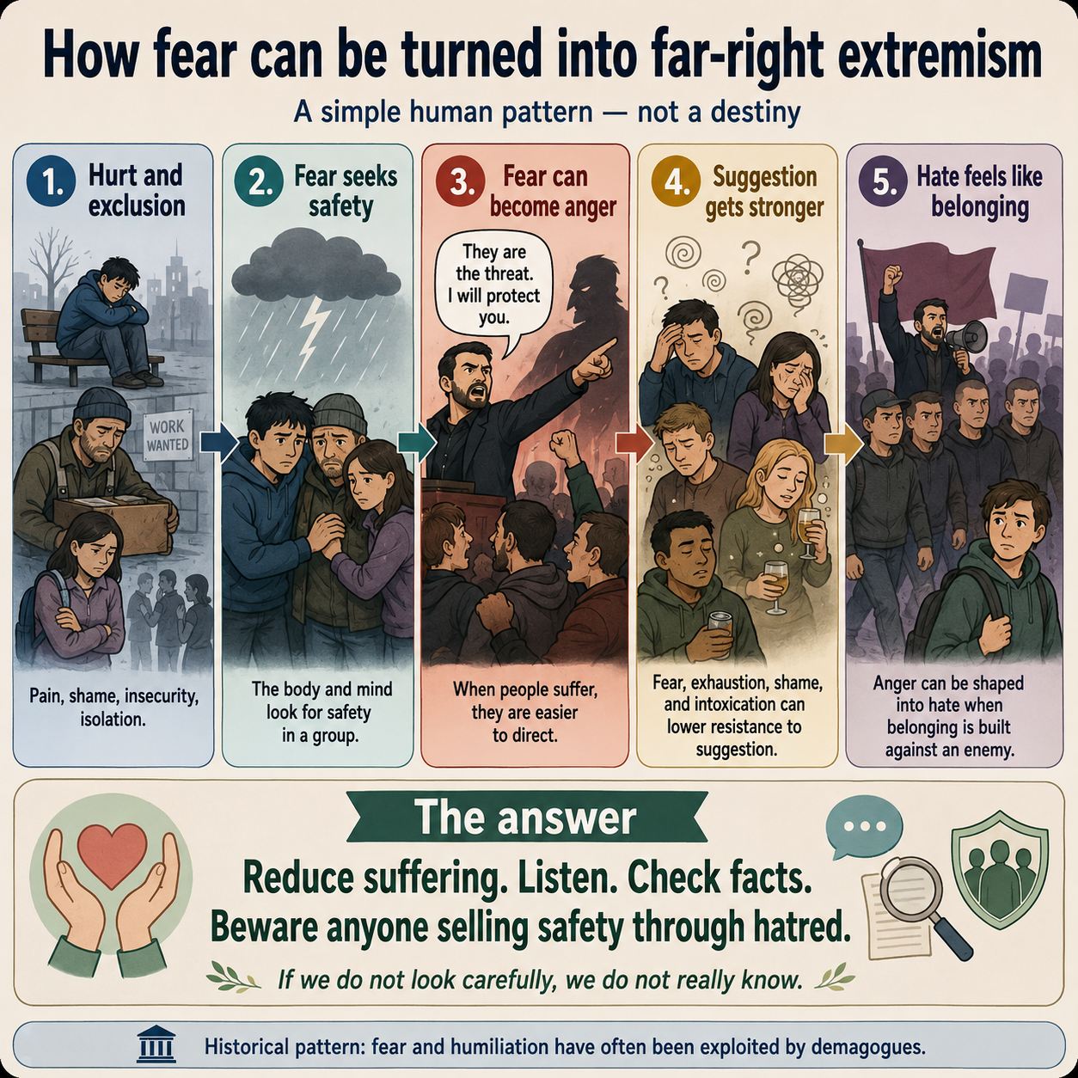
Figure 1. How fear can be turned into far-right extremism. This is a conceptual communication aid, not a validated causal scale, prediction instrument or diagnostic sequence.

Where the graphic is deliberately simple
The graphic leaves out ideology, organised recruitment, social networks, opportunity, personality, political conditions and protective relationships. Those omissions make the pattern easy to see, but they would make it misleading if presented as a complete theory. The paper supplies the missing layers.

3. What research supports
Evidence | Finding | Fair interpretation
Field-wide meta-analysis [1] | Risk factors differ across radical attitudes, intentions and behaviours; the evidence base is heterogeneous. | Use combinations and context, not a single risk marker.
Identity systematic review, 75 studies [2] | Some identity concepts have empirical support, while many proposed links need further testing. | Identity can matter without being a sufficient cause.
Quest-for-significance research [3] | Loss, humiliation or threatened significance can motivate attempts to matter; narratives and networks can channel the response. | The need to matter is human. Violence is one possible, not inevitable, means.
Far-right contagion study, 416 cases [4] | Observed patterns were consistent with reinforcement across online and physical networks. | Exposure plus reinforcement matters; “contagion” is a model, not a claim that people are diseases.
Manifesto analysis [5] | Far-right terrorist texts repeatedly organised identity around exclusion, perceived replacement threat, protection and glorification. | The protector story is visible in extremist communication itself.

Fear can be sold as certainty
A threat does not need to be wholly invented to be exploited. Real pressures—housing, jobs, rapid change, crime, war or institutional failure—can be selected, exaggerated, stripped of proportion and attached to an entire group. The manipulative move is not merely to say that a problem exists; it is to make one identity the universal cause and domination the only imaginable safety response.

The body before the argument
Threat responses narrow attention toward danger and action. In ordinary life this can be protective. Under sustained uncertainty, shame or exhaustion, the same narrowing may make a simple, confident explanation feel relieving. This is a design hypothesis, not a licence to diagnose people from posture, speech or political opinion. The proper response is to slow the decision environment and improve evidence, not to covertly manipulate arousal.

4. The ‘enemy within’: a metaphor with a warning attached
In this paper, “the enemy within” is my metaphor for unexamined fear: a feeling can be real even when its explanation is incomplete. The phrase also has a dangerous political history. Governments and movements have used it to label minorities, dissidents and neighbours as internal enemies. The metaphor must therefore turn inward toward examination of fear—not outward into suspicion of a category of people.
A safe use of the metaphor
Ask: What am I afraid will happen? What evidence supports that prediction? What evidence would change my mind? Who benefits if I attach the fear to an entire group? What response protects people without removing somebody else’s equal humanity?

The hunger-and-poison analogy
A hungry person needs food. If the only offered meal contains poison, hunger explains why the offer has power; it does not make the poison nourishing. In the same way, needs for safety, respect, purpose and belonging are legitimate. A movement can meet those needs while attaching blame, hierarchy and permission to harm. Prevention should provide real nourishment—security, voice, community and agency—without the poison of dehumanisation.

‘Alien,’ unfamiliarity and imagination
The word “alien” does not literally mean “I do not know.” It commonly marks someone or something as foreign, unfamiliar or outside. The psychologically useful point is narrower: when information is incomplete, imagination fills gaps. That capacity creates art, empathy and possible futures; under fear, it can also generate worst-case stories. The answer is not to stop imagining. It is to mark the difference between observation, inference and invention.
Record separately | Example
Observed | A housing waiting list grew by a measured amount.
Inferred | A policy or population change contributed to the pressure.
Unknown | The relative contribution of supply, income, household size, migration and local administration.
Invented / asserted | One human group secretly caused the whole problem and intends harm.

5. History: suffering is exploitable, but ideology still matters
Nazi Germany is an extreme warning against reducing history to emotion alone. The United States Holocaust Memorial Museum documents a developed racist, antisemitic and ultranationalist ideology, organised propaganda, discriminatory law, coercive institutions and escalating violence. Nazi propaganda falsely blamed Jews for Germany’s political, social, economic and cultural problems and presented the regime as restoring order [6–8].
Post-war anger, economic and political crisis and perceived humiliation helped make some audiences receptive, but they did not mechanically produce genocide. Existing antisemitism, racist doctrine, leadership choices, institutions, censorship, intimidation, war, collaboration and opportunism were decisive. Many people exposed to hardship did not become Nazis; people also resisted. The lesson is both psychological and institutional: fear can widen an opening, while organised power decides how that opening is used.
Stage | Historical mechanism | Modern safeguard
Problem | Complex crises are personalised onto an out-group. | Publish disaggregated evidence and uncertainty; correct false causal claims.
Belonging | An idealised national community defines who counts. | Make civic belonging equal and non-ethnic; protect minority rights.
Protection | Authorities claim exclusion or violence will restore order. | Require proportionality, due process, judicial review and named accountability.
Normalization | Repetition, law and public passivity make escalating harm ordinary. | Protect dissent, independent media, records, whistleblowers and review.
Do not dehumanise the dehumaniser
Calling people monsters may feel morally clear, but it can reproduce the same essentialising logic. Hold actions, organisations and ideologies accountable in precise terms. Preserve the possibility of disengagement and return without weakening protection for those at risk.

6. A social technology for interruption
The practical task is to interrupt the pathway at more than one point. Material support without factual accountability can leave propaganda untouched. Fact-checking without dignity can sound like contempt. Dialogue without rights can expose targeted people to abuse. Security without lawful limits can validate the authoritarian claim that force is the only language. The components must work together.
Need or mechanism | Intervention | Safeguard / measure
Immediate threat or distress | Trauma-informed listening, crisis support, housing/debt/health referral. | Do not equate distress with dangerousness; record voluntary take-up and outcomes.
Uncertainty | Explain what is known, unknown and being tested; provide stable review dates. | Correct publicly; do not manufacture certainty.
Need to matter | Real responsibility, contribution, mentoring, work, care and civic roles. | No loyalty test; roles must not require an enemy.
Group separation | Equal-status, purposeful contact around shared tasks [9]. | Prepare, facilitate and protect participants; contact can fail in hostile conditions.
Polarised discussion | Representative deliberation with balanced evidence and independent facilitation [10]. | Ordinary unstructured discussion can intensify polarisation.
Extremist repetition | Network-aware counters, credible messengers, friction before sharing and transparent moderation. | Avoid secret persuasion profiles and viewpoint surveillance.
Movement toward violence | Proportionate safeguarding, lawful investigation, exit support and risk management. | Behaviour and evidence—not identity, diagnosis or lawful belief—must drive coercive action.

The conversation protocol
- Hear the fear without affirming a false accusation.
- Ask what concrete harm is predicted and what evidence supports it.
- Separate people, policies, institutions and actions; do not let a group label substitute for causation.
- Name genuine trade-offs and failures so reassurance is not dishonest.
- Offer a non-humiliating route to revise a claim or leave a group.
- Set a clear boundary around threats, coercion, stalking, hate crime and violence.
- Record uncertainty, corrections and follow-up rather than declaring instant transformation.

7. Safeguards against misuse
Misuse risk | Required protection
Profiling lawful political opinion | Never infer risk from party, class, nationality, religion, autism, mental health or a single belief. Use evidence of behaviour, context and independently reviewable criteria.
Calling dissent ‘extremism’ | Define the protected rights floor and distinguish disagreement, radical reform, hateful ideology and preparation for violence.
Covert emotional manipulation | No hidden arousal engineering, personalised psychological targeting or manufactured fear. State the aim, method and sponsor.
Excusing harm because someone was afraid | Explanation should guide proportionate response; it does not erase another person’s right to safety or remedy.
Forcing targeted groups to educate aggressors | Participation must be voluntary, supported and stoppable; professionals and evidence can carry the burden.
False neutrality | Human equality and freedom from violence are non-negotiable. Facilitation does not require treating dehumanising claims as equally valid.
Security theatre | Any surveillance or coercive power must be necessary, lawful, time-limited, attributable and independently challengeable.

A note on communication practitioners
This project was partly prompted by conversations and popular communication frameworks about fear, influence and behaviour, including a recollection associated with Chase Hughes. I could not verify a specific primary statement precise enough to cite as research. The paper therefore does not rely on that attribution. Its factual claims rest on the sources listed below; the unverified recollection remains a disclosed design prompt, not evidence.

8. How to test the technology
A responsible pilot should test help before assuming persuasion works. It should be voluntary for ordinary participants, independently governed and designed with people vulnerable to far-right targeting as well as people experienced in disengagement, youth work, mental health, community safety and civil liberties.
Element | Minimum design
Sites | Several matched local areas or services; do not infer national effects from one neighbourhood.
Participants | Adults recruited through transparent routes; never label a person an extremist for study participation.
Intervention | Material problem-solving, structured listening, evidence separation, shared-task contact and access to exit support.
Comparison | Usual practice or delayed-start group where ethical; record other local changes.
Primary outcomes | Threats/violence, dehumanising attitudes, social isolation, trust, wellbeing, service use and disengagement—measured separately.
Harms | Stigma, retaliation, increased surveillance, participant distress, targeting of minorities and polarisation.
Time | Baseline, immediate follow-up and longer follow-up; attitudinal change alone is insufficient.
Governance | Independent ethics review, privacy controls, published protocol, adverse-event process and participant withdrawal.

Stopping rules
- Pause if threats, harassment or doxxing increase.
- Stop any component that stigmatises a protected group or deters people from ordinary services.
- Do not scale if the programme improves survey language while worsening violence, trust or rights.
- Publish null and adverse findings; do not optimise only for a persuasive success story.

What success would mean
Success is not everybody holding the same politics. It is fewer people being recruited through fear and dehumanisation; fewer threats and acts of violence; stronger capacity to distinguish evidence from blame; more legitimate routes to safety, significance and belonging; and institutions that protect equal rights while remaining open to correction.

9. Evidence and limitation register
Claim | Evidence status | Limitation / correction rule
Fear can contribute to extremist receptivity. | Plausible and indirectly supported through threat, uncertainty, grievance and significance research. | Do not describe fear as a necessary or sufficient cause; update if stronger causal reviews contradict the model.
Identity needs can matter. | Supported for some concepts across a 75-study systematic review [2]. | Effects and definitions vary; keep identity constructs separate.
Networks reinforce far-right radicalisation. | One spatiotemporal study of 416 US cases found patterns consistent with complex contagion [4]. | Not proof of literal contagion or universal applicability.
Extremist protector narratives use threat and exclusion. | Supported by far-right manifesto analysis [5] and documented Nazi propaganda [6–8]. | Texts show rhetoric and ideology, not every recruit’s private motive.
Contact can reduce prejudice. | Large meta-analysis across 515 studies [9]. | Contact quality and power conditions matter; do not force unsafe encounters.
Deliberation can reduce polarisation. | Systematic review finds effects depend on design [10]. | Unstructured discussion may polarise; evaluate the actual format.
A help-first protocol will prevent violence. | Untested proposal. | Pilot before scale; pre-register outcomes and stopping rules.
Correction invitation
If a source is misread, a pathway is overstated or a safeguard is missing, the correction belongs in the public record. The proposal is offered to be improved, not defended as an identity.

Conclusion
The humane insight at the centre of this paper survives scrutiny: beneath some visible hatred there may be fear, loss, uncertainty or a need to matter. Seeing that layer can improve prevention because it reveals needs that an extremist movement is exploiting. But compassion becomes dangerous if it erases ideology, organisation, choice or the people harmed. The full model must hold both truths at once.
The practical answer is neither contempt nor surrender. Reduce preventable suffering. Let people speak without letting accusation become fact. Provide belonging without an enemy, significance without domination and security without persecution. Protect rights and intervene lawfully when conduct crosses into threat or violence. Keep records, admit uncertainty and measure whether the intervention helps.
The social-technology principle
Fear should be heard as information, not obeyed as an instruction. Safety should be built through truth, material care, equal humanity and accountable power—not sold through hatred.
This paper is released as an open working proposal for public scrutiny, research testing and careful adaptation. It may be shared and improved with attribution. It must not be used to diagnose individuals, disguise surveillance or manipulate people without their informed awareness.

References
1. Wolfowicz, M., Litmanovitz, Y., Weisburd, D. & Hasisi, B. (2020). A field-wide systematic review and meta-analysis of putative risk and protective factors for radicalization outcomes. Journal of Quantitative Criminology.
2. Echelmeyer, L., Slotboom, A.-M. & Weerman, F. (2023). The putative effect of identity on extremist radicalization: a systematic review of quantitative studies. Studies in Conflict & Terrorism.
3. Kruglanski, A. W. et al. (2014). The psychology of radicalization and deradicalization: how significance quest impacts violent extremism. Political Psychology, 35(S1), 69–93.
4. Youngblood, M. (2020). Extremist ideology as a complex contagion: the spread of far-right radicalization in the United States between 2005–2017. Humanities and Social Sciences Communications, 7.
5. Demir, C. K. (2024). Taking stock of far-right terrorism through manifestos: glorification of identity. European Journal of International Security, 9(3), 398–416.
6. United States Holocaust Memorial Museum. Nazi Propaganda.
7. United States Holocaust Memorial Museum. Defining the Enemy.
8. United States Holocaust Memorial Museum. Introduction to the Holocaust.
9. Pettigrew, T. F. & Tropp, L. R. (2006). A meta-analytic test of intergroup contact theory. Journal of Personality and Social Psychology, 90(5), 751–783.
10. Caluwaerts, D. et al. (2023). Deliberation and polarization: a multi-disciplinary review. Frontiers in Political Science, 5.
11. United Nations Secretary-General (2015). Plan of Action to Prevent Violent Extremism, A/70/674.
12. Brouillette-Alarie, S. et al. (2022). Systematic review on the outcomes of primary and secondary prevention programs in the field of violent radicalization. Journal for Deradicalization, 30, 117–168.
Evidence status: peer-reviewed syntheses and primary studies are separated from historical institutional sources and from this paper’s original design proposals. Accessed 26 August 2026.

