THE GREEN TANK

STOP
REFRIGERATING
THE AISLE
  - The energy, commercial and human case for closing supermarket refrigerated display cabinets
UK evidence briefing · August 2026
Public-interest working paper · version 1.0
This paper proposes a measured, food-safe and customer-tested transition from open refrigerated cases to doors, lids and effective night blinds. It separates field evidence from illustrative assumptions and provides a transparent calculation that any retailer can replace with its own metered data.

Executive summary
Supermarkets routinely use open-fronted refrigerated display cabinets because they are familiar and easy to browse. The physical consequence is equally familiar: cold air and moisture spill into the aisle. Closing the display retains visibility and access while reducing the thermal exchange the refrigeration system must overcome.
42%  measured cabinet-energy reduction in one field trial | 99%  customers supporting doors after installation | £12,071  central annual saving for an illustrative 1 GWh UK store
The central UK scenario assumes refrigeration is 40% of store electricity, open chilled cases account for half of that refrigeration load, and doors reduce the affected load by 25%. The arithmetic is 0.40 × 0.50 × 0.25 = 5% of whole-store electricity. At the official January–March 2026 non-domestic average price of 24.1416p/kWh including the Climate Change Levy, a 1 GWh store saves approximately 50 MWh and £12,071 per year. These are scenarios, not forecasts for a named retailer.
The human point
Food needs cold. Customers and staff do not need a refrigerated draught. For people with cold-triggered pain or circulation problems, a warmer, calmer aisle can also be an accessibility improvement.

Recommendation
- Use and repair night blinds immediately whenever stores are closed.
- Specify closed chilled cabinets by default at the next replacement or refit.
- Survey and pilot retrofit doors on suitable open cabinets; recommission the complete cabinet.
- Publish metered energy, temperature, customer and category-sales results.
- Include cold-aisle exposure in accessibility and staff thermal-comfort assessments.
Sources: [1], [3], [5], [6], [7]

1. The avoidable system loss
An open display cabinet maintains a cold product zone with an air curtain. The curtain is not a wall: warm, humid air enters and cold air escapes. The refrigeration system must remove the additional heat and moisture. The store may then spend further energy managing the resulting cold aisle and humidity. The food load is necessary; the uncontrolled exchange with the aisle is not.
A simple distinction
The proposal is not to warm the food. It is to place a transparent, openable boundary between the food’s controlled environment and the people’s occupied environment.

2. The technology is already recognised
The UK Energy Technology List (ETL) testing method recognises strip curtains, blinds, transparent sliding doors, transparent hinged doors and enhanced airflow measures for open-fronted refrigerated display cabinets. It uses established cabinet test standards and requires the same temperature classification before and after a retrofit.
The ETL door procedure also tests normal access: each door is opened 10 times per hour for 15 seconds during a 12-hour cycle. A cabinet does not pass by remaining sealed and unusable. This is important because it reframes the decision: the issue is engineering, procurement and implementation—not whether customers can open a door.
Sources: [1], [9]

Why adoption can lag despite available technology
- Existing cabinets have different frames, temperatures, airflow and controls; retrofits are not one-size-fits-all.
- Capital budgets may prioritise visible expansion over avoided operating cost.
- Retailers may fear reduced impulse sales even when customer acceptance is high.
- Condensation, anti-sweat heating, door swing, seals, stocking and accessibility require engineering attention.
- Savings can be undermined if controls are not recommissioned or doors are left obstructed.

3. What the evidence says

Measured field trial: Countdown Pukekohe South
A government-supported New Zealand trial installed 58 doors on dairy display cabinets and monitored refrigeration energy, cabinet and aisle temperatures, product sales and customer opinion. Energy use fell immediately by 42%, exceeding the pre-trial expectation of 30%. The report calculated annual savings of approximately NZ$23,000, a 3.5-year simple payback and a 29% return on investment.
Measure | Observed result | Interpretation
Cabinet energy | 42% reduction | Strong site-specific result; not a universal guarantee
Aisle conditions | Temperature improved and stabilised | Customers perceived better comfort
Customer support | 53% before; 99% after | Acceptance increased after lived experience
Staple dairy / chilled drinks | No sales impact reported | Access remained commercially workable
Some non-staple items | Initial reductions; most recovered in 5–7 weeks | Merchandising and transition monitoring matter
Quick and easy meals | 5.23% lower in the limited post-door period | Do not hide the adverse signal; test placement and signage
The doors were later removed after retailer concern about some non-staple sales. The report notes that complete post-removal sales data were unavailable. The responsible reading is therefore neither “doors never affect sales” nor “doors stop consumption.” Core categories were unaffected, customer support became overwhelming, and some impulse categories needed active management.

Evidence range
The U.S. Department of Energy reported an engineering potential of roughly 50–80% of refrigeration-system electricity for door retrofits on existing open cases, excluding space-conditioning savings. A comparative live-store paper reported lower realised savings of roughly 20–35% and warned that laboratory results can overstate field performance. This paper therefore uses 25% for the affected case load in its central calculation.
Sources: [2], [3], [4]

4. The human and accessibility case
A refrigerated aisle can feel merely uncomfortable to one person and become painful or exclusionary to another. The NHS states that cold can trigger Raynaud’s symptoms including pain, numbness and pins and needles. This does not mean every refrigerated aisle causes a medical event, and it would be wrong to make that claim. It does mean avoidable cold-air spill deserves consideration in an accessible retail environment.
A barrier around the cold—not around the person
Transparent doors retain sightlines and ordinary product access while reducing direct cold-air spill. Handles, opening forces, reach ranges and door swing must be designed for disabled shoppers, wheelchair users, older customers and people carrying baskets or children.

Staff exposure
Customers pass through the aisle. Staff may stock, rotate, clean and check the same cabinets repeatedly across a shift. HSE guidance requires reasonable indoor workplace temperatures and recommends separating people from sources of heat or cold using barriers where practicable. Cabinet doors are a direct example of controlling the source.

Observed comfort improvement
The EECA trial reported that aisle temperature improved and stabilised after the doors were fitted, and that customers perceived the aisle as more comfortable. This human benefit is not included in the monetary model below; nor are potential space-conditioning savings. The financial case is therefore intentionally narrower than the total benefit.
- Assess aisle temperature and draughts at customer and staff positions.
- Consult disabled customers and staff before selecting handles and door geometry.
- Retain unobstructed routes and avoid door conflicts with mobility aids or trolleys.
- Provide assisted shopping without making it the only accessible route to products.
- Record complaints and comfort feedback before and after installation.
Sources: [3], [6], [7], [10]

5 — Transparent calculation method
The correct commercial calculation uses the retailer’s own half-hourly electricity data, refrigeration sub-metering, cabinet inventory and tariff. Until those data are supplied, a transparent scenario is more honest than a false “typical supermarket.”

Central scenario
Factor | Central value | Status / rationale
Whole-store annual electricity | 0.5, 1.0 or 2.0 GWh | Illustrative store loads; not claimed averages
Refrigeration share | 40% | Conservative assumption; EECA report describes ~50% as generally accepted
Share attributed to open chilled cases | 50% | Scenario assumption to be replaced by sub-metering / engineering model
Door saving on affected load | 25% | Inside reported 20–35% live-store range and below the 42% field-trial result
Electricity price | 24.1416p/kWh | Official UK non-domestic average including CCL, Q1 2026
Whole-store saving | 5% | 0.40 × 0.50 × 0.25

Equations
Annual energy saving
Store electricity (kWh) × refrigeration share × affected open-case share × retrofit reduction
Annual money saving
Annual energy saving (kWh) × actual delivered electricity price (£/kWh)
For a 1 GWh store: 1,000,000 × 0.40 × 0.50 × 0.25 = 50,000 kWh. At £0.241416/kWh, that equals £12,070.81 per year, rounded to £12,071.
Sources: [3], [4], [5]

6. Store and network savings
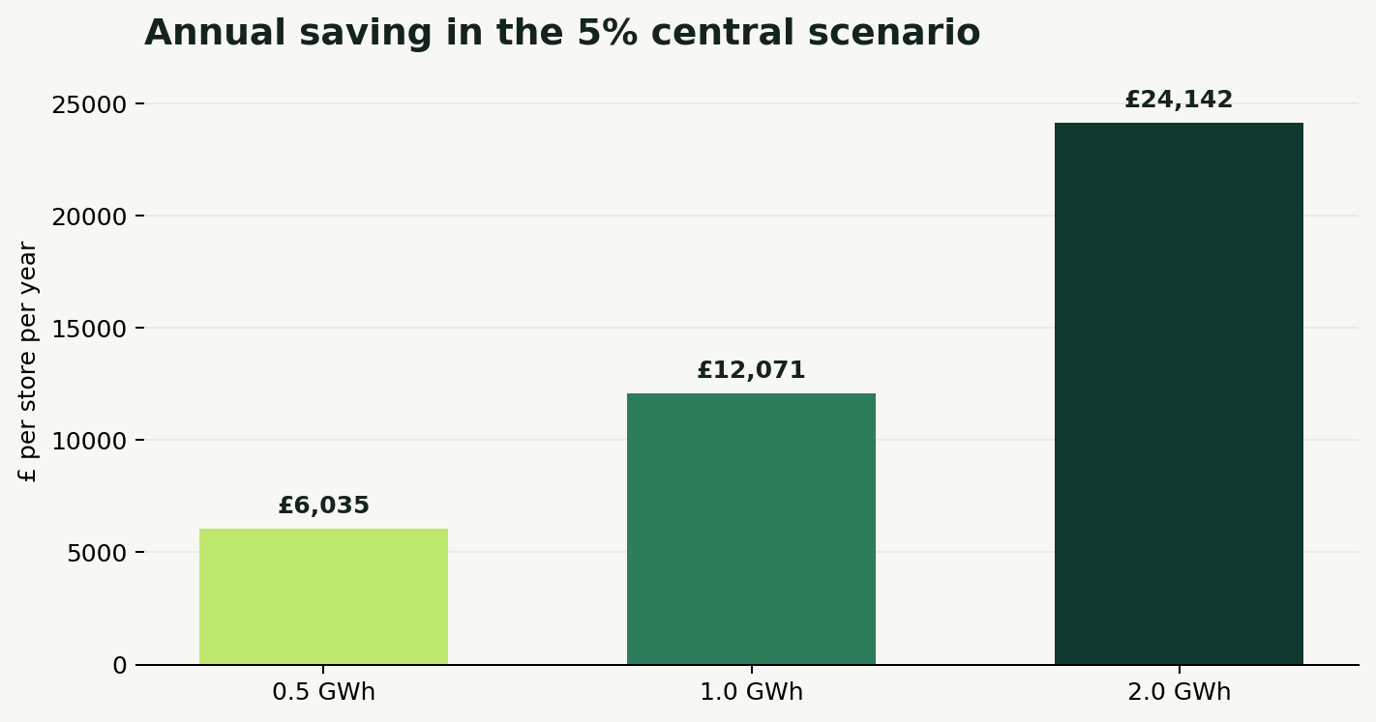
Illustrative annual store use | Whole-store saving | Energy saved | Money saved
0.5 GWh | 5% | 25 MWh | £6,035
1.0 GWh | 5% | 50 MWh | £12,071
2.0 GWh | 5% | 100 MWh | £24,142

Network effect
5 GWh  100 stores | 50 GWh  1,000 stores | £12.07m  annual saving at 1,000 stores
The network example assumes every store uses 1 GWh and achieves the central 5% saving. It is a scale illustration, not a description of any actual UK chain. The calculation excludes maintenance, comfort, heating or dehumidification effects, so those should be assessed separately rather than silently added.
Sources: [5]

7. Sensitivity: the result should survive disagreement
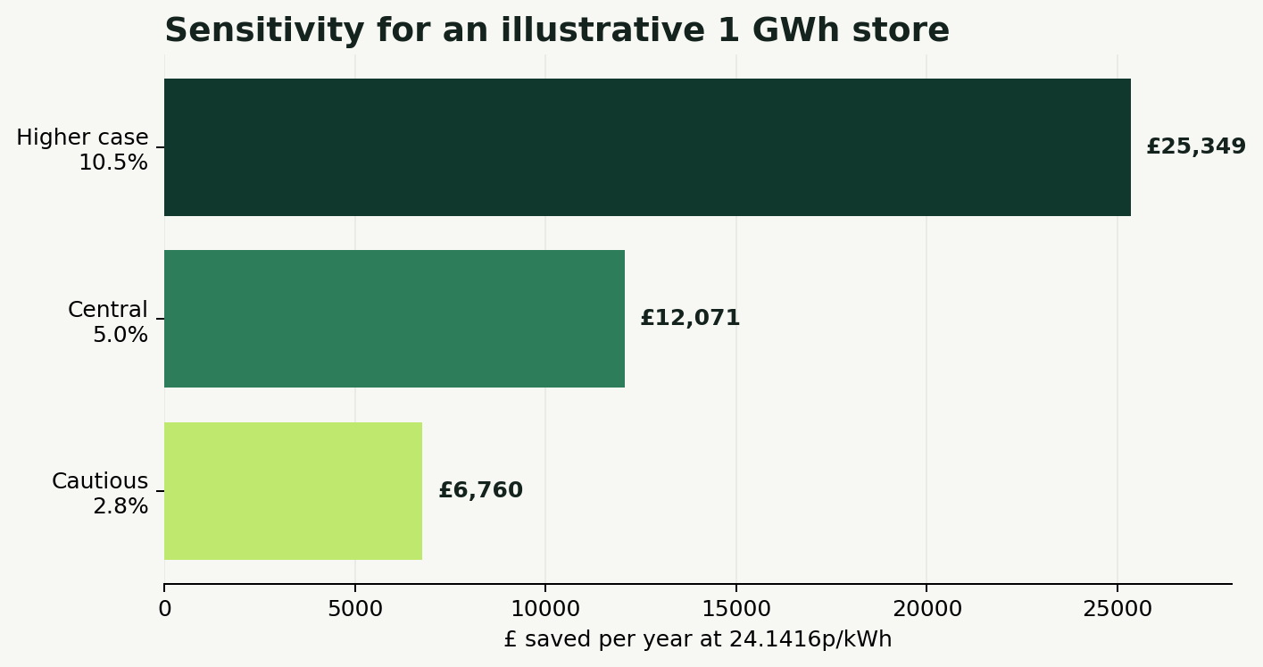
Scenario | Refrigeration share | Open-case share | Door saving | Whole-store result | £/year at 1 GWh
Cautious | 35% | 40% | 20% | 2.8% | £6,760
Central | 40% | 50% | 25% | 5.0% | £12,071
Higher case | 50% | 60% | 35% | 10.5% | £25,349
The cautious case is commercially meaningful even when every key assumption is reduced. The higher case is plausible in favourable conditions but must not be promised. A measured pilot should determine which case applies to each cabinet type and climate zone.

Normalised cabinet check
The ETL threshold for a vertical M1 cabinet is no more than 6.0 kWh per day per square metre of total display area. A worked example at that threshold with a 25% reduction saves 1.5 kWh/day/m², or about 548 kWh/year/m²—worth roughly £132/year/m² at the Q1 2026 average price. This is an eligibility-threshold example, not a claim about every cabinet.
Sources: [1], [5]

8. Costs, payback and procurement
Door price alone is not the project cost. A robust bid includes surveys, fabrication, controls, recommissioning, anti-sweat strategy, installation outside trading peaks, metering, temperature validation, accessibility, maintenance and staff training. Instead of inventing one national retrofit price, use the measured annual saving to set the affordable ceiling.
Target simple payback | Annual saving: 1 GWh central case | Maximum installed project cost
2 years | £12,071 | £24,142
3 years | £12,071 | £36,213
5 years | £12,071 | £60,354
The ceiling is annual saving multiplied by the target payback. Retailers should then adjust for financing, maintenance, tax, equipment life and any verified heating or dehumidification effects. Procurement should require performance measurement, not only product supply.

A staged commercial route
- Baseline: at least four representative weeks plus temperature and weather context; longer where seasonality is material.
- Pilot: several cabinet types in several stores, with matched controls where possible.
- Gate: food safety and accessibility first; then energy; then category sales and customer comfort.
- Scale: approve only the cabinet/site combinations that meet the agreed hurdle.
- Verify: publish normalised kWh/day/m² and whole-store change with caveats.
Sources: [1], [3], [5]

9. Implementation safeguards
Risk | Control | Evidence to retain
Food temperature drift | Recommission airflow, controls and defrost; log product simulator temperatures | Before/after temperature records and alarm logs
Condensation / misting | Specify glazing and anti-sweat controls for local dew point | Humidity, glass temperature and heater energy
Door access barrier | Test opening force, handles, reach, door swing and trolley clearance | Disabled-user review and observed shopping trials
Sales disruption | Improve signage and layout; monitor by category for at least 12 weeks | Units, value, margin and control-store comparison
Savings shortfall | Sub-meter cases and whole refrigeration plant; verify controls | kWh/day/m², ambient conditions and opening pattern
Maintenance failure | Clean seals, repair closers and keep doors unobstructed | Inspection and work-order records

10. Policy and industry proposal
- Closed cabinets should be the default for new and replacement chilled displays; open designs should require a documented exception.
- Public support should pay for verified outcomes—measured kWh and compliant temperatures—not merely installation.
- Retailers should disclose cabinet-level energy classes and estate retrofit progress.
- Accessibility and staff thermal comfort should be explicit success criteria alongside energy and sales.
- Independent replication should test different UK store formats, climates and product categories.
The aim is not punitive. It is to make the efficient design the ordinary design, while allowing evidence-based exceptions for genuine operational needs.
Sources: [1], [7], [8], [9], [10]

11. Measurement protocol and limitations

Minimum public protocol
- State cabinet make, model, temperature class, display area, product category and door type.
- Measure baseline and retrofit periods long enough to capture trading patterns; report ambient temperature and humidity.
- Record door openings or use an agreed standardised opening schedule.
- Report refrigeration-system kWh and, where possible, whole-store kWh.
- Confirm equal temperature classification and food-safety compliance before comparing energy.
- Report sales by category, customer feedback, accessibility findings and maintenance events.
- Publish negative, neutral and positive results using the same definitions.

Limitations of this paper
The store electricity loads are illustrative. The central 40% refrigeration share and 50% open-case share are assumptions. Electricity price data are a quarterly national average and may differ substantially from a retailer’s contract. The field trial was conducted in Auckland, not the UK, and its sales dataset was incomplete. The live-store 20–35% range comes from a comparative industry paper. Savings depend on climate, case design, controls, maintenance and shopping behaviour. No claim is made that every open aisle causes pain, only that cold can be painful for some people and that avoidable draughts should be considered in accessible design.
What would change the conclusion?
If a properly recommissioned, food-safe and accessible retrofit repeatedly failed to save enough energy to meet the retailer’s hurdle—or caused a sustained net commercial loss that could not be corrected—the case for that cabinet/site combination would fail. The method is designed to find that honestly.

Conclusion
Open refrigerated cabinets are a solvable form of energy loss. Doors, lids, blinds and airflow measures already exist, and recognised test methods already account for customer opening. A monitored supermarket trial demonstrated 42% cabinet-energy savings, improved aisle comfort and 99% customer support after installation, while also revealing the need to manage some impulse categories carefully.
Using cautious UK assumptions and the latest official business electricity price, a 1 GWh store saves about 50 MWh and £12,071 each year. At 1,000 stores, the same scenario becomes 50 GWh and £12.07 million annually. The precise total is uncertain; the direction is not. Retailers can replace every assumption in this paper with measured values and make a transparent decision.
The proposition
The food needs the cold. The aisle does not. Close the cabinet, measure the result and share the evidence.

References
[1] UK Energy Technology List, retrofit testing method for open-fronted refrigerated display cabinets
[2] U.S. Department of Energy, High Impact Technology Catalyst market transformation plan (2016)
[3] EECA / AIRAH archive, Trial Retrofit of Doors on Open Refrigerated Display Cabinets
[4] Aerofoil Energy, disparity between laboratory and live-store door savings
[5] Department for Energy Security and Net Zero, non-domestic energy prices; Q1 2026 data published 30 June 2026
[6] NHS, Raynaud’s
[7] Health and Safety Executive, thermal comfort control measures
[8] Ecodesign requirements for refrigerating appliances with a direct sales function
[9] UK Energy Technology List, refrigerated display cabinets
[10] Health and Safety Executive, workplace temperature law
Prepared as a public-interest working paper. Figures are rounded. “Saving” means avoided electricity expenditure before financing, tax and unverified secondary effects. Contact: thegreentank@proton.me

