CL17 Emission Transitive Emission Ongoing Research Study

Abstract
Emission Transitive Emission is an open, ongoing investigation of whether an output from one energy or manufacturing process can become a controlled input to another. The recovered CL17 work combines alternative fuels, carbon reuse, electrolysis, batteries, engine–generator systems, emissions capture, heat and water recovery, and refill–return–regenerate logistics. It contains two structured research databases, prior reports, source data, system figures and verification records. The primary matrix maps 26 species, 48 reaction records and 38 pathways. The supplemental workbook enumerates 14,400 bounded system configurations. Of those configurations, 1,134 are marked Candidate, 2,124 Research only, 4,302 Incomplete and 6,840 Reject. These are screening classifications, not experimental validation.
The strongest focused research candidate is demand-regulated acetylene generation within a stationary or depot-centred system. The chemistry and several component technologies have substantial prior art, including carbide hydrolysis, demand control, acetylene engine trials, carbon-dioxide-to-carbide laboratory routes, series-hybrid buffering and mobile capture studies. The complete CL17 integration has not been demonstrated. It must therefore be developed through independent mass and energy balances, process-safety review, supervised bench testing, engine and emissions measurement, lifecycle assessment and staged prototype gates.

Study status and authorship
Ongoing research status
This document records a research programme and a request for collaboration. It is not a declaration of a finished invention, a safety case, a vehicle approval, or proof that any candidate has a favourable lifecycle result. Each claim is intended to remain open to correction by calculation, experiment and independent review.
The originating researcher is AL of The Green Tank. The work arose from sustained conceptual mapping conducted with a laptop and AI assistance. Disability and social exclusion have restricted access to laboratories, engineering networks and equipment; those barriers do not determine whether the questions are scientifically testable. This study asks research organisations to judge the work by its evidence, transparent uncertainties and experimental value. The request is for access and partnership, not charity.
Any collaboration should record AL’s originating contribution, preserve dated versions of the CL17 files and agree authorship, background intellectual property, new results, publication rights and data access before experimental work begins. Accessibility requirements should be discussed at project formation and budgeted as research-enabling costs where eligible. UKRI states that applicants can request reasonable adjustments throughout assessment and may request project-specific adjustment costs that arise directly from the research. ^{[40]}

Evidence classes used in this study
Class | Meaning
Established | Industrial chemistry, published measurements or mature adjacent systems with repeatable evidence.
Demonstrated | A peer-reviewed laboratory, engine or pilot result under stated conditions.
Modelled | A calculated or simulated result that still requires experimental confirmation.
Proposed | A CL17 system integration or application hypothesis not yet demonstrated.
Rejected or incomplete | A combination that violates a screening rule, lacks a necessary route, or creates an unacceptable unresolved hazard.

Executive finding
Evidence verdict
There is something technically real to investigate. On-demand carbide-to-acetylene generation, acetylene engine operation, series-hybrid electrical buffering, exhaust scrubbing and carbon capture all have published or patented precedents. Recent laboratory work also shows that carbon dioxide can be converted into lithium or calcium carbide intermediates and then into acetylene. What has not been demonstrated is the complete closed-loop vehicle proposed here: lithium-carbide cartridges, minimal acetylene hold-up, an engine–generator, electrical storage, exhaust capture, and depot regeneration operating safely and with a favourable whole-system energy and carbon balance.
The most important discovery in the prior-art search is unusually close to the Bubble Butt concept. A 1972 United States patent proposed controlled calcium-carbide hydrolysis, an acetylene-fuelled engine, an afterburner, and passage of combustion products through the calcium-hydroxide slurry produced by the fuel-generating reaction. ^{[8]} Later patents proposed demand-regulated onboard acetylene generation and recovery of reaction and exhaust heat. ^{[6][7][9]} These documents establish prior proposals, not verified performance, safety, emissions compliance or commercial viability.
The strongest modern scientific foundation is at the stationary chemical-production end. McEnaney and colleagues demonstrated a lithium-mediated cycle in which lithium was generated electrochemically, reacted with carbon sources to form lithium carbide, and hydrolysed to acetylene while regenerating lithium hydroxide. The reported current efficiency was 15% with carbon dioxide and more than 55% with graphitic carbon. ^{[2]} A later calcium route reported 92% current efficiency for acetylene formation after a two-step high-temperature electrochemical process. ^{[3]} Current efficiency is not the same as plant efficiency or round-trip fuel efficiency; neither paper demonstrates a vehicle system.
A focused three-month programme could credibly produce a literature-validated system model, ranked chemistry pathways, safe bench demonstrations performed by an equipped laboratory, preliminary emissions data and a down-selected prototype architecture. It should not promise a road-ready fuel or certified vehicle in that period. Crash safety, durability, transient operation, cartridge logistics, emissions certification and lifecycle verification would remain later-stage work.

What is established and what remains proposed
Pathway element | Evidence level | What the evidence actually supports | Sources
Carbide + water → acetylene | Established industrial chemistry | CaC₂ generators have more than a century of operating history; formal generator safety guidance exists. | [4–5, 10–11]
Pressure/demand-regulated generation | Established prior art | Automatic portable generators and vehicle-oriented demand control were patented. | [5–7]
Acetylene in engines | Laboratory demonstrated | SI and CI engine studies show combustibility and controllability, but efficiency and pollutants vary strongly with mixture and load. | [12–14]
CO₂ → carbide → acetylene | Laboratory demonstrated | Lithium- and calcium-mediated electrochemical routes have been reported. | [2–3]
Series hybrid + electrical buffer | Mature adjacent technology | The engine can be decoupled from wheel transients; batteries and supercapacitors can buffer power. | [15–17]
Wet exhaust scrubbing | Established adjacent technology | Useful for cooling, particulate matter and some soluble gases; plain water is not a high-capacity CO₂ capture medium. | [20–21]
Onboard CO₂ capture | Modelled; limited demonstrations | Published designs target high capture but impose equipment, regeneration and storage burdens; larger vehicles are favoured. | [18–19, 22]
Li₂C₂ cartridge + engine-generator + capture + depot loop | Proposed integration | No complete prototype or validated lifecycle result was found. | Research gap

Recovered CL17 research corpus
The present paper is based on the recoverable project record in the working collection and the current conversation frame. The record includes the primary CL17 chemistry network, the supplemental interactive-system investigation, the evidence review, two Bubble Butt concept boards, source datasets, figures, builders and verification logs. No additional specifically identifiable CL17 download was found in the available file collection. Missing chat-only material should therefore be described as unavailable rather than represented as an original recovered file.
Asset group | Recovered extent | Purpose
Primary chemistry network | 26 species; 48 reaction records; 38 pathways; 6 shortlisted programmes; 37 source records | Screening map of inputs, processes, outputs, hazards and applications
Supplemental systems study | 8 fuels; 13 electrolysis routes; 6 H₂/O₂ roles; 8 battery routes; 11 coproduct routes; 4 CO₂ products; 36 source records | Interactive links among combustion, electrolysis, storage, capture, recycle and manufacturing
Combination explorer | 14,400 bounded configurations | Cross-product screening rather than proof of physical validity
Prior reports | Three DOCX reports with rendered PDF counterparts | Narrative evidence, equations, cautions and research recommendations
Figures and concept boards | Five principal images | CL17 network, system architecture, HHO energy balance and two Bubble Butt boards
Reproducibility material | Two JSON datasets, four builder scripts and verification records | Source reconstruction, formula checks and audit trail

Bounded combination results
Status | Count | Share | Interpretation
Candidate | 1,134 | 7.875% | Passes current screening rules; still requires calculation and experiment.
Research only | 2,124 | 14.750% | Scientifically interesting but unsuitable for immediate application or missing a critical proof.
Incomplete | 4,302 | 29.875% | One or more material, energy, safety, application or regeneration links are not defined.
Reject | 6,840 | 47.500% | Fails a stated rule or contains an unsuitable combination within the current model.
Total | 14,400 | 100.000% | All combinations in the bounded explorer.

The 1,134 Candidate rows are hypotheses selected by the workbook’s present rules. They are not 1,134 valid fuels. The 2,124 Research only rows may contain useful electrolytes, sorbents, catalysts or catalyst precursors, battery materials, heat-transfer media, manufacturing feedstocks or diagnostic controls even when they fail as primary fuels. The model should retain rejected and incomplete rows with reasons because a failed sequence can still reveal a useful intermediate or show where a different reaction would be required.
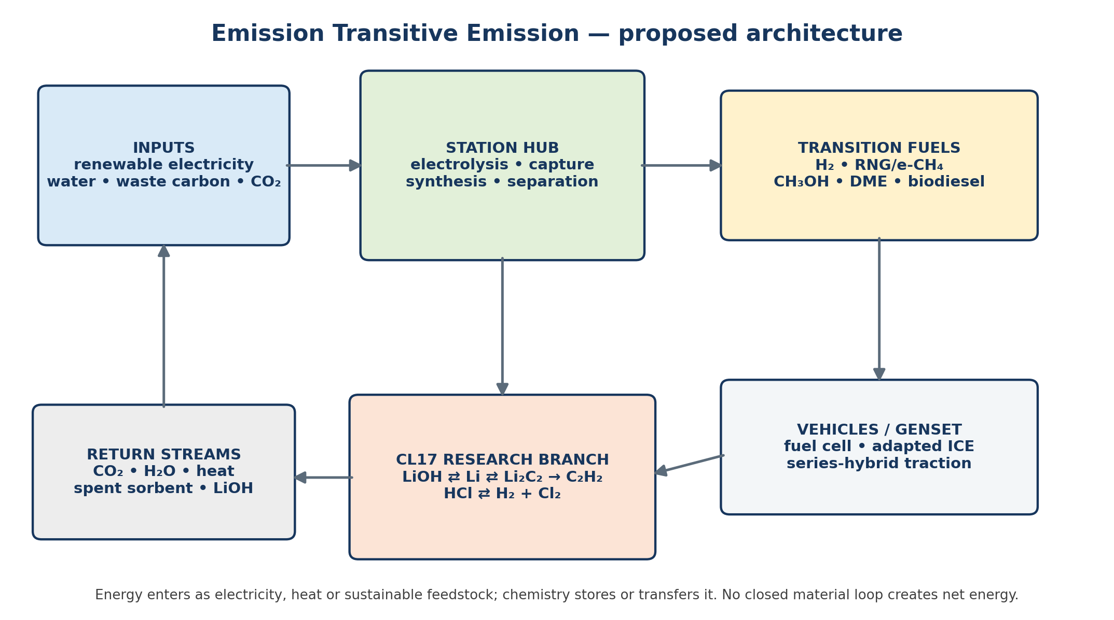
Figure 1 Recovered CL17 network overview
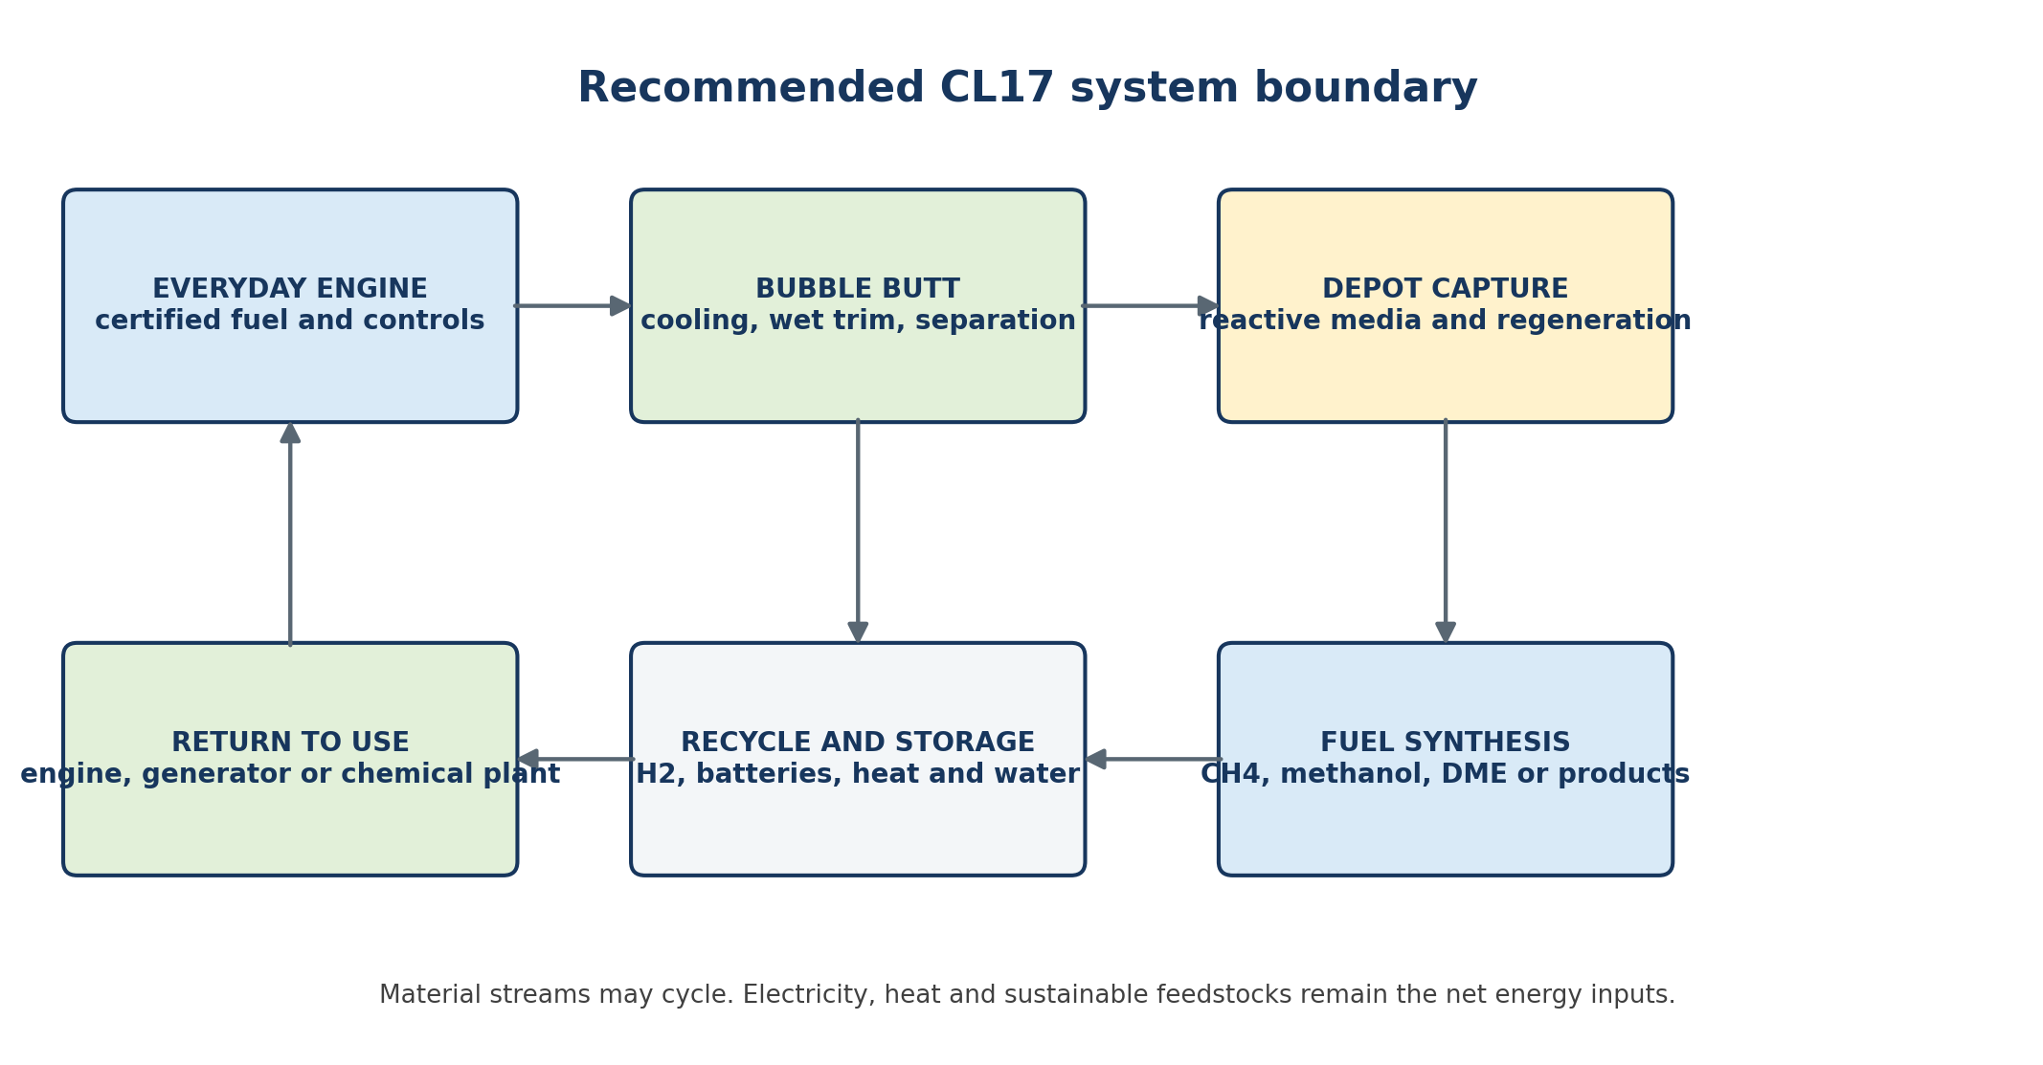
Figure 2 Supplemental interactive-system architecture

Research method and global reporting standards
Future versions should use SI units, unambiguous chemical formulae and IUPAC names, balanced reactions, stated temperature and pressure, lower or higher heating value labels, uncertainty ranges, dated source access and persistent DOI links. Each result should identify its system boundary, functional unit, baseline and evidence class. Lifecycle work should follow the principles and requirements of ISO 14040 and ISO 14044, including goal and scope, inventory, impact assessment, interpretation, limitations and critical review. ^{[44][45]}
The digital record should follow the FAIR principles so that data, workflows and models are findable, accessible, interoperable and reusable. ^{[35]} Every dataset release should carry a version, machine-readable metadata, column definitions, units, source provenance, change log, licence decision and SHA-256 checksum. The paper uses numbered Vancouver-style references; future technical reports may adapt the formatting required by a target journal without changing source identity.

Project vision
The CL17 matrix is treated here as a connected research repository: chemistry, electrolysis, fuels, batteries, heat recovery, emissions separation, material return and manufacturing are examined as one system. Its guiding principle is that an output should not automatically be labelled waste. It may instead be a feedstock, an energy carrier, a recoverable material, a treatment burden or a residue that must be safely contained.
The public-interest aim is to develop transition technologies that can reduce dependence on newly extracted fossil carbon and make useful low-carbon systems accessible beyond incumbent fuel supply chains. That aim must be tested by mass balance, energy balance, lifecycle assessment and safety evidence. Processing can transform or separate waste, but it cannot make matter, energy losses, toxicity or disposal obligations disappear.
A disciplined statement of the ambition
With a small engineering team, an appropriately equipped laboratory and AI-assisted modelling, a three-month sprint should seek prototype evidence—not predetermined confirmation. The result may be a viable fuel pathway, a stationary manufacturing process, a useful emissions retrofit, several application-specific systems, or a well-supported decision to reject some branches early.

The proposed integrated system
Stage | Input | Output | Evidence status
1 Stationary manufacture | Low-carbon electricity + recovered LiOH/carbonate + captured CO₂ or qualified carbon source | Dry, quality-controlled carbide carrier; separated coproducts | Demonstrated only as laboratory chemistry for Li route
2 Refill and return | Fresh cartridge and water delivered; spent hydroxide/carbonate returned | Material custody and batch traceability | Proposed logistics architecture
3 On-demand reaction | Metered solid–liquid contact | Acetylene + hydroxide + heat | Established for CaC₂; Li₂C₂ vehicle form unproven
4 Power conversion | Conditioned acetylene to dedicated engine-generator | Electricity + heat + exhaust | Engine operation demonstrated; integrated set unproven
5 Electrical buffer | Generator + regenerative braking | DC bus, battery and/or supercapacitor | Mature adjacent architecture
6 Bubble Butt treatment | Cooled exhaust and selected capture media | Reduced PM/soluble pollutants; possibly concentrated CO₂ or carbonate | Needs pollutant-specific design and testing
7 Depot regeneration | Returned products, captured carbon, renewable electricity and heat integration | Regenerated carrier + managed residues | Central unresolved efficiency and cost question

The “capacitor tank” idea is best implemented electrically. A battery or supercapacitor downstream of the generator can supply acceleration and absorb regenerative-braking pulses while the chemical reactor and engine-generator operate slowly or near a selected steady point. Series-hybrid literature supports the architecture, while battery–supercapacitor research supports using high-energy storage for duration and high-power storage for short transients. ^{[15][16][17]} This reduces the required chemical response rate; it does not eliminate the need for safe gas-side control.

Chemistry and conservation limits

Core lithium carbide reaction
Fuel-release reaction
Li₂C₂ + 2 H₂O → C₂H₂ + 2 LiOH + heat
For every kilogram of theoretical acetylene product, the stoichiometric feed is approximately 1.46 kg lithium carbide and 1.38 kg water, producing approximately 1.84 kg lithium hydroxide. These values assume pure materials and complete reaction; a real system would carry packaging, excess water, controls, cooling equipment and unreacted or contaminated material.

Combustion reaction
Ideal complete combustion
C₂H₂ + 2.5 O₂ → 2 CO₂ + H₂O + heat
Acetylene has a lower heating value of about 48.2 MJ/kg, or 13.4 kWh/kg of chemical energy. ^{[1]} Complete combustion produces about 3.38 kg CO₂ and 0.69 kg water per kilogram of acetylene. It therefore does not have zero-carbon exhaust. Its mass-specific fuel energy is higher than petrol, but the total carried reactant mass is much larger once lithium carbide and reaction water are counted.
Energy carrier | LHV by mass | LHV by volume | Equivalent | Interpretation
E5 petrol | ≈42–43 MJ/kg | ≈31.5–32.5 MJ/L | ≈8.8–9.0 kWh/L | Liquid fuel benchmark; value varies by blend and season.
Acetylene | ≈48.2 MJ/kg | ≈0.056 MJ/L as gas near normal conditions | ≈13.4 kWh/kg; ≈0.0156 kWh/L gas | A litre comparison is meaningless unless pressure, temperature and storage form are stated.
Li₂C₂ + stoichiometric water | ≈17.0 MJ/kg combined feed | System-dependent | ≈4.7 kWh/kg combined feed | Before reactor, containment, cooling and conversion losses.

Benchmark basis: NIST acetylene thermochemistry and government/DOE fuel-property ranges. Values are rounded screening figures, not certification data. ^{[1][25][26]}

The no energy gain rule
If captured CO₂ and water are the ultimate feedstocks, making acetylene is the energetic reverse of burning acetylene. The theoretical minimum renewable-energy input therefore cannot be lower than the fuel energy later released, and real electrolysis, heating, separation, compression, pumping and regeneration make the actual input larger. A favourable system can still be useful as energy storage, transport fuel or carbon recycling, but it cannot be self-powering.

The byproduct capture limit
Lithium hydroxide can chemically bind carbon dioxide: 2 LiOH + CO₂ → Li₂CO₃ + H₂O. However, the LiOH produced while making one mole of acetylene can bind only one mole of CO₂, while combustion of that acetylene produces two moles. On stoichiometry alone, the fuel-generation by-product can bind at most 50% of its own ideal combustion CO₂. The same one-half relationship holds for Ca(OH)₂ made from CaC₂. Additional sorbent or repeated regeneration would be required for higher capture.
Capture also competes with carrier regeneration: once LiOH is converted to carbonate, the depot process must accept and separate that carbonate or convert it back. This is not a fatal flaw; it is a design choice that must appear explicitly in the material and energy balance.

Water recovery opportunity
The hydrolysis step consumes two moles of water per mole of acetylene, while combustion creates one mole. Perfect exhaust condensation could therefore replace at most half of the reaction water before real losses and contamination. This makes water recovery a useful subsystem, not a closed source of all required water.

Research already completed

A century of demand regulated acetylene generation
Portable calcium-carbide generators were used historically for lighting and industrial applications by bringing carbide and water together only when gas was required. The American Chemical Society records their early commercial importance. ^{[4]} Patents from 1931 onward describe automatic response to gas pressure or demand. ^{[5]} The existence of these systems is strong evidence that controlled generation is physically possible, but modern vehicle crashworthiness and emissions standards are a different engineering problem.

Vehicle prior art
Document | Date | Relevant proposal | Meaning for CL17
US 3,664,134 | 1972 | Carbide-water reactor, acetylene engine, afterburner and exhaust contact with Ca(OH)₂ slurry | Closest discovered precursor to Bubble Butt; patent claims are not test validation.
US 4,054,423 | 1977 | Pressure-regulated onboard CaC₂/water generator feeding a vehicle engine without conventional gas storage | Direct precedent for demand-controlled onboard generation.
US 4,444,159 | 1984 | Compact generator intended for engine power with fast water-flow response and cooling | Precedent for cartridge-like charging and response goals; design also included gas storage.
US 6,282,900 | 2001 | Calcium-carbide power system with reaction and exhaust heat recovery | Precedent for treating hydrolysis heat as a recoverable system output.

Modern carbon dioxide to acetylene chemistry
The lithium route most directly supports the CL17 concept. In the 2020 study, lithium metal was electrochemically generated from LiOH, then reacted with CO₂, methane, carbon monoxide or solid carbon to form carbide-containing products. Hydrolysis generated acetylene and returned LiOH. The authors reported 15% current efficiency to acetylene using CO₂ and more than 55% using graphitic carbon. ^{[2]} This is proof of a chemical cycle, not proof of acceptable energy consumption, long life, scale, cost or cartridge manufacture.
The 2024 calcium study separated carbon deposition from carbide formation and reported 92% current efficiency to acetylene in the selected laboratory process. ^{[3]} It strengthens the general concept of turning captured CO₂ into a carbide intermediate. It also suggests that calcium deserves attention as a control pathway because CaC₂ generation and hydrolysis are industrially familiar, even though conventional coal-based calcium carbide is carbon-intensive.
A Chinese lifecycle study reported roughly 6.77 tonnes CO₂-equivalent per tonne of acetylene for the conventional calcium-carbide route. ^{[23]} Separate process studies have proposed carbon capture and carbide-slag recycling to improve this system. ^{[24]} The lesson is that carbide chemistry is not automatically low-carbon: the source of carbon, electricity, heat and metal regeneration controls the result.

Engine performance and pollutant evidence
Published engine trials confirm that acetylene can contribute useful combustion energy. They do not establish a universal power increase. A gasoline–acetylene study found lower brake thermal efficiency at rich and stoichiometric conditions but higher efficiency in some lean conditions. It also found lower unburned hydrocarbons, condition-dependent carbon monoxide, and generally higher NOₓ except at very lean operation. ^{[12]} A later diesel–acetylene study found lower brake thermal efficiency and soot but higher CO, HC and NOₓ under its test conditions. ^{[13]} Reviews conclude that engine design, load, mixture preparation, ignition timing, pilot fuel and excess-air ratio determine the outcome. ^{[14]}
Output | What research indicates | Screening result | Required interpretation
CO₂ | Produced whenever carbon in acetylene is oxidised | ≈3.38 kg/kg C₂H₂ under complete combustion | Capture or renewable-carbon sourcing can change lifecycle result, not the combustion stoichiometry.
NOₓ | Often rises with high flame temperature and oxygen availability | Mixed, frequently adverse | Requires dedicated combustion calibration, EGR and/or aftertreatment study.
CO and unburned HC | Sensitive to mixture, quenching and transient control | Mixed | Cannot be claimed lower without a specific engine map and catalyst system.
Soot/PM | May fall in some diesel dual-fuel tests; acetylene is also a soot precursor in rich flames | Potential advantage, not guaranteed | Measure particle number, mass and size, not visible smoke alone.

Answer to “does it put out more power?”
Acetylene contains more chemical energy per kilogram than E5 petrol, but that does not mean the complete system creates more power. Shaft or electrical power depends on fuel flow, air handling, knock limits, engine efficiency, generator efficiency and the mass and losses of the carbide–water system. It produces broadly the same pollutant families as other carbon fuels—CO₂, NOₓ, CO, hydrocarbons and possibly particles—although the quantities and treatment opportunities differ.

Minimal gas hold up rather than zero gas
Demand control can avoid storing the journey’s fuel as acetylene, which is a real safety advantage. It cannot mean that no gas is ever present. During operation there must be a finite reaction space, separators, piping and an intake path containing acetylene. Wet particles can continue reacting briefly after water flow stops, and heat, pressure, contamination or valve failure can upset the response.
The correct engineering target is therefore: no journey-scale acetylene inventory; minimum verified gas hold-up; bounded post-shutdown generation; fail-closed reactant isolation; monitored pressure and composition; flashback protection; controlled consumption or safe handling of residual gas; and crash-tolerant separation of dry carbide from water. EIGA guidance for stationary wet generators emphasises formal safeguards, buffers, mechanical integrity, inspection and maintenance. ^{[10][11]} Acetylene has an exceptionally broad flammable range and can decompose violently under unsuitable conditions. ^{[27]}

HHO and hydrogen as reaction assistants
“HHO” is a mixed hydrogen–oxygen product, not a catalyst. A catalyst changes reaction rate without being consumed; hydrogen is consumed as a fuel and oxygen is consumed as an oxidiser. Research on hydrogen-rich-gas enrichment shows that small hydrogen additions can speed early flame development, extend lean operation and sometimes improve efficiency or reduce CO/HC when the engine and controls are optimised. ^{[28][29]} NOₓ, knock, pre-ignition and backfire can worsen in other conditions.
Onboard electrolysis powered by the same engine–alternator cannot deliver free net energy: mechanical-to-electric, electrolysis and combustion losses make the return smaller than the input. A scientifically useful CL17 investigation would instead compare (a) separated, station-produced hydrogen as a combustion promoter; (b) hydrogen used at the depot to convert captured CO₂ into methanol, methane or other carriers; and (c) electrolysis only when surplus low-carbon electricity is available. Mixed oxyhydrogen should not be stored.
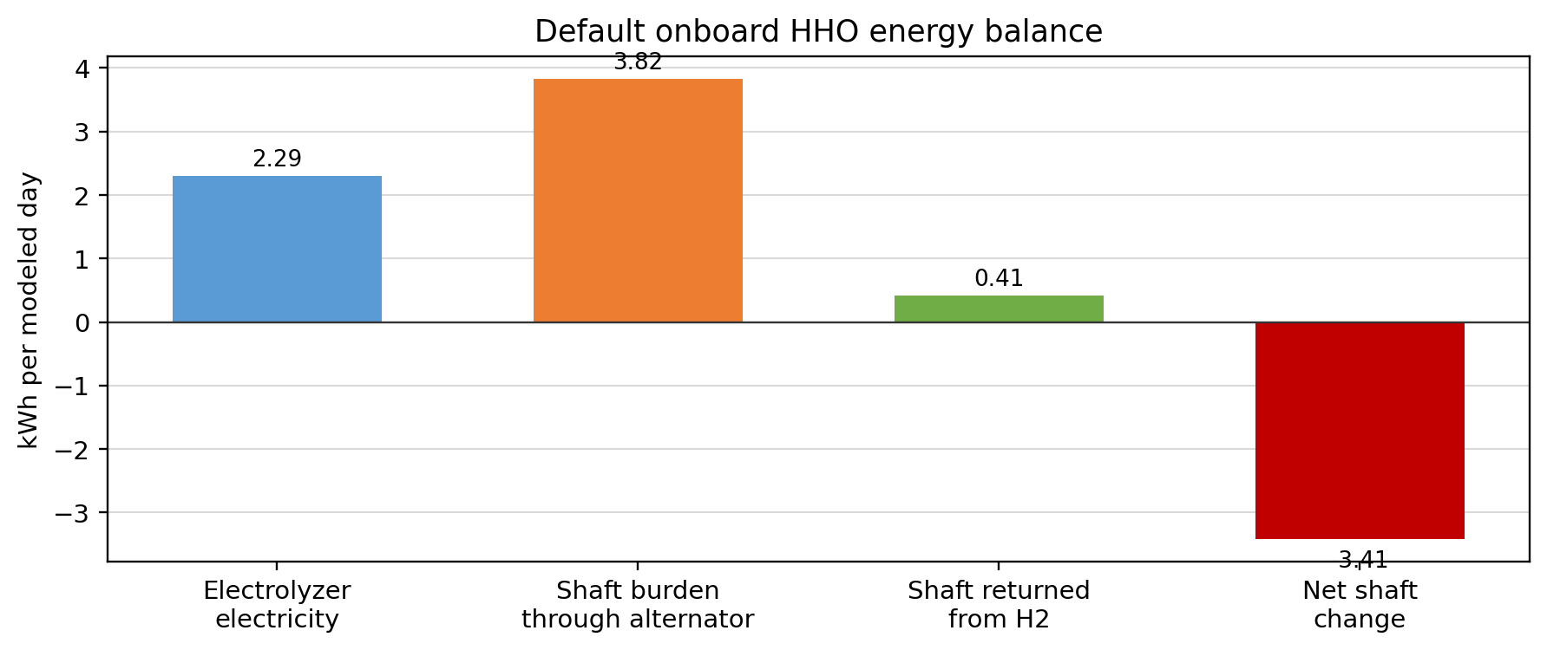
Figure 3 Recovered HHO energy-balance screen

Battery and active reflux possibilities
Lithium carbide has also been investigated as a high-capacity lithium-ion battery cathode. A 2016 paper reported a theoretical capacity near 1,400 mAh/g and experimental electrochemical behaviour, while follow-on work observed structural change and capacity loss during cycling. ^{[30][31]} This is evidence of a separate battery-material research path. It does not show that a fuel cartridge can simultaneously be a durable traction battery and an acetylene precursor.
The practical near-term integration is conventional electrical storage around the engine-generator. “Active reflux” can then mean measured feedback loops: recover braking energy; use exhaust and reaction heat where temperature levels match; condense water; return hydroxide/carbonate; and recycle captured carbon at the depot. Each loop must include its pumps, heat exchangers, separators, control energy, contamination and purge streams.

Bubble Butt and emission transformation
Bubble Butt should be treated as a modular exhaust-treatment platform, not one universal liquid bubbler. Water-based wet scrubbers are established for cooling exhaust, removing particulate matter and collecting some soluble gases. The U.S. EPA describes wet scrubbers primarily as controls for particulate matter and acid gases, and diesel studies show performance depends strongly on design and operating conditions. ^{[20][21]} CO₂ is only weakly captured by plain water at exhaust conditions; meaningful carbon capture normally needs reactive sorbents, adsorption, membranes, mineralisation or separation of a concentrated stream.
Onboard carbon-capture research is real. One published temperature-swing adsorption design modelled 90% capture using exhaust heat, while acknowledging steady-state assumptions and the need for prototype and dynamic validation. ^{[18]} Other analyses find onboard capture more attractive for long-range heavy vehicles and ships than for light passenger cars because equipment and stored CO₂ add mass and volume. ^{[19]} A shipboard chemical-absorption demonstration confirms that mobile capture equipment can be engineered, but scale and duty cycle differ greatly from a car. ^{[22]}
Bubble Butt function | Transferred output | Potential value | Boundary condition
Cooling and water condensation | Heat + water | Useful | Recovered water is contaminated and supplies at most part of hydrolysis demand.
Droplet/PM collection | Slurry or filter cake | Useful retrofit target | Creates a managed liquid/solid waste stream.
Soluble/acid gas capture | Dissolved ions/salts | Pollutant-specific | Requires chemistry control and disposal or regeneration.
CO₂ + LiOH/Ca(OH)₂ | Carbonate + water | Chemically credible | By-product amount captures at most about half of the fuel’s own CO₂.
Concentrated CO₂ storage | Returnable CO₂ inventory | Possible in larger platforms | Compression, containment, heat and mass penalties must be counted.
CO₂ reuse as fuel feedstock | Recycled carbon carrier | Potential carbon loop | Re-emits when burned; climate value depends on low-carbon energy and avoided fossil carbon.

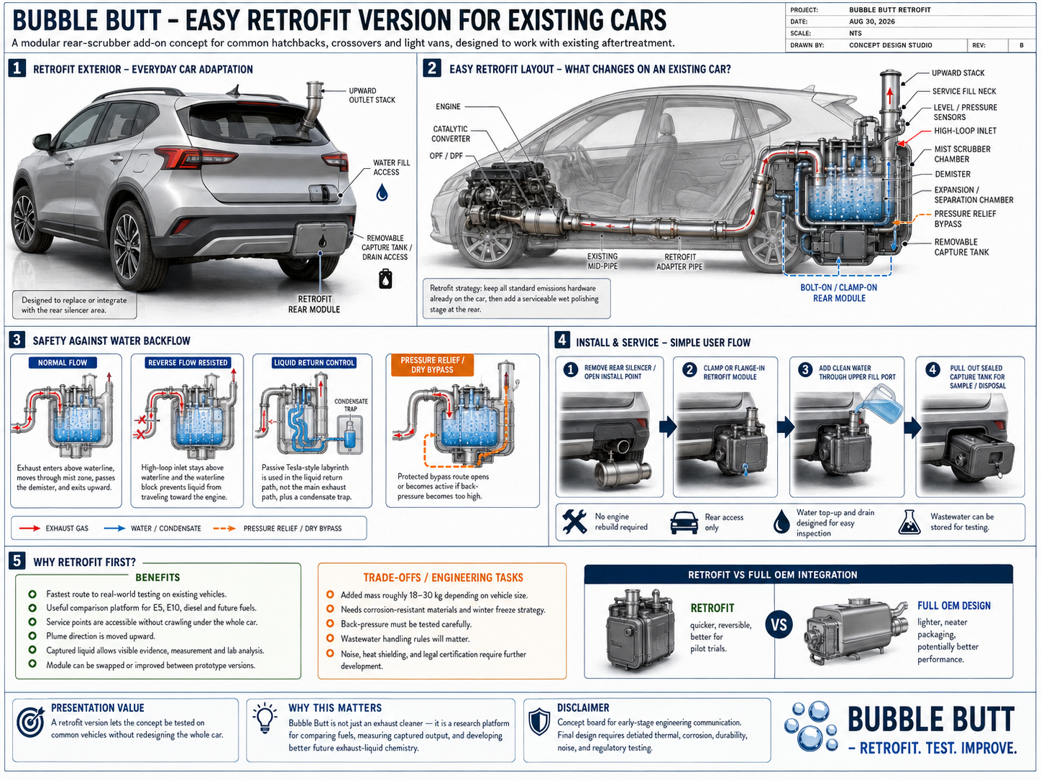
Figure 4 Recovered Bubble Butt retrofit concept board
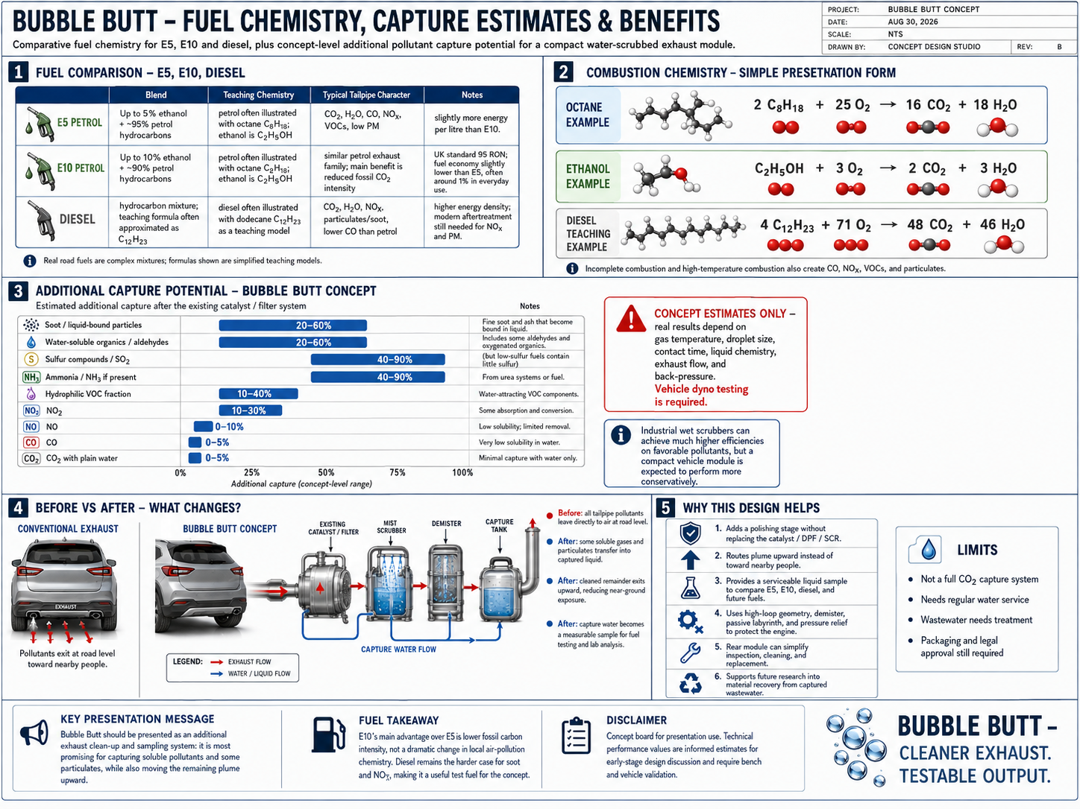
Figure 5 Recovered Bubble Butt fuel and capture concept board

Scientific meaning of no waste
The project principle is valuable when stated as a design rule: every output must have a named destination. That destination may be reuse, regeneration, saleable coproduct, safe storage, controlled treatment or final disposal. Separation changes the form and concentration of matter; it may make recovery possible, but it can also create a smaller, more hazardous waste stream. Heat can be recovered only where its temperature and timing match a useful demand.
- A pollutant moved from exhaust gas into scrubber water has been transferred, not eliminated.
- CO₂ reused to make fuel is delayed and recycled, not permanently removed, unless some carbon is durably stored.
- A hydroxide converted to carbonate remains valuable only if a practical regeneration or product route exists.
- A high current efficiency for one electrochemical step does not establish good whole-cycle efficiency.
- A negative result is useful when it prevents unsafe or uneconomic scale-up.

Three month collaborative research sprint
The following programme is deliberately framed to create decision-quality evidence without promising a certified transport fuel in twelve weeks. Hazardous experiments must be designed and conducted by qualified laboratories under their own safety systems.
Period | Work package | Core activity | Decision output
Weeks 1–2 | System definition and evidence register | Freeze boundaries; map every mass, energy and hazard stream; patent landscape; select Ca and Li controls. | System block model, source library, initial HAZID
Weeks 2–4 | Thermodynamic and lifecycle screen | Model theoretical and realistic energy demand, CO₂ sourcing, water, sorbent regeneration and logistics. | Ranked pathway matrix; E5/B7/LPG/CNG/BEV benchmark
Weeks 3–6 | Safe chemistry validation | Independent laboratory verifies yields, purity, heat release, residual reaction and by-product composition at small scale. | Reproducible data package; reject/continue gates
Weeks 5–8 | Power and control simulation | Digital model of generator–reactor–buffer–motor dynamics; failure-state analysis; cartridge concept. | Response envelope and minimum buffer sizing
Weeks 6–10 | Emissions and capture bench work | Test acetylene or representative gas in a stationary engine/generator; measure regulated and unregulated emissions; assess modular capture. | Engine map and capture mass balance
Weeks 9–12 | Integrated stationary demonstrator plan | Combine validated subsystems at stationary scale; complete cost, lifecycle and safety review. | Prototype specification, budget and Phase 2 decision

Team and facilities requested
Role | Primary responsibility
Chemical/process lead | Reaction pathway, separation, heat and mass balance
Electrochemist/materials scientist | Carbide formation, electrolyte selection, LiOH/carbonate regeneration, chloride corrosion
Combustion and controls engineer | Engine calibration, generator operating map, transient control
Power-electronics engineer | DC bus, battery/supercapacitor sizing and safety
Emissions/capture specialist | Gas analysis, PM measurement, sorbent and wastewater assessment
Process-safety engineer | HAZID/HAZOP, protection layers, failure and crash scenarios
Lifecycle/economic analyst | Well-to-wheel carbon, cost and infrastructure comparison
AI/modelling support | Literature triage, experiment design support, surrogate models, uncertainty tracking and design-space ranking

Facilities and equipment required
The programme does not require one organisation to own every capability. It requires a lead host that can coordinate safe access to shared university, independent-laboratory, test-cell and pilot facilities. Equipment selection must follow the host’s risk assessment; the list below defines capability, not an operating recipe.
Capability | Indicative resources | Decision supported
Data and modelling | Version-controlled repository; thermochemical and property data; process simulation; transient controls model; lifecycle and techno-economic tools; uncertainty and provenance tracking. | All phases
Chemical reaction work | Ventilated or enclosed small-scale reactor capability; calibrated mass, temperature, pressure and heat-release measurement; inert handling where required; controlled quench and residue collection. | Chemistry gate
Chemical analysis | GC-TCD/FID or equivalent permanent-gas and hydrocarbon analysis; GC-MS or FTIR where impurities require identification; ion chromatography, ICP-OES, XRD, Raman or microscopy through shared analytical services. | Yield, purity and contamination
Electrochemistry | Potentiostat/galvanostat; separated electrolysis cells; membrane evaluation; gas quantification; corrosion coupons; glovebox or specialist high-temperature molten-salt access only where justified. | Regeneration and battery routes
Power systems | Engine–generator dynamometer or load bank; programmable DC source/load; battery or supercapacitor buffer; inverter and motor emulator; fast data acquisition and safety-rated control hardware. | Transient and efficiency testing
Emissions and capture | Calibrated CO₂, CO, NOₓ, total-hydrocarbon and O₂ analysers; mass-flow and humidity measurement; heated sampling where needed; particle mass and number measurement; capture-media and wastewater analysis. | Emissions gate
Process safety | Gas detection; ventilation; ignition-source control; flashback and overpressure protection; isolation and emergency shutdown; remote operation; secondary containment; approved storage and waste routes. | Required before hazardous work
Pilot integration | Skid-mounted stationary system, physical separation of incompatible reactants, guarded test area, remote monitoring, documented inspection and maintenance, and independent pre-start review. | Only after earlier gates pass

How collaborators can provide access
Partner | Practical contribution
University host | Appoint an academic lead, provide laboratory governance, recruit students or research staff, and coordinate analytical facilities.
Independent laboratory | Repeat critical measurements, verify gas composition and residues, and provide an impartial data package.
Engine or vehicle partner | Supply a representative stationary engine or generator, controls expertise, instrumentation and compatibility assessment.
Electrochemistry partner | Evaluate carbide regeneration, chloride handling, membranes, corrosion and alternative carbon-to-fuel routes.
Safety and regulatory partner | Lead HAZID and HAZOP, define protection layers, review chemical duties and map the route to vehicle or stationary approval.
Community or public-interest partner | Define affordability, ownership, workforce and local-benefit measures; represent affected users in decisions.
Funding partner | Support staff time, facility fees, consumables, independent replication, accessibility costs and open-data preparation.

A workable first approach is a two-page expression of interest containing the research question, recovered evidence, first-stage test boundary, team gaps, equipment gaps, accessibility needs, requested in-kind access, a twelve-week budget and the decision gates in this paper. It should be sent to chemical engineering, electrochemistry, combustion, sustainable fuels and process-safety groups as one coordinated request rather than as separate unconnected ideas.
Electrolysis routes should be benchmarked against current system data. The U.S. Department of Energy distinguishes alkaline, proton-exchange-membrane and solid-oxide systems and notes that electricity source determines the associated emissions. ^{[32]} Its 2022 PEM system status was 55 kWh per kilogram of hydrogen, about 61% efficiency on a lower-heating-value basis. ^{[33]} These values prevent hidden electricity demand from disappearing inside a fuel-cycle claim.

Collaboration and decision structure
Function | Lead | Required decision
Research origin and system logic | AL and The Green Tank | Maintain the problem statement, contribution record and community-purpose tests.
Scientific quality | Academic and independent technical leads | Approve methods, uncertainty treatment, replication and publication claims.
Safety authority | Host laboratory and process-safety lead | Hold stop-work authority and approve each experimental stage.
Data stewardship | Data lead with AI and laboratory support | Maintain identifiers, schemas, source provenance, code versions and checksums.
Application decision | Cross-disciplinary review board | Compare stationary, depot, industrial and vehicle cases at each gate.
Public and workforce value | Community and worker representatives | Test whether costs, skills, ownership and benefits are fairly distributed.

Stage gates
1. Chemistry gate: measured yield, purity, heat release and residual reaction are reproducible.
2. Energy gate: credible renewable electricity-to-wheel efficiency and cost are competitive for at least one use case.
3. Safety gate: no journey-scale acetylene storage, bounded gas hold-up and acceptable failure-state consequences are demonstrated by qualified reviewers.
4. Emissions gate: a complete pollutant inventory shows improvement without unacceptable NOₓ, particle or liquid-waste transfer.
5. Circularity gate: returned products have a verified regeneration or market route and contamination does not accumulate without control.
6. Application gate: stationary generation, depot fleets, agricultural machinery or emergency power is selected before any road-vehicle programme.

Priority experiments and modelling questions
- What acetylene yield and impurity profile can be obtained from candidate Li₂C₂ forms over repeated batches?
- How quickly does gas generation stop after reactant isolation, and what minimum gas hold-up is unavoidable?
- What is the total electricity and heat demand per kilogram of regenerated carbide, including separations and losses?
- Can recovered LiOH or carbonate be regenerated without accumulating chloride, metals, soot or water contaminants?
- Does a steady engine-generator operating point materially improve efficiency and emissions compared with direct mechanical drive?
- What electrical buffer size decouples road transients from safe chemical response?
- Which emissions are reduced, which increase, and which are transferred to liquid or solid capture media?
- Can the by-product hydroxide perform useful partial CO₂ capture without disrupting its return-to-fuel route?
- Is stationary manufacture with conventional acetylene delivery safer and more efficient than onboard generation?
- Which use case delivers the largest avoided fossil-carbon benefit per unit of renewable electricity and critical material?

Recommended first prototype boundary
Start stationary
The first integrated prototype should be a remotely operated stationary generator–reactor–electrical-buffer test rig at a qualified facility. It should use a mature carbide route as a control and introduce lithium chemistry only after its material handling and regeneration data are independently reviewed. A road vehicle should be a later application, not the first experiment.
This boundary still tests the distinctive CL17 logic: on-demand generation, minimal gas inventory, steady power conversion, electrical transient storage, heat and water recovery, pollutant measurement, product return and regeneration. It also makes comparison with conventional fuels and direct battery-electric operation much easier.

Updated exploration request
The following consolidates the current Emission Transitive Emission request and incorporates the evidence review.

An open request for scientific and engineering assistance
My name is AL, and I am seeking assistance to explore a connected body of ideas concerning alternative fuels, emissions capture, energy storage, recovery of useful materials, and the transfer of matter and energy between processes. I call the investigation Emission Transitive Emission.
The central question is simple: can the output or emission from one process become the controlled input to another process instead of being discarded into the environment?
This is not a claim of a finished fuel or a self-powering machine. Every pathway must obey conservation of energy and materials. External energy will be required, preferably from renewable or otherwise low-carbon sources. Processing does not make waste disappear; it can separate, transform, concentrate, recover or safely contain it.
Existing research shows that several parts of this vision are real. Carbide–water acetylene generation and automatic control have a long history; vehicle-oriented generators, by-product exhaust scrubbing and heat recovery have been patented; acetylene has been tested in engines; lithium- and calcium-mediated routes from carbon dioxide to acetylene have been demonstrated in laboratories; and series-hybrid electrical buffering and mobile carbon capture have substantial adjacent research. ^{[2][3][5][6][8][9][12][18]} The complete integrated system remains unproven, which is precisely why a disciplined programme is needed.

Research paths to explore
- Waste cooking oil and biodiesel in suitable older diesel generators or engines.
- Generator, battery, inverter and electric-drive series-hybrid systems.
- Water electrolysis using suitable electrolytes, with hydrogen and oxygen produced and handled separately.
- Hydrogen used as a controlled combustion promoter or stationary chemical feedstock, not described as a catalyst or free source of energy.
- Renewable hydrogen combined with captured carbon dioxide to produce methane, methanol, DME or other synthetic fuels.
- Lithium-mediated pathways, including lithium carbide reacting with water to produce acetylene and lithium hydroxide.
- Calcium-carbide pathways as an established control case, including electrochemical production from captured CO₂.
- Recovery and regeneration of lithium or calcium hydroxide/carbonate at a controlled stationary facility.
- Acetylene as a manufactured energy carrier with minimal operational hold-up, while recognising its fire, decomposition and flashback hazards.
- Methane, methanol, DME, hydrogen, ammonia, synthetic liquids, biodiesel and algae-derived oils as alternative fuel candidates.
- Capturing carbon dioxide and other emissions for reuse as chemical feedstocks or managed temporary storage.
- The Bubble Butt retrofit as a pollutant-specific platform for cooling, water recovery, particulate capture, chemical scrubbing or CO₂ separation.
- A refill–return–regenerate system in which vehicles or stationary generators receive an energy carrier and return concentrated products to a depot.
- Producing hazardous or bulky intermediates at controlled stations rather than transporting or storing unnecessary gas inventories.
- Repurposing useful heat, water, carbon, minerals and chemical residues while identifying every unrecoverable purge or disposal stream.
Chlorine, chlorides and lithium chloride should be examined for their roles in electrochemistry, corrosion, separation, contamination and toxicity. They should not be assumed to be fuels: lithium chloride mixed with water does not itself produce a fuel gas. High-temperature chloride electrolyte systems require specialist materials and containment.

Combination mapping
1. Every technically plausible input → process → output pathway.
2. Whether one output can safely and usefully become another process input.
3. Which materials can be recovered, returned or regenerated and how impurities accumulate.
4. External electricity, heat, compression, separation and transport required at every stage.
5. Net energy efficiency and unavoidable conversion losses.
6. Lifecycle carbon emissions, including energy source and equipment, rather than tailpipe claims alone.
7. Toxicity, causticity, corrosion, fire, explosion, pressure and environmental risks.
8. Compatibility with petrol, diesel, LPG, CNG, hybrid and electric vehicle architectures.
9. Stationary generation, transport, heating, agricultural, industrial and emergency-power applications.
10. Infrastructure, manufacturing, maintenance, material availability and realistic cost.
11. Household, community, filling-station, fleet-depot and industrial scale—while excluding scales that cannot be made safe.
12. Whether a pathway reduces extraction and pollution or merely transfers them into another medium or location.
Promising combinations should be compared with E5 and E10 petrol, B7 diesel, LPG, fossil CNG and battery-electric systems using the same functional unit, such as useful electricity delivered or vehicle-kilometres under a defined duty cycle.

Safety position
Mixed oxyhydrogen should not be stored or treated casually. Hydrogen and oxygen should be separated and managed using certified equipment. Onboard production of acetylene from reactive lithium compounds may be substantially less safe than stationary manufacture. “On demand” must mean minimal verified hold-up and bounded shutdown behaviour, not an assertion that no gas exists in the apparatus.
This request is for literature review, simulation, process-safety analysis and supervised testing in qualified facilities—not improvised hazardous experimentation.

Assistance required
I currently lack the laboratory space, specialist equipment, research capacity and technical access needed to test these possibilities properly. I am asking for assistance from universities, independent laboratories, chemists, electrochemists, chemical and process engineers, combustion and automotive engineers, power-electronics specialists, environmental scientists, process-safety specialists, students, manufacturers and responsible funding organisations.
- A structured literature, standards and patent review.
- Chemical, thermodynamic, process and transient-system modelling.
- Reaction yield, purity, heat-release and energy-balance measurements.
- Lifecycle carbon, toxicity and emissions analysis.
- Safe supervised bench experiments and independent replication.
- Gas composition, particle and exhaust analysis.
- Materials, corrosion, catalyst and contamination testing.
- Recovery, separation and regeneration experiments.
- Engine-generator and electrical-buffer compatibility assessment.
- HAZID, HAZOP, protection-layer and failure-mode analysis.
- Economic, infrastructure, material-circularity and application modelling.
- Access to suitable laboratory space, equipment and qualified supervision.
- Help rejecting weak pathways early and selecting those that merit prototypes.

Intended outcome
A focused three-month collaboration should aim for measured bench prototypes, a validated system model and a ranked research portfolio. The final answer may be one fuel, several fuels for different applications, a stationary production process, a transition retrofit, or an integrated system connecting renewable energy, fuel manufacture, vehicles, emissions capture and material regeneration.
The important principle is that an emission does not always have to be the end of a process. With the correct chemistry, energy source, recovery system and safety controls, it may become the beginning of another. I believe the CL17 matrix contains real and valuable research questions. I now need people with the facilities, knowledge and equipment to investigate them carefully, openly and honestly.
AL
The Green Tank

Adapting new energy carriers to existing technology
The transition hypothesis is to use suitable existing engines, generators, depots and maintenance skills where adaptation produces a better overall result than immediate replacement. This does not mean preserving every internal-combustion application. Direct electrification should remain the control case because it often avoids multiple fuel-conversion losses. A CL17 route earns a place only where it provides a measured advantage in duty cycle, resilience, asset reuse, storage, local feedstocks, infrastructure or cost.
Legacy asset or use | Possible CL17 role | Decision rule
Existing stationary generator | Early controlled application for certified transition fuels or measured acetylene trials | Safety, emissions, efficiency and supervision are easier to control than on-road use.
Series-hybrid retrofit or new platform | Engine operates near a selected point while a battery or supercapacitor handles transients | Additional conversion losses must be outweighed by improved engine operation and asset reuse.
Fleet-depot system | Refill–return–regenerate logistics with central quality control and capture-media handling | Strong candidate where vehicles return regularly and materials can be accounted for.
Agricultural or emergency power | Local fuel or energy-carrier production where grid access or supply resilience matters | Reliability and safe storage may matter more than peak efficiency, but emissions still count.
Passenger vehicle | Late-stage application only after stationary and fleet evidence | Crash, public exposure, packaging, approval and service-network burdens are highest.

Community value and a just transition
The social aim is to reduce dependence on concentrated fossil-fuel supply by enabling transparent, locally serviceable energy and material systems where the evidence supports them. A change in chemistry does not automatically transfer power to people. Ownership, access to data, repair rights, financing, training, feedstock control and fair prices determine who benefits. The International Labour Organization’s just-transition guidance treats low-carbon change as a practical programme for decent work, social protection and dialogue among governments, workers and employers. ^{[41]}
Public-interest test | Measure
Energy and material control | Share of feedstock, generation, regeneration or storage under community, cooperative, municipal or small-enterprise control.
Affordability | Delivered energy cost, exposure to volatile imports and access for low-income or remote users.
Work and skills | Paid training, recognised qualifications, job quality and transfer of existing mechanical and industrial skills.
Repair and resilience | Availability of parts, diagnostic access, modular replacement, local maintenance time and outage recovery.
Environmental performance | Lifecycle greenhouse gases, air pollutants, water use, material loss and final waste per functional unit.
Public accountability | Open methods, independent tests, declared conflicts, versioned datasets and published negative results.

The programme is intended to move work rather than erase workers. Engine technicians, fabricators, electricians and plant operators would work alongside chemists, materials scientists, data specialists, safety professionals and environmental analysts. Training should be built into the research budget and prototype design so that knowledge does not remain locked inside one laboratory or company.
The project’s values statement is that the physical world is not defective simply because current systems use it badly. Science can improve how people understand energy, matter, waste and one another. That is a social perspective, not a laboratory result. The technical work remains falsifiable: an appealing philosophy cannot rescue a pathway that fails energy, safety, emissions, cost or material-accounting tests.

Safety regulation and approval route
In Great Britain, laboratory and pilot work involving flammable gases, reactive chemicals, pressure and corrosive materials requires competent legal review. DSEAR requires employers to identify dangerous substances, assess risks, control or mitigate them, plan for emergencies, train people and classify places where explosive atmospheres may occur. ^{[36]} COSHH requires hazardous-substance risks to be identified, assessed and controlled. ^{[37]} COMAH may apply to establishments holding relevant dangerous substances above regulatory thresholds. ^{[38]}
A modified vehicle must follow the approval route for its jurisdiction. UK Individual Vehicle Approval uses inspection and, for normal IVA, documentary evidence; some compliance testing must be carried out by an authorised designated technical service. ^{[39]} The project should obtain written advice from the relevant vehicle approval, roadworthiness, insurance, pressure-system, environmental-permitting and dangerous-goods authorities before moving beyond controlled off-road testing.
The safety file should include chemical inventories and safety data sheets, a process description, DSEAR and COSHH assessments, HAZID and HAZOP records, pressure and ignition studies, control and shutdown philosophy, proof-test intervals, ventilation and gas-detection design, emergency response, waste routes, operator competence and management of change. No road demonstration should occur until the host organisation and relevant authorities approve it.

Research governance and protection of contribution
Control | Minimum requirement
Contribution register | Date each concept, dataset, calculation, drawing, correction and experimental result; name the contributor and reviewer.
Background intellectual property | List material brought into the project by AL, each institution and each partner before work starts.
New intellectual property | Agree ownership, licensing, community-access aims and patent decisions before disclosing enabling detail.
Publication | Pre-register key comparisons where practical; publish methods, uncertainty and negative results subject to safety and legitimate IP limits.
Independent review | Use a laboratory or analyst that did not build the system to repeat the decisive measurements.
Conflicts and funding | Declare financial interests, in-kind support, fuel or equipment donations and publication restrictions.
Accessibility | Provide communication formats, flexible participation, assistance and remote access needed for AL and other disabled contributors.

Immediate actions to open the research
1. Freeze this package as version 1.0 and record its SHA-256 checksums.
2. Nominate a host investigator in chemical or process engineering and a separate process-safety lead.
3. Hold a two-hour cross-disciplinary review of the six shortlisted primary programmes and the supplemental matrix rules.
4. Choose one stationary use case and one direct-electrification control with the same functional unit.
5. Recalculate all mass, energy and carbon balances from primary data before ordering experimental hardware.
6. Prepare a HAZID and legal-applicability register; remove any pathway that cannot be safely tested by the host.
7. Define a calcium-carbide control and a separate lithium-mediated research question; do not combine them prematurely.
8. Book analytical, electrochemical, engine-test and emissions facilities through the smallest capable partner network.
9. Write a twelve-week budget including staff, facility charges, consumables, independent replication, accessibility and data publication.
10. Publish the accepted protocol and record every rejected route with its reason so later researchers can revisit it when technology changes.

Conclusions for research partners
Decision | Current evidence-based position
Worth pursuing now | Stationary mass/energy model; CaC₂ control experiments; independent Li₂C₂ yield and impurity data; engine-generator emissions map; electrical-buffer simulation; by-product capture stoichiometry.
Do not claim yet | Road-ready fuel, zero gas inventory, net energy gain, zero pollution, closed water loop, full CO₂ capture by the hydroxide by-product, or economic competitiveness.
Most defensible novelty area | Integration of a modern low-inventory chemical generator with electrical transient buffering, measured exhaust/material recovery, and depot regeneration using low-carbon power.
Highest-risk dependency | Efficient, safe and repeatable carbide regeneration—especially the lithium route—after contamination and capture duties are included.
Best first market hypothesis | Controlled stationary or fleet-depot power where equipment can be supervised and returned materials can be handled centrally.

There is more prior work here than may first appear, including a strikingly similar 1972 exhaust-scrubbing patent. The opportunity is not to ignore that history, but to combine it with modern electrochemistry, sensing, power electronics, lifecycle methods and safer system architecture. The project should proceed as a falsifiable engineering programme: quantify every input, output, loss and hazard, then retain only the combinations that survive measurement.

Sources
[1] NIST Chemistry WebBook. Acetylene thermochemical data, CAS 74-86-2. Open source 1
[2] McEnaney, J. M. et al. “A cyclic electrochemical strategy to produce acetylene from CO₂, CH₄, or alternative carbon sources.” Sustainable Energy & Fuels 4 (2020): 2752–2759. DOI 10.1039/C9SE00799G. Open source 2
[3] Suzuki, Y. et al. “High-efficient acetylene synthesis by selective electrochemical formation of CO₂-derived CaC₂.” Chemical Engineering Journal 494 (2024): 153013. DOI 10.1016/j.cej.2024.153013. Open source 3
[4] American Chemical Society. “Commercialization of Calcium Carbide and Acetylene,” National Historic Chemical Landmark. Open source 4
[5] U.S. Patent 1,809,521. “Acetylene generator.” Published 1931. Open source 5
[6] U.S. Patent 4,054,423. “Variable pressure fuel generator and method.” Published 1977. Open source 6
[7] U.S. Patent 4,444,159. “Calcium carbide/water acetylene gas generator.” Published 1984. Open source 7
[8] U.S. Patent 3,664,134. “Combustion system.” Published 1972. Open source 8
[9] U.S. Patent 6,282,900. “Calcium carbide power system with waste energy recovery.” Published 2001. Open source 9
[10] European Industrial Gases Association. Doc. 237/21, “Safe Operation of Acetylene Generator Systems.” Open source 10
[11] European Industrial Gases Association. Doc. 239/23, “Mechanical Integrity of Acetylene Generator Systems.” Open source 11
[12] İlhak, M. İ. et al. “An experimental investigation of the use of gasoline-acetylene mixtures at different excess air ratios in an SI engine.” Energy 175 (2019): 434–444. DOI 10.1016/j.energy.2019.03.058. Open source 12
[13] Fil, H. E. et al. “Experimental assessment on performance, emission and combustion characteristics of the use of diesel-acetylene mixtures at different loads in a CI engine.” Fuel (2022). DOI 10.1016/j.fuel.2022.124469. Open source 13
[14] Raman, R. and Kumar, N. “Performance, combustion and emission analysis of internal combustion engines fuelled with acetylene.” International Journal of Ambient Energy. DOI 10.1080/01430750.2019.1663369. Open source 14
[15] U.S. Department of Energy, Alternative Fuels Data Center. Hybrid-electric vehicle operation and fuel-economy resources. Open source 15
[16] Elkholy, M. H. et al. “Review of battery–supercapacitor hybrid energy storage systems for electric vehicles.” Results in Engineering 24 (2024): 103598. DOI 10.1016/j.rineng.2024.103598. Open source 16
[17] Miller, M. et al. “Modelling and Analysis of Plug-in Series-Parallel Hybrid Medium-Duty Vehicles.” UC Davis Institute of Transportation Studies. Open source 17
[18] Sharma, S. and Maréchal, F. “Carbon Dioxide Capture From Internal Combustion Engine Exhaust Using Temperature Swing Adsorption.” Frontiers in Energy Research 7 (2019): 143. DOI 10.3389/fenrg.2019.00143. Open source 18
[19] Schmauss, T. A. and Barnett, S. A. “Viability of Vehicles Utilizing On-Board CO₂ Capture.” ACS Energy Letters 6 (2021): 3180–3184. DOI 10.1021/acsenergylett.1c01426. Open source 19
[20] U.S. Environmental Protection Agency. “Wet Scrubbers for Particulate Matter,” Air Pollution Control Cost Manual, Chapter 2, Section 6. Open source 20
[21] Abdulwahid, A. A. et al. “Underground Diesel Exhaust Wet Scrubbers: Current Status and Future Prospects.” Energies 11 (2018): 3006. DOI 10.3390/en11113006. Open source 21
[22] Mitsubishi Shipbuilding / ClassNK. “Development of Onboard CO₂ Capture System,” ClassNK Technical Journal 5 (2022). Open source 22
[23] Zhang, S. et al. “Life cycle assessment of acetylene production from calcium carbide and methane in China.” Journal of Cleaner Production 322 (2021): 129055. DOI 10.1016/j.jclepro.2021.129055. Open source 23
[24] Wang, H. et al. “Carbon-calcium composite conversion of calcium carbide-acetylene system: On the imperative roles of carbon capture and solid waste recycling.” Applied Energy 327 (2022): 120139. DOI 10.1016/j.apenergy.2022.120139. Open source 24
[25] U.S. Department of Energy, Alternative Fuels Data Center. “Fuel Properties Comparison.” Open source 25
[26] UK Government. “E10 petrol explained,” including E5 and E10 ethanol-content definitions. Open source 26
[27] NOAA CAMEO Chemicals. “Acetylene” response and hazard data. Open source 27
[28] Conte, E. and Boulouchos, K. “Influence of Hydrogen-Rich-Gas Addition on Combustion, Pollutant Formation and Efficiency of an IC-SI Engine.” SAE Technical Paper 2004-01-0972. DOI 10.4271/2004-01-0972. Open source 28
[29] Elnajjar, E. et al. “Review of hydrogen–gasoline SI dual fuel engines: Engine performance and emission.” Energy Reports 9 (2023). DOI 10.1016/j.egyr.2023.03.054. Open source 29
[30] Tian, N. et al. “Li₂C₂, a High-Capacity Cathode Material for Lithium Ion Batteries.” Angewandte Chemie International Edition 55 (2016): 644–648. DOI 10.1002/anie.201509083. Open source 30
[31] Li, Y. et al. “In situ study on the charge/discharge of nanocrystalline Li₂C₂ as a new cathode material.” RSC Advances 6 (2016): 54256. DOI 10.1039/C6RA08990A. Open source 31
[32] U.S. Department of Energy. “Hydrogen Production: Electrolysis.” Electrolyser families, scale and electricity-source considerations. Accessed 13 September 2026. Open source 32
[33] U.S. Department of Energy. “Technical Targets for Proton Exchange Membrane Electrolysis.” 2022 system status and research targets. Accessed 13 September 2026. Open source 33
[34] Argonne National Laboratory. GREET publications and fuel-cycle modelling resources. Accessed 13 September 2026. Open source 34
[35] Wilkinson, M. D. et al. “The FAIR Guiding Principles for scientific data management and stewardship.” Scientific Data 3 (2016): 160018. DOI 10.1038/sdata.2016.18. Open source 35
[36] UK Health and Safety Executive. “The Dangerous Substances and Explosive Atmospheres Regulations 2002.” Updated 14 October 2024; accessed 13 September 2026. Open source 36
[37] UK Health and Safety Executive. “Control of Substances Hazardous to Health.” Accessed 13 September 2026. Open source 37
[38] UK Health and Safety Executive. “Control of Major Accident Hazards.” COMAH Regulations 2015 guidance. Accessed 13 September 2026. Open source 38
[39] UK Government. “Individual vehicle approval.” Inspection, documentary evidence and designated technical-service requirements. Accessed 13 September 2026. Open source 39
[40] UK Research and Innovation. “Disability and accessibility support for UKRI applicants and grant holders.” Updated 13 February 2026; accessed 13 September 2026. Open source 40
[41] International Labour Organization. “Guidelines for a just transition towards environmentally sustainable economies and societies for all.” 2016. Open source 41
[42] International Renewable Energy Agency. “Innovation Outlook: Renewable Methanol.” 2021. Open source 42
[43] UK Parliament. Equality Act 2010, section 20, duty to make adjustments. Open source 43
[44] International Organization for Standardization. ISO 14040:2006, Environmental management — Life cycle assessment — Principles and framework. Confirmed 2022. Open source 44
[45] International Organization for Standardization. ISO 14044:2006, Environmental management — Life cycle assessment — Requirements and guidelines. Confirmed 2022. Open source 45

Evidence use note
Peer-reviewed papers support laboratory chemistry, engine tests and system modelling. Patents are used only to identify prior proposals and possible novelty constraints. Standards and industry guidance support hazard framing. Numerical values in this study are rounded screening calculations and should be independently reproduced before design decisions.

Attachments and preservation record
The files below are included in the accompanying preservation package. The register distinguishes recovered project material from the present synthesis. Intermediate render pages and unrelated files retrieved during title searches are excluded. The package manifest records file size and SHA-256 checksum for each included item.
Type | Package path | Purpose
Present study | 01_Paper/CL17_Emission_Transitive_Emission_Ongoing_Study.docx | This ongoing study in editable form
Present study | 01_Paper/CL17_Emission_Transitive_Emission_Ongoing_Study.pdf | Rendered preservation copy
Primary database | 02_Databases/CL17_Emission_Transitive_Emission_Matrix.xlsx | Species, reactions, pathways, thermochemistry, shortlist and sources
Supplemental database | 02_Databases/CL17_Supplemental_Interactive_Systems.xlsx | HHO roles, electrolysis, batteries, coproducts, capture and 14,400-case explorer
Previous report | 03_Previous_Reports/CL17_Emission_Transitive_Emission_Report.docx and .pdf | Primary matrix report
Previous report | 03_Previous_Reports/CL17_Supplemental_Investigations.docx and .pdf | Supplemental systems report
Previous report | 03_Previous_Reports/Emission_Transitive_Emission_Evidence_Review.docx and .pdf | Acetylene and integrated-system evidence review
Source data | 04_Data/cl17_data.json | Machine-readable primary network source
Source data | 04_Data/cl17_supplement_data.json | Machine-readable supplemental source
Figure | 05_Figures/cl17_network.png | Primary network overview
Figure | 05_Figures/supplement_architecture.png | Interactive-system architecture
Figure | 05_Figures/hho_energy_balance.png | Onboard HHO energy screen
Recovered concept | 05_Figures/bubble_butt_retrofit.png | Bubble Butt retrofit board
Recovered concept | 05_Figures/bubble_butt_fuel_chemistry.png | Bubble Butt fuel and capture board
Builders | 06_Source_Builders | Python and JavaScript document and workbook builders
Verification | 07_Verification | Workbook inspections, formula scans and interactive checks
Reference register | 08_Reference_Register/CL17_Source_Register.csv | Deduplicated source inventory from the recovered datasets and this study
Integrity | MANIFEST.csv and SHA256SUMS.txt | Package inventory and checksums

Recovery note: two Bubble Butt images were located in the available persistent file collection. The CL17 matrices, reports, data and builders were recovered from the current working collection. No other specifically identifiable CL17 download was located. If an earlier original file becomes available, it should be added as a new preserved object with its original filename, date, provenance and checksum rather than silently replacing this package.

