National PACE Resilience Service Proposal
Public Assistance Communication and Emergency Support
Concept proposed by AL | 20 September 2026 | United Kingdom
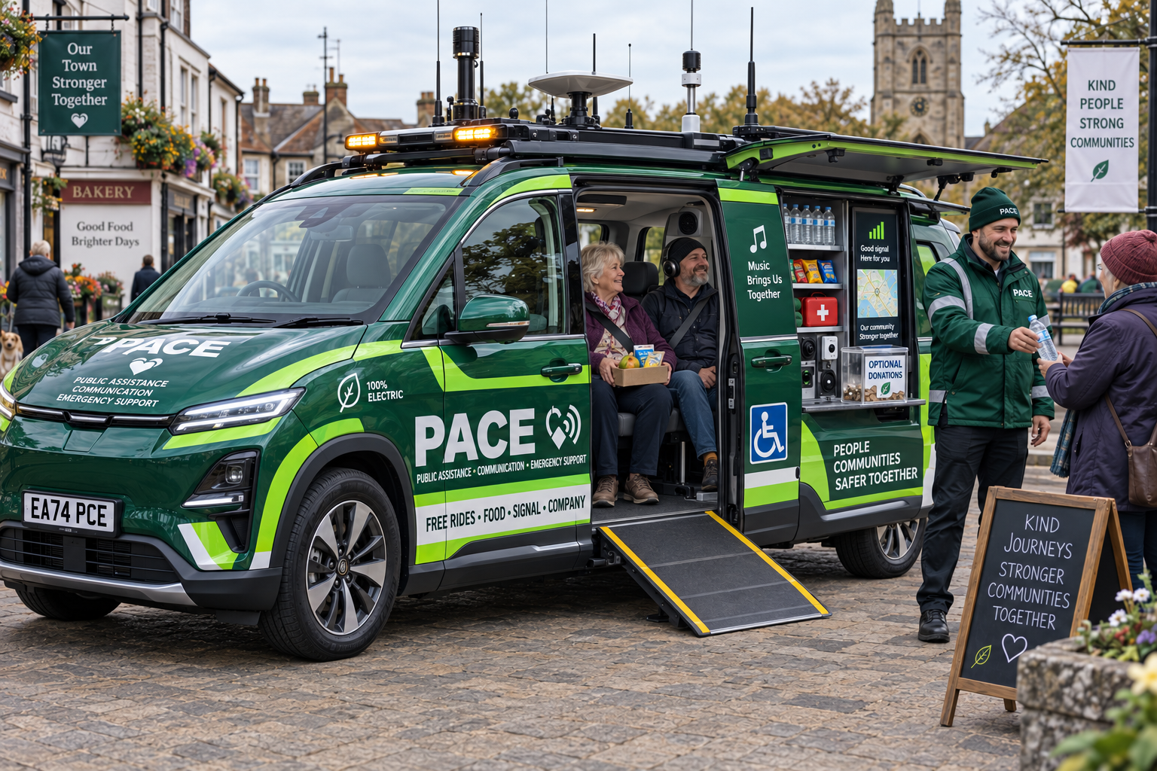
Illustrative concept for an accessible electric PACE community vehicle
This proposal establishes a civilian public service using electric vehicles as mobile welfare points, communications relays, lawful sensor platforms and shared community transport. PACE vehicles would support the public and emergency responders without exercising police powers. The recommended next step is a controlled local pilot designed with residents, emergency services, highways authorities, network operators and independent oversight.

Proposal at a glance
Element | Proposed approach
Status | Civilian government licensed public service with no coercive or enforcement powers
Operator entry | Three years of licensed driving experience and a short free role specific driving assessment
Vehicles | Accessible electric cars and MPVs equipped for welfare, communications, mapping and shared journeys
Community benefit | Free food, drink, charging, connectivity, company and available passenger places
Network role | Distributed emergency communications and coverage support with lawful spectrum awareness
Road role | Predictable lawful driving with a network governed maximum speed ceiling and no minimum pace requirement

Purpose and service identity
PACE stands for Public Assistance Communication and Emergency Support. It is proposed as a national civilian resilience service delivered through a distributed fleet of green vehicles. Each vehicle would provide an immediate local benefit while contributing to a wider emergency network.
PACE operators would be public service drivers rather than police officers. Their authority would be limited to offering help, operating approved equipment, recording objective public conditions and relaying information to the responsible service. Police, fire, ambulance, coastguard, highways and defence authorities would retain their existing decision making and operational responsibilities.

Founding principles
- Help is available because a person needs it, not because they can prove eligibility.
- PACE may offer assistance but cannot stop, search, detain, pursue, penalise or compel anyone.
- Operators and passengers participate by consent and may decline an unsuitable or unsafe journey.
- Connectivity, food, drink and transport are never conditional on providing personal information or making a donation.
- Monitoring concerns road, environmental and network conditions. It does not create authority for indiscriminate interception of private communications.
- Every protected system access and transmission is authenticated, proportionate and auditable.

Functions of a PACE vehicle
Function | What the vehicle provides
Welfare | Water, hot or cold drinks, long life food, blankets, hygiene supplies, first aid and charging
Shared journeys | Free available seats, accessible transport, companionship and help reaching safe practical destinations
Communications | Emergency Wi Fi, mobile coverage support, authorised radio, satellite backhaul and store and forward messaging
Sensing | Time stamped road, traffic, environmental, positioning and network availability information
Emergency support | Verified alerts and resilient communications links to the appropriate authorised service
Road presence | Calm and predictable travel at a safe lawful pace agreed for the route and conditions

Community journeys and companionship
Anyone may ask to join an available PACE journey without explaining or proving why. A place depends only on safe capacity, mutual consent, the planned route and respectful conduct. A passenger may travel quietly, talk, listen to music or volunteer to help. Assistance is not conditional on performing work.
Anyone may join an available PACE journey without explaining their reason. Travel, food, drink and company are free. Donations are optional and confer no privilege. Participation requires mutual consent, safe conduct and willingness to travel peacefully together.

Passenger safeguards
- Vehicles used for passenger journeys must have suitable seats, restraints, accessibility equipment, insurance and maintenance records.
- The driver controls safe capacity, route changes and whether a journey can continue.
- A passenger or operator may end participation at a safe location.
- Safeguarding procedures apply to children and adults at risk, with additional checks for roles that involve regular unsupervised contact.
- A PACE journey complements rather than displaces ambulance transport, licensed patient transport or an emergency evacuation order.

Volunteers and paid staff
PACE would use a mixed workforce. Paid operators would remain responsible for the vehicle, safety, equipment and records. Paid specialists could provide technical, welfare, accessibility and coordination support. Registered volunteers and spontaneous helpers could assist with simple supervised tasks when conditions allow.

Operator entry and pay
A PACE operator would not need to be a police officer or hold an emergency service qualification. Entry would require at least three years of licensed driving experience, the correct licence for the assigned vehicle and completion of a short role specific driving assessment. The assessment and required introductory training would be provided free of charge so applicants are not required to buy access to the job.
The post would provide regular paid employment at a genuine living wage rather than the statutory minimum. Pay should recognise responsibility for passengers, public equipment, welfare supplies and emergency communications. Volunteers may support the service, but volunteer labour should not replace the paid core workforce.
Role | Permitted contribution | Boundary
PACE operator | Driving, welfare support, approved communications and incident reporting | No police or compulsory powers
Technical specialist | Vehicle systems, connectivity and sensor maintenance | Access limited to assigned systems
PACE companion | Supplies, company, translation and practical community help | No protected network or personal record access
Emergency volunteer | Temporary support during outages, floods, severe weather or evacuation | Works within a defined supervised task
Passenger helper | Offers safe assistance during a journey | Help is optional and may stop at any time

Communications and coverage support
PACE vehicles would form a distributed communications mesh. They could add temporary capacity where ordinary networks are weak or unavailable and reroute authorised emergency messages when a single route fails. A large fleet would reduce dependence on any one vehicle, but the service should never claim that a vehicle is impossible to locate, disable or attack.
Community connectivity would use authorised neutral host small cells, Wi Fi, satellite links and operator agreements. A coverage radius of about one kilometre or more is a design objective rather than a guarantee. Actual range and capacity depend on terrain, buildings, antenna position, spectrum, power and network approval.

Spectrum and transponder functions
Wideband spectrum awareness would measure signal presence, availability, congestion, interference and possible loss of navigation services. It would not permit indiscriminate interception of private message or call content. Publicly broadcast transponder signals could be received and mapped where lawful. Any PACE transmission would use assigned identities, approved power levels and authenticated protocols. Jamming, spoofing and false transponder identities would be prohibited.

Network separation
Network layer | Purpose | Access rule
Community layer | Public connectivity, welfare access and non sensitive service information | Open or ordinary authenticated access
Emergency layer | Priority messaging, verified alerts, routing and resilience for authorised responders | Accredited users and encrypted gateways
Defence boundary | Civil emergency coordination involving military personnel | Separated from tactical command, intelligence and weapons systems

Ordinary PACE cars should not carry tactical military command traffic. They may support military personnel with food, welfare, navigation and civil emergency communications. Keeping operational defence traffic on a separately identified and controlled system protects the civilian character of the fleet and the trust of communities.

Mapping and guidance
Approved sensors could provide time stamped maps of road hazards, congestion, environmental conditions, network coverage and navigation integrity. Guidance functions would support safe routes, responder access, evacuation and service coordination. They would not support weapons targeting or autonomous enforcement.

Road pace and deployment
PACE vehicles would use routes and pace ranges agreed through published arrangements with highways authorities and communities. Drivers would travel at the lowest safe and lawful speed appropriate to conditions without creating an unreasonable obstruction. They would not form rolling roadblocks, pursue vehicles or claim exemptions available to emergency responders.

Network governed maximum speed
The electric drivetrain would use authenticated PACE network data to apply an automatic maximum speed ceiling for the vehicle's current road and operating conditions. The ceiling is the fastest speed the vehicle may reach, not a target speed and not a minimum. The driver remains responsible for the road and may travel more slowly whenever visibility, traffic, weather, passengers or any other safety consideration requires it.
The automatic ceiling would be set only by signed, time limited and location specific network instructions. The network service would calculate the value from authorised road information and the agreed PACE operating policy. A changed ceiling must be shown to the driver before it takes effect and applied progressively rather than through sudden braking. Missing, expired or conflicting data would trigger a defined safe fallback and a visible warning instead of allowing the vehicle to guess. A temporary safety override could be used only to avoid an immediate hazard, with the event logged for review.
This system would govern PACE fleet vehicles only. It would not create or alter a legal speed limit for other road users unless the competent highway authority had separately made that limit lawful.
Operators would be requested rather than compelled to accept a specific deployment. A driver could decline because of health, safety, fatigue, competence or suitability without being forced into confrontation or danger. Normal employment arrangements would still define availability, training and reasonable duties.

Food drink donations and music
PACE operators would be authorised and funded to give food, drink and essential welfare supplies free of charge to members of the public, emergency responders, NHS and voluntary workers, highways and utility crews, and military personnel. No proof of need, payment or explanation would be required for ordinary assistance.
The service could accept money and suitable supplies through transparent arrangements. Donations would remain optional, would not buy priority or influence, and would be publicly accounted for. Cash handling should be minimised where practical without excluding people who can donate only in cash.
Music may be played inside a PACE vehicle when the driver and passengers agree. The level must remain low enough for the driver to hear traffic, warnings and emergency communications. Anyone may request silence or lower volume, and operational messages always take priority. External music would respect quiet areas and applicable permissions.

Vehicle and energy design
Design area | Proposed requirement
Energy | Battery electric propulsion using renewable electricity contracts with reserve power for essential communications
Accessibility | Step free or ramp access where the vehicle class permits, wheelchair space and accessible controls
Safety identity | Distinct green civilian livery, amber warning lights and no resemblance to police or military vehicles
Speed governance | Electric drivetrain ceiling set by authenticated location specific PACE network data while allowing any lower safe speed
Modularity | Different vehicle types for connectivity, welfare, accessible journeys and major incident support
Resilience | Local energy storage, vehicle to load power, replaceable communications modules and offline procedures
Human space | Comfortable passenger seating separated safely from equipment and supplies

Privacy accountability and public trust
PACE must be governed as public infrastructure rather than an unaccountable surveillance fleet. Its legitimacy depends on visible rules, limited purposes and independent inspection. The service should publish equipment categories, data fields, retention periods, access roles, incident logs and aggregate performance without exposing personal or protected operational information.
- Collect only data needed for a defined safety, network or welfare purpose.
- Do not use facial recognition or covert individual tracking as an ordinary PACE function.
- Do not require passengers or welfare recipients to identify themselves unless a separate legal and safety requirement applies.
- Encrypt protected data in transit and at rest, and keep civilian, emergency and defence systems separated.
- Record protected access and transmissions in tamper evident audit logs.
- Provide an accessible written complaints process and independent investigation route.
- Require explicit legal authorisation and public scrutiny before adding any coercive or intrusive capability.

Main risks and controls
Risk | Required control
PACE appears to be policing | Civilian livery, no blue lights, no enforcement powers and clear public operating rules
Private communications are intercepted | Spectrum measurements exclude content collection unless separately and lawfully authorised
Civilian vehicles become military assets | Exclude tactical military command, intelligence and weapons traffic from ordinary PACE vehicles
Slow driving creates danger | Route specific safe pace policy, driver training and a prohibition on deliberate obstruction
Incorrect speed data creates danger | Signed time limited instructions, advance warning, progressive limiting, defined fallback and logged safety override
Passengers or volunteers are harmed | Suitable insurance, safeguarding, seat capacity, supervision, check in and incident procedures
Donations influence service | Optional donations, no donor priority and published accounts
Coverage claims exceed performance | Publish measured coverage and describe one kilometre as an objective, not a promise

Proposed pilot
A pilot should test the service before national legislation or procurement. It should include an urban neighbourhood, a rural area with weak coverage and a transport corridor. Local residents and frontline services should help select routes, operating hours, welfare stock and privacy controls.

Pilot stages
Stage | Work
Design | Agree governance, service boundaries, vehicle classes, safety cases and community oversight
Static trial | Test welfare provision, charging, connectivity and public access while vehicles remain parked
Limited routes | Run published routes with trained operators and restricted sensor functions
Emergency exercise | Test network loss, store and forward messages and coordination with authorised responders
Independent review | Evaluate safety, privacy, public trust, coverage, cost and operational usefulness before expansion

Measures for evaluation
- Vehicle and communications availability, including recovery after an outage.
- Measured changes in usable mobile coverage and capacity around deployed vehicles.
- Number and type of welfare interventions recorded without unnecessary personal data.
- Passenger and operator safety reports, accessibility outcomes and service feedback.
- Accuracy and usefulness of verified road, environmental and network alerts.
- Traffic effects on agreed routes, including evidence of obstruction or unsafe overtaking.
- Accuracy, availability and safe operation of network speed ceilings, including fallback and override events.
- Energy use, renewable electricity share, maintenance requirements and total operating cost.
- Complaints, data access events and independent audit findings.

Decision requested
The proposal asks public authorities, emergency services, network operators, community organisations and residents to examine whether a locally governed PACE pilot should proceed. Approval should depend on a published safety case, communications licensing, insurance, accessibility, safeguarding, data protection, procurement and independent oversight arrangements.
The pilot should preserve the central design choice: PACE has the practical means to help but no general power to control people. Its value should be judged by safer roads, stronger communications, useful emergency information and direct assistance delivered with consent.

