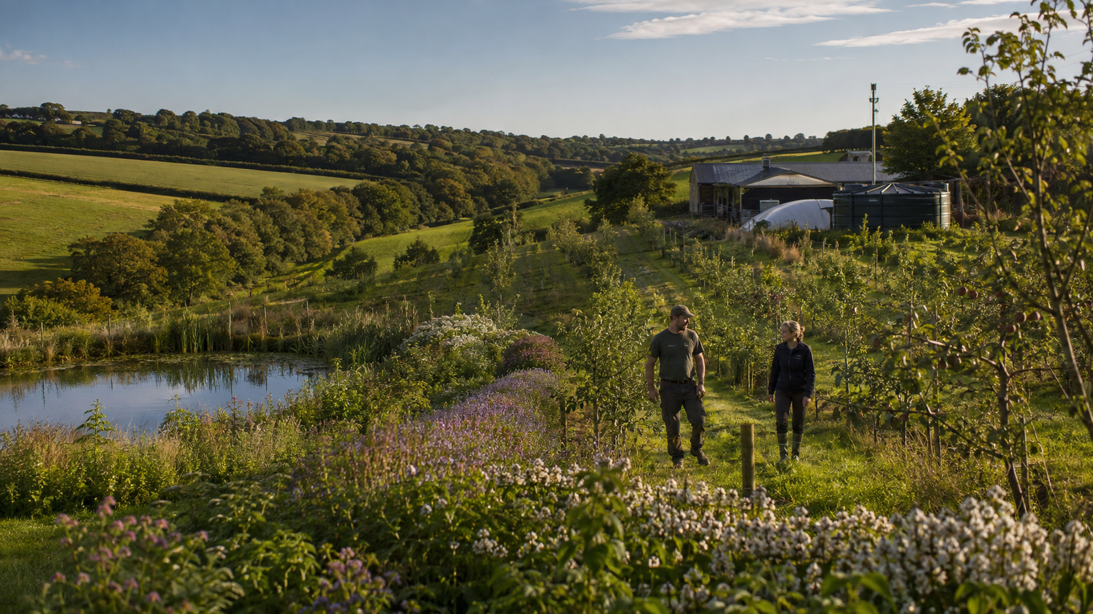

The Perennial
Resilience Plan
Food in two years • cooler ground in weeks • water security • controlled-environment recovery
A practical proposal for UK farmers, water-using businesses, investors, local authorities and national government.
Three linked sections
1. Productive perennial agroforestry. 2. Green Tent systems for difficult land. 3. A full aquaponics operating model.

Decision draft • United Kingdom • 19 August 2026

Document status and engineering guardrails
This is a policy and pilot-development document. It identifies a credible direction, species portfolio, operating model, evidence base and stage gates. Site-specific designs, structural loads, pressure systems, hydrogen plant, electrical work, food safety, fish welfare and planning submissions must be completed and signed off by appropriately qualified professionals.
Safety correction
The proposal does not store mixed “HHO” gas and does not claim net energy creation. Electrolysis produces separate hydrogen and oxygen streams. Electricity and useful heat are prioritised; an ORC or steam expander is considered only when scale, temperature and economics justify it.

Loop separation
Clean steam/feedwater, aquaponic nutrient water, greenhouse humidity condensate and potable water remain separate, connected only through engineered heat exchangers or validated treatment barriers.

Contents
- Executive summary and national case
- Section 1 — Perennial farming, planting, benefits, water, herbs, bees and stewardship
- Section 2 — Green Tent recovery system for difficult land
- Section 3 — Aquaponics: biology, media, hydraulics, commissioning, operation and UK compliance
- Implementation plan, metrics, decision asks and references

Executive summary
The proposal is deliberately staged. Existing trees, hedges, wet features and soil cover deliver protection immediately. Bearing-age or grafted fruit, soft fruit and perennial herbs can provide early food—often within one or two growing seasons on a suitable site. Orchard, nut and canopy benefits deepen over five years and beyond. Difficult land is addressed separately through controlled systems rather than pretending every hectare can be made safe by planting directly into it.
Programme | Immediate decision | 24-month proof
Perennial farms | Fund site plans, fast-bearing strips and two years of aftercare. | Tree survival, yield, water use, farm operations, biodiversity and margin.
Business water | Introduce annual water-balance and annual-equivalent resilience planning for every materially water-dependent business. | Stored/reused/shared capacity, quality, demand reduction and continuity performance.
Green Tent | Commission one independently reviewed demonstrator on a defined difficult-land category. | Net energy, useful heat, water recovery, emissions, capex/opex, uptime and safety.
Aquaponics | Build as a life-support and biofiltration system with redundancy and registration. | Fish welfare, conversion, crop output, nutrient additions, water quality and labour.

Why this framing has the best chance of adoption
- It protects farm operations and cash flow rather than treating food production as a land-use problem.
- It makes early benefits explicit while avoiding blanket promises.
- It uses current funding where the planting specification fits, but does not distort rootstock or layout merely to chase a payment.
- It translates universal ambitions into flexible, auditable compliance routes.
- It makes ambitious engineering falsifiable: meter the input, output, losses, water and carbon fate.

The national case
The Environment Agency’s 2025 National Framework estimates a 4,940 Ml/day public-water deficit for England by 2055 before additional action, with potential wider-economy needs around 1,000 Ml/day. The UK Pesticides National Action Plan 2025 sets a target to reduce each of 20 Pesticide Load Indicator metrics by at least 10% by 2030 from a 2018 baseline. Forest Research found 59% of surveyed cereal farmers likely or extremely likely to plant trees within five years, while also identifying cost, uncertainty, labour and machinery conflict as practical barriers.
Adoption principle
“Farm with trees” is stronger than “replace farming with trees”. Start with alleys, edges, shelter, runoff paths and orchard blocks that respect machinery, tenancy, labour and market access.

SECTION 1
Farm with trees. Keep the farm working.
Perennial food, shade, water, living soils, herbs, bees and lawful stewardship.
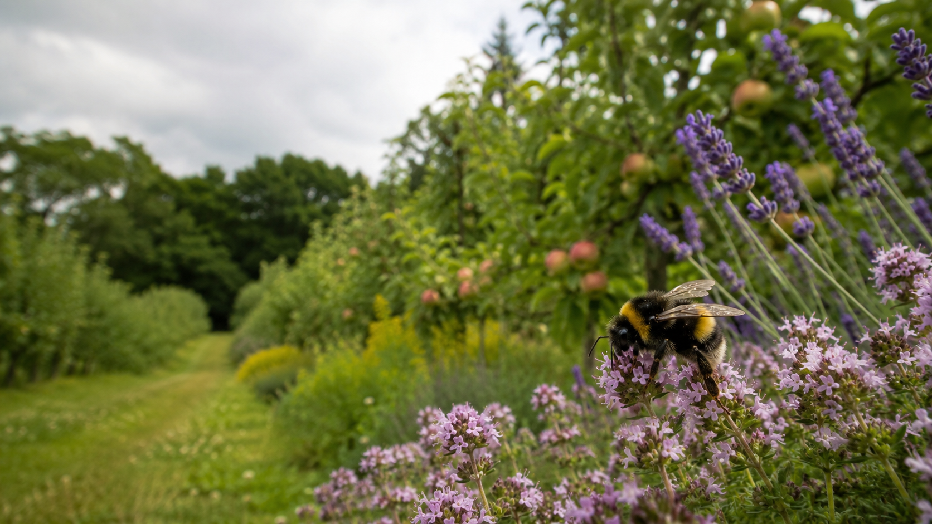

1.1 Principles and benefit stages
Stage | What changes | Benefits that can be measured
Day 1 | Retain veteran trees, hedges, shade, wet features and permanent cover. | Avoided canopy loss; mapped fire/water assets; protected habitat.
Weeks | Mulch and living groundcover protect exposed soil. | Lower surface temperature, less splash/erosion, better infiltration conditions.
Months | Young roots, shelter and flowering strips establish. | Wind reduction, root channels, pollinator use, runoff observations.
1–2 years | Early fruit, shrubs and herbs produce; shade footprint grows. | Kg harvested, canopy area, survival, irrigation and pesticide records.
2–5 years | Orchard production rises and some nuts begin. | Diversified revenue, soil cover, microclimate, habitat and water indicators.
5+ years | Mature perennial structure provides long-lived services. | Stable output, lower disturbance, carbon stock and landscape-scale resilience.

Cooling starts before the first crop. Leaves intercept radiation and transpire water; mulch and living cover reduce direct solar loading of bare ground. The size of the effect depends on canopy, soil moisture, weather, surface colour and wind, so pilot sites should measure shaded and unshaded surface and soil temperatures rather than quote a universal number.

1.2 Layout patterns, grants and operating access
Pattern | Best use | Design notes
Alley cropping | Arable or horticultural farms that must keep machinery access. | Orient and space rows around real equipment, tramlines, turning and light. Planned England alleys may be 10–51 m; verify the current action.
Silvopasture | Livestock shade, shelter and fodder. | Guard young trees; manage grazing timing and soil compaction; keep water points from tree bases.
Orchard + understory | High-diversity food and direct sales. | Fruit/nuts above soft fruit, perennial vegetables, herbs and managed groundcover.
Riparian/runoff belt | Water quality, flow interception and erosion control. | Use contour, buffer and flood-risk evidence; preserve access and drainage function.
Hedge/shelterbelt | Low land-take entry point. | Edges, corners, wind lines and habitat links; avoid shading high-value crops unexpectedly.

England’s 2026 agroforestry funding includes planning and tree-establishment actions, but eligibility is specification-dependent. One key nuance is that funded agroforestry fruit trees may require semi-vigorous or vigorous rootstocks. An ultra-dwarf early-bearing orchard may therefore be a useful commercial layer without qualifying for the same action. Wales, Scotland and Northern Ireland operate different schemes and must be checked at application date.

1.3 Species and benefit portfolio
“First useful harvest” is an indicative range for healthy, suitably sourced stock with adequate establishment water. It is not a guarantee. Bearing-age trees can shorten the wait but cost more and may transplant less easily. Rootstock, cultivar, pollination partners, frost pockets, soil and pruning materially change timing.
Species / layer | Food role | First useful harvest | Main benefit | UK note / risk
Apple | Sweet, storage, juice | 1–3 | Early food; blossom; later shade | Dwarf trees crop early; larger rootstocks give resilience/scale and may fit grants.
Pear | Sweet/storage | 2–4 | Fruit; blossom; medium canopy | Choose compatible pollination group and site away from severe frost pockets.
Plum / damson | Sweet/savoury processing | 2–4 | Early fruit; preserves; blossom | Some self-fertile cultivars; manage silver leaf risk and prune at correct season.
Sour cherry | Fruit/processing | 2–4 | Compact fruit layer | Bird protection and rain-cracking considerations.
Quince | Fruit/pectin | 2–4 | Processed staple; blossom | Prefers moisture-retentive but drained soil.
Fig | Sweet | 1–2 | Very early food in warm microclimate | Sheltered UK sites; restrict roots where appropriate; winter damage risk.
Elder | Flowers/berries | 1–2 | Fast habitat and processing crop | Cook/process berries appropriately; manage suckering.
Currant/gooseberry/raspberry | Soft fruit | 1–2 | Fast cash-flow understory | Not trees, but crucial to the two-year food promise.
Medlar / mulberry | Speciality fruit | 2–5 | Diversification and long life | Site/cultivar dependent; market development needed.
Sea buckthorn | Acid fruit | 2–4 | Wind tolerance, dense habitat | Spreads; usually needs male/female plants; harvest can be difficult.
Hazel | Nut | 3–5 | Protein/fat; coppice/habitat | Squirrel pressure and cultivar/pollination planning.
Sweet chestnut | Starch nut | 5–8+ | Long-term staple and canopy | Needs space and suitable climate/soil; later return.
Walnut | Oil/protein nut | 6–10+ | High-value legacy crop | Large spacing; allelopathy/competition and late frost need consideration.
Carob | Sweet/savoury pod flour | 4–6+ grafted; longer from seed | Dryland pod concept | RHS H3: a UK open-field staple claim is not credible nationally. Use only mild/protected, contained research pilots.
Honey locust | Pods mostly fodder | 4–8+ | Potential fodder/shade | Use selected thornless cultivars; do not market as a mainstream human staple without food evidence.
Oak/acorns | Processed starch | Long-term | Biodiversity and heritage food | Requires correct species identification and leaching/processing; not a quick crop.

“Bean tree” safety rule
Catalpa pods and laburnum are not general foods; laburnum is toxic. Black locust is also not a routine food tree. Common names are not evidence of edibility. Require botanical identification, credible food-safety sources and invasive-species review.

1.4 Perennial herbs and vegetables
Function | Examples | Management
Kitchen herbs | Rosemary, thyme, sage, oregano, chives, lovage, sorrel, tarragon, fennel. | Place close to access and harvesting; choose drainage/light by species.
Perennial food | Asparagus, rhubarb, globe artichoke/cardoon, perennial kale, wild garlic, sea beet. | Allocate permanent beds; do not expect asparagus peak yields immediately.
Pollinators | Lavender, hyssop, yarrow, bee balm, angelica, knapweed, flowering herbs. | Plan a flowering sequence; avoid pesticide exposure during bloom.
Soil/biomass | White/red clover, vetch, comfrey, managed nettle patches. | Prevent spread into crops; cut/export biomass where nutrient loading matters.
Contained vigorous herbs | Mint and lemon balm. | Use barriers, pots or bounded beds where spread would create labour.

1.5 How to plant a tree
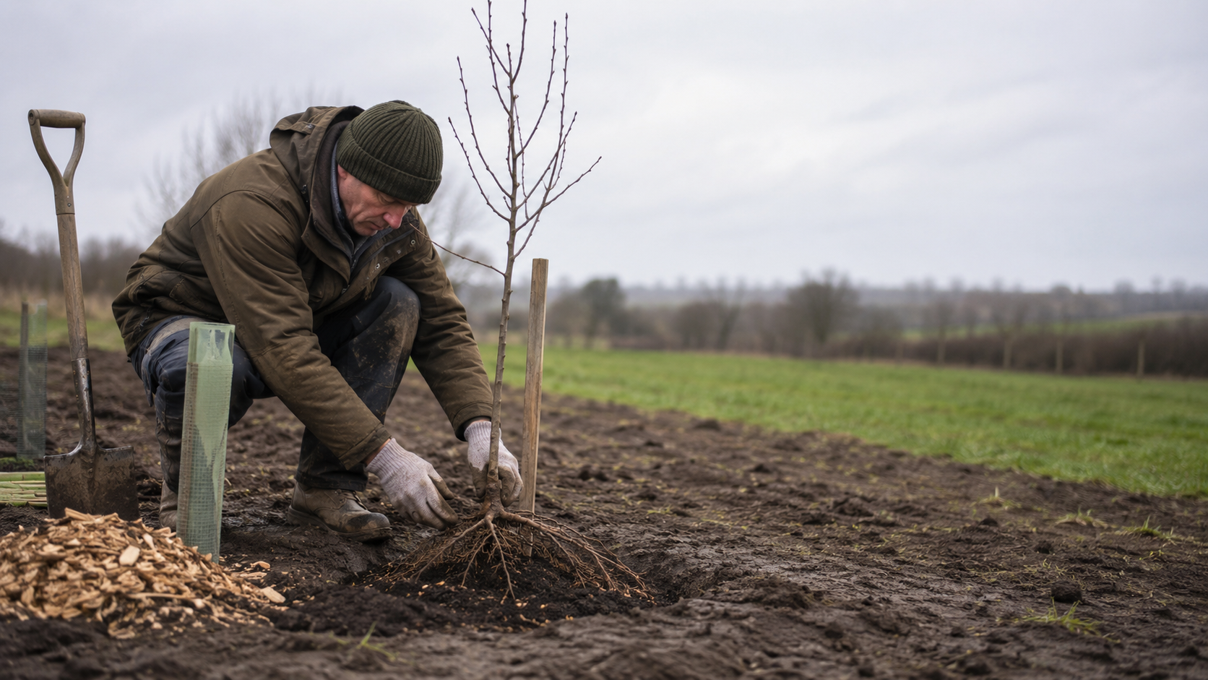
Step | Method | Reason
1. Survey | Map services, drains, access, slopes, shade, wind, soil constraints, designated sites and operational routes. | Prevents conflict, damage and inappropriate planting.
2. Specify | Choose botanical species, cultivar, rootstock, plant size, pollination partners and guard type. | The rootstock governs mature size, bearing, anchorage and grant fit.
3. Time | Plant bare-root stock in dormancy when soil is neither frozen nor waterlogged. Container stock can extend the season with irrigation. | Reduces stress and cost.
4. Hole | Dig broad enough for roots, not deeper than the root system; loosen glazed sides. | Avoids buried stem and encourages outward rooting.
5. Place | Spread roots naturally and set the root collar at finished ground level. | Buried collars encourage decline; exposed roots desiccate.
6. Backfill | Use excavated soil, firm gently and water in. Avoid a concentrated fertiliser pocket. | Maintains soil continuity and removes large air gaps.
7. Protect | Low stake and flexible tie if required; guard/fence for rabbits, deer, voles or livestock. | Prevents rubbing, browsing and wind-rock.
8. Mulch | Maintain roughly a 1 m weed-free spot/band. Keep mulch away from the trunk. | Reduces competition and protects moisture without rotting bark.

1.6 First 24 months: aftercare and metrics
- Water deeply according to soil and weather; avoid a rigid calendar. Record litres per tree and drought response.
- Inspect after wind, grazing changes and machinery operations. Repair guards, ties, fences and washouts.
- Maintain the weed-free zone; keep mulch off the trunk; do not let guards choke stems.
- Replace failures in the first suitable dormant season and record cause, not just number.
- Formative-prune for the intended system; remove dead/damaged material with clean tools and correct timing.
- Track survival, canopy size, labour, irrigation, crop kg, rejected fruit, pest interventions, pollinator observations and runoff/soil moisture indicators.

1.7 Bees and pesticide-last crop protection
Pesticides are not morally neutral, but a successful farm policy must give growers a workable decision ladder. “Pesticide-last” means prevention, monitoring and non-chemical controls first, with a targeted, legally approved intervention retained when thresholds and crop/welfare consequences justify it.
Priority | Action | Examples
1 | Prevent | Resistant cultivars, hygiene, rotation, balanced nutrition, physical design and diverse habitat.
2 | Monitor | Scouting, traps, weather data, forecasting and written action thresholds.
3 | Physical/biological | Barriers, pruning, predators, parasitoids and approved biocontrols.
4 | Target precisely | Lowest-risk effective product, correct dose/timing, buffer zones and no routine blanket treatment.
5 | Review | Record result, non-target effects and whether design or timing can prevent recurrence.

Pollinator practice
Do not spray flowering groundcover by default. Follow labels, protect water, avoid drift and time any necessary treatment away from bloom and pollinator activity as far as the authorised use permits.

1.8 Universal business water resilience obligation
Proposed policy: every business whose continuity depends materially on water must maintain an audited annual water balance and demonstrate annual-equivalent resilience. The obligation applies regardless of sector, but the compliance route is proportionate to health, fire, structural, contamination and economic constraints. “One year” means a portfolio capable of covering or replacing annual demand—not necessarily one huge tank on every roof.
Compliance route | Minimum features | Critical caveat
Onsite storage | Covered/opaque tanks; screened vent; first-flush/diversion; overflow; level monitoring; inspection and cleaning access. | Closed is not airtight. Design for pressure, frost, legionella/control needs and structural load.
Process circularity | Reuse wash/process water, condensate and cooling water where legal and safe; segregate qualities. | Never cross-connect non-potable and potable systems; control solvent/leaching compatibility.
Demand reduction | Leak detection, dry processes, controls and water-efficient equipment. | Resilience must not reward inflated baselines.
Shared catchment asset | Reservoir, wetland, aquifer recharge or contracted strategic capacity. | Needs enforceable allocation, drought rules, environmental permissions and quality plan.
Phased compliance | Illustrative 25% → 50% → 100% annual-equivalent pathway. | Set sector-specific deadlines and protect small-firm viability.

Physics and materials
Water evaporates because surface molecules escape into air; being a solvent chiefly matters because it can dissolve tank/pipe constituents and carry contamination. Use compatible certified materials, covers, safe vents, overflow and treatment appropriate to end use.

1.9 Resident stewardship model
On-site stewards can observe leaks, fire risk, browsing, vandalism and disease earlier than remote contractors. They can maintain guards, record wildlife, coordinate harvests and prune dead material if trained. The credible model is a community land trust, cooperative tenancy or paid farm-steward role—not informal dependency.
- Secure lawful accommodation, sanitation, potable water and safe access.
- Written rights, duties, hours, remuneration, insurance and dispute/exit process.
- Residency must not be coercively tied to unpaid labour.
- Planning, housing, safeguarding and employment advice before occupation.
- Training for tools, work at height, first aid, fire, water systems and biosecurity.

SECTION 2
Make difficult land productive again.
A controlled-environment food, heat and water pilot for quarries, hardstand, compacted sites and contained brownfield land.
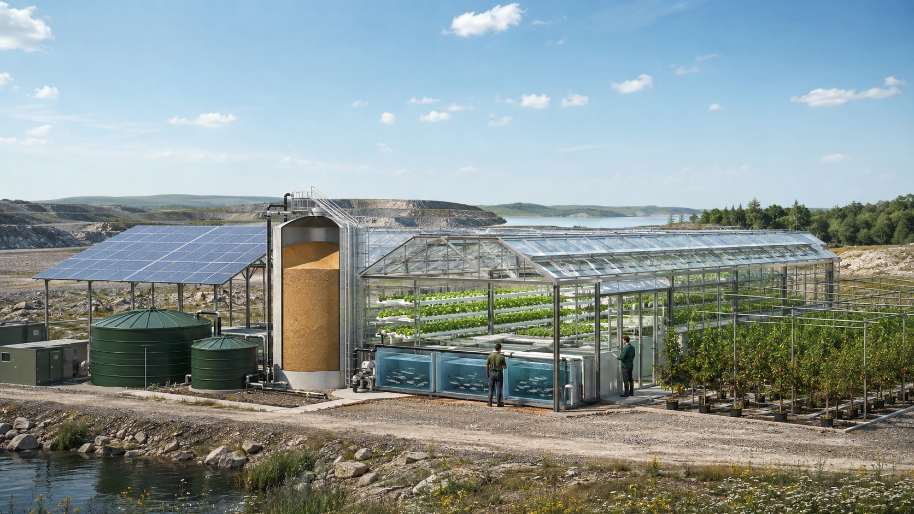

2.1 Scope: “unfarmable” is a diagnosis
Land category | Potential route | Non-negotiable check
Quarry / hardstand | Modular greenhouse, rain capture, imported clean media and wind-rated structure. | Drainage, foundations, access, glare, ecology and planning.
Compacted / saline | Raised contained beds, water treatment and clean logistics. | Salt balance, dust, flood pathway and separation from hostile soil.
Brownfield / contaminated | Sealed floor, clean/dirty zoning and no crop contact with site soil. | Phase I/II contamination assessment, vapour/gas, waste classification and worker exposure.
Post-industrial heat source | Use compatible, metered waste heat through heat exchangers. | Contaminants, reliability, contract duration and carbon accounting.

2.2 Five-loop architecture
Loop | Core path | Boundary rule
Electrical | PV + grid/battery → pumps, aeration, controls, lighting and heat pumps. | Life-support loads are prioritised and backed up.
Thermal | Surplus electricity/solar heat → sand or other thermal store → greenhouse/fish/root-zone heat. | Use heat directly before reconverting it to power.
Clean steam/feedwater | Rated boiler → optional expander → condenser cube → polished return tank. | No contact with fish nutrient water.
Aquaponics | Fish → solids capture/mineralisation → biofilter → plant beds → sump → fish. | Never boil nutrient water; protect biofilter oxygen and flow.
Humidity/water/carbon | Evapotranspiration → dehumidification/condensation → treatment/top-up; compatible CO₂ → plants/algae. | Condensate and gas quality are tested; carbon fate is verified.

2.3 Energy hierarchy and hydrogen safety
The energy system is an efficiency hierarchy, not a loop that creates energy. Pumps and aeration use electricity directly. Low-grade heat serves space, root-zone or fish-water duties through heat exchangers. Sand storage can shift heat in time. Only a sufficiently large, hot and frequently used heat source should be evaluated for an ORC or steam expander.
Priority | Technology | Decision rule
1 | Direct electricity | Serve aeration, circulation, controls and safety loads first.
2 | Direct heat / heat pump | Deliver useful heat at the temperature actually required.
3 | Thermal storage | Size from hourly/seasonal heat model, losses and charge/discharge duty.
4 | ORC / steam power recovery | Proceed only after heat-grade, capacity factor, maintenance and economics study.
5 | Hydrogen | Use certified electrolyser, separated H₂/O₂, detection, ventilation and compliant storage; consider sale/seasonal backup.

No mixed HHO
A hydrogen/oxygen mixture is a severe explosion hazard. Oxygen is vented safely or used only in an engineered, certified application. Hydrogen is not the primary short-cycle route back to electricity because round-trip losses are high.

2.4 Steam Condensation & Heat Recovery Cube
The “steam cube” is best defined as a packaged condenser, heat-recovery, condensate-polishing and instrumentation subsystem. It sits on the clean steam/feedwater loop. It is not a chamber that discharges steam into the greenhouse.
- Receive exhaust steam from a rated expander or pressure-control duty.
- Condense on corrosion-compatible surfaces with access for inspection and cleaning.
- Recover latent heat through a closed heat exchanger to greenhouse air, root zones or fish-water secondary loop.
- Measure inlet/outlet pressure, temperature, flow, conductivity and condensate quality.
- Collect condensate in a covered return tank; polish and dose as required by boiler-water chemistry.
- Use dehumidifiers or purpose-designed condensing surfaces for greenhouse humidity; high humidity increases disease and condensation risk.
- Include pressure relief, isolation, drainage, safe blowdown, legionella/control review and written operating limits.

2.5 Water recovery
Greenhouse evapotranspiration moves irrigation water into air. Dehumidification with latent-heat recovery can recover a portion of both water and heat, but recovered condensate is not automatically potable or nutrient-complete. It can contain volatile compounds, metals from surfaces or hygiene hazards. Test, treat and remineralise for its intended use.
Water stream | Likely destination | Treatment / control
Roof rainwater | Non-potable top-up or storage | Debris screen, first flush where appropriate, covered tank, overflow and quality monitoring.
Greenhouse condensate | Aquaponic top-up after validation or clean irrigation | Surface compatibility, disinfection if required, remineralisation and batch release.
Boiler condensate | Clean feedwater return | Boiler chemistry, conductivity, corrosion and blowdown controls.
Aquaponic purge/mineralised water | Separate orchard/tree nursery or lawful reuse | Pathogen/nutrient assessment, filtration and controlled application.
Fish-system water | Recirculate in fish loop | Do not send directly to steam boiler or potable system.

2.6 CO₂ and nutrient recovery
Plants and algae can take up carbon dioxide, but uptake is not automatically permanent greenhouse-gas removal. Carbon is quickly returned if biomass decomposes or is burned. A credible claim records the source CO₂, energy used, biomass output and final fate. Compatible biomass may become feed or product; residues may be considered for engineered biochar where contaminants, permanence and life-cycle accounting are acceptable.
Separate carbon and hydrogen
Hydrogen combustion produces water, not CO₂. The carbon loop must have its own source, quality controls and accounting. Never pipe unknown exhaust into food production without contaminant and worker-safety assessment.

2.7 Engineering work packages before build
Work package | Required output
Site and planning | Contamination, ecology, flood/drainage, transport, utilities, neighbours and consent route.
Mass/energy balance | Hourly electricity, heat, water, humidity, feed, nutrient, biomass, losses and seasonal model.
Process safety | HAZID/HAZOP, pressure systems, hydrogen zoning/detection/ventilation, fire strategy and emergency shutdown.
Food and fish safety | HACCP, biosecurity, animal welfare, water-quality plan and mortality disposal.
Controls and resilience | Failure modes, alarms, backup duration, manual operation, spares and cyber/remote access.
Commercial | Offtakes, tariffs, feed/seed inputs, labour, maintenance, replacement cycles and sensitivity analysis.

SECTION 3
Aquaponics: a living treatment plant that also grows food.
Fish, microbes, plants, hydraulics and backup power designed as one biological system.

3.1 What aquaponics is—and is not
Aquaponics combines recirculating aquaculture with hydroponic plant production. Fish feed supplies most nitrogen. Fish excrete ammonia; uneaten feed and faeces add solids and nutrients. Microbes oxidise ammonia to nitrite and then nitrate. Plants and associated microbes remove a portion of dissolved nutrients before water returns to fish.
Inputs remain
Aquaponics does not eliminate inputs. It needs fish feed, energy for aeration and pumping, top-up water, seed/plant material, labour and often targeted iron, calcium, potassium or other supplements. It concentrates management rather than abolishing it.

3.2 Process loop
Stage | Function | Failure if neglected
Fish tank | Hold fish at safe density with oxygen, temperature and flow. | Stress, disease, mortalities and ammonia spikes.
Solids capture | Remove settleable and suspended faeces/uneaten feed. | Clogged roots/media, oxygen demand and anaerobic zones.
Mineralisation | Recover some nutrients from captured solids under controlled conditions. | Nutrient loss or uncontrolled putrefaction.
Biofilter | Provide oxygenated surface for nitrifying communities. | Ammonia/nitrite toxicity.
Plant unit | Remove nitrate and other nutrients; grow saleable biomass. | Nutrient accumulation/deficiency and unstable balance.
Sump/pump/return | Collect, aerate and recirculate water. | Rapid loss of flow and oxygen; overflow or dry running.

3.3 Nitrogen cycle: ammonia → nitrite → nitrate
Fish excrete total ammonia nitrogen as NH₃/NH₄⁺. The unionised NH₃ fraction increases as pH and temperature rise and is more toxic. Ammonia-oxidising organisms produce nitrite (NO₂⁻), which is also toxic because it interferes with oxygen transport. Nitrite-oxidising organisms—often Nitrospira-like communities in working systems—produce nitrate (NO₃⁻), which plants can use.
Biological step | Needs | Operator evidence
Ammonia oxidation | Dissolved oxygen, biofilm surface, temperature stability and alkalinity. | Ammonia falls under a known test load while nitrite rises.
Nitrite oxidation | Oxygen, mature community and stable chemistry. | Nitrite subsequently falls and nitrate accumulates.
Plant uptake | Healthy roots, light, temperature, balanced nutrients and compatible pH. | Nitrate trend responds to plant biomass and harvest.
Harvest/export | Regular crop removal and solids management. | Nitrogen leaves as fish/plant product or managed residual.

Many mixed systems use roughly pH 6.8–7.2 as a compromise, but the safe operating envelope is species- and design-specific. Do not use pH alone: record dissolved oxygen, temperature, alkalinity, total ammonia, calculated unionised ammonia where relevant, nitrite, nitrate, flow, feed and behaviour.

3.4 Volcanic rock and other media
Washed lava rock or pumice can provide root support and large biofilm surface area. The media must be tested for pH reaction, contaminants, abrasion and food-contact suitability. A coarse grade around 12–20 mm is common in media beds, but hydraulic design and crop roots determine the final grading.
Medium | Advantages | Risks / controls
Washed lava rock / pumice | Porous, durable, high surface area, can be locally available. | Heavy; sharp; traps solids. Prefilter, support structurally and provide clean-outs.
Expanded clay | Light, easy for roots and handling, predictable. | Cost; may float initially; embodied energy.
Washed gravel | Low cost and robust. | Very heavy; carbonate reaction possible; variable contaminants. Vinegar fizz is only a crude screen, not certification.
Recycled glass foam | Light and porous in some products. | Product-specific food/contact evidence and abrasion testing required.

Never use unknown rubble
Demolition aggregate may contain asbestos, lead, hydrocarbons, salts or reactive fines. “Recycled” is not automatically safe for fish or food.

3.5 System types and crop fit
System | Good fit | Strength | Watch
Flood-and-drain media | Herbs and mixed crops | Accessible and tolerant; media hosts biofilm. | Weight, solids accumulation and uneven flow.
Deep-water culture / rafts | Leafy greens | Stable root-zone water and commercial density. | Needs excellent solids removal and aeration.
NFT channels | Small leafy crops | Low water volume and clean harvesting. | Blockage, root mats and rapid pump-failure risk.
Dutch buckets | Tomato, cucumber, pepper and other fruiting crops | Large modular root zone. | Nutrient supplementation and hydraulic balancing.
Decoupled aquaponics | Higher-control commercial plant production | Fish and plant chemistry can be optimised separately. | More equipment, controls and operator skill.
Tree nursery/polishing loop | Young fruit/nut trees and shrubs in large containers | Uses filtered purge/mineralised water outside core fish loop. | Root clogging, uneven demand and long crop cycles; separate hydraulics.

3.6 Aquaponic tree farming: credible configuration
Mature trees should not normally sit in standard recirculating pipes or NFT channels. Large roots clog, demand varies seasonally and tree timescales do not match the rapid feedback needed for fish welfare. The credible model is a core aquaponic unit for leafy greens, herbs and selected fruiting crops, plus a separated tree nursery or orchard polishing loop supplied with filtered, analysed purge water or a controlled nutrient stream.
- Use large inert media containers, wicking beds or drip irrigation with drainage collection.
- Keep isolation valves and a return-quality barrier so root-zone pathogens or sediments cannot reach fish.
- Analyse nutrient balance; fish water is often short of potassium, calcium or iron for demanding crops.
- Use irrigation scheduling by container/root-zone moisture, not continuous flooding by default.
- Treat mature field orchard irrigation as a regulated water-reuse application, not part of the fish life-support loop.

3.7 Commissioning and cycling
Phase | Actions | Gate
Dry/wet commissioning | Materials approval, disinfect/rinse protocol, leak/overflow test, pump curves, alarms, backup and probe calibration. | System holds water; safe overflow and emergency aeration proven.
Fishless or low-load cycle | Add controlled ammonia source or approved inoculum; run aeration continuously; track ammonia/nitrite/nitrate. | Both oxidation steps demonstrated under a known test load.
Gradual stocking | Add fish/feed in small increments; increase plant area with loading. | Stable trends, welfare and response procedures demonstrated.
Production | Routine feed, harvest, solids/mineralisation and supplementation plan. | Documented standard operating procedures and trained cover.

Cycling commonly takes several weeks—often roughly 4–8—but temperature, inoculum, media and loading can shorten or lengthen it. Calendar time is not the commissioning test; conversion performance is.

3.8 Monitoring and response
Variable | Why it matters | Response principle
Fish behaviour/mortality | Fastest whole-system warning. | Observe at every visit/feed; stop feed and investigate abnormal behaviour.
Dissolved oxygen | Fish and nitrifiers are oxygen-dependent. | Species-specific alarm; start backup aeration immediately.
Flow and water level | Controls filtration and gas exchange. | High/low alarms, gravity overflow, spare pump and visual indicators.
Temperature | Governs fish metabolism, oxygen solubility and ammonia toxicity. | Match species; control rate of change as well as absolute value.
pH and alkalinity | Nitrification consumes alkalinity and pushes pH down. | Trend and buffer with approved compounds; avoid abrupt correction.
Ammonia/nitrite | Direct toxicity and evidence of loading/biofilter failure. | Reduce/stop feed, restore oxygen/flow, confirm test and follow welfare plan.
Nitrate/plant health | Shows balance between feed loading and plant uptake. | Adjust plant area, harvest, supplementation or controlled water exchange.
Feed, water, energy, supplements | Determines cost and environmental performance. | Meter per kg fish and crop; investigate drift.

3.9 Resilience, biosecurity and food safety
- Dual air pumps on independent circuits where practicable; UPS/battery or generator sized for survival duty, not average duty.
- High/low water, power, oxygen and temperature alarms with tested callout.
- Gravity-safe overflow, anti-siphon design, isolation valves, spare pump/blower and critical spares.
- Quarantine and controlled aquatic-animal movements; cleaning zones and mortality plan.
- Potable-quality top-up where required, backflow prevention and strict separation from potable plumbing.
- HACCP-based harvest and packing; avoid uncontrolled splashing of fish water onto ready-to-eat leaves.
- Chemical/material approval for tanks, liners, pipes, sealants and media.
- Written fish welfare thresholds and competent holiday/out-of-hours cover.

3.10 UK regulatory route
In England and Wales, a fishery, cropping-water or aquaponic system may need registration under aquatic animal-health rules; species, movements and biosecurity requirements must be confirmed with the competent authority. Planning, building control, abstraction, discharge, trade effluent, waste, food business registration, animal by-products and environmental permits can also apply. Scotland and Northern Ireland have distinct authorities and processes.
Register early
Do not purchase fish before confirming registration, species permissions, movement documentation, supplier status, welfare capacity and contingency disposal.

Implementation: 24-month national pilot
Stage | Months | Deliverables
Select | 0–3 | 10–20 perennial farm sites across farm types; 1–3 difficult-land categories; one lead aquaponics site; baselines; partners; advisory panel.
Design | 3–6 | Planting plans, water balances, hydraulic/process models, contamination and planning routes, HAZID/HAZOP, welfare/HACCP and procurement.
Build | 6–12 | First tree strips, herbs and storage; one instrumented Green Tent/aquaponics demonstrator; training and operating procedures.
Prove | 12–24 | Open quarterly data, independent audit, farmer/operator interviews, incident/failure reporting and investability assessment.

Pilot measurement framework
Theme | Measures
Farm and food | Tree/shrub survival, canopy, flowering, kg/grade crop, labour, machinery disruption, margin, crop loss and market route.
Water | Demand baseline, storage/reuse/shared capacity, litres per output, leakage, condensate, quality, overflow and drought continuity.
Soil/microclimate | Surface/soil temperature shaded vs control, soil moisture/infiltration indicators, erosion/runoff and groundcover.
Biodiversity/IPM | Flowering continuity, pollinator observations, pesticide load/use, pest pressure and non-chemical intervention.
Aquaponics/welfare | Feed, biomass, mortality, oxygen, ammonia/nitrite excursions, water exchange, supplement use, uptime and alarms.
Energy/carbon | Electricity, useful heat, thermal-store losses, any recovered power, hydrogen in/out, carbon source/fate and whole-system emissions.
Social/governance | Steward terms, paid hours, training, incidents, community benefit and farmer/operator confidence.
Finance | Capex, opex, replacement reserve, revenue by product/service, grants, downtime and sensitivity to energy/feed/water prices.

Decision asks
- Protect and map existing perennial assets immediately.
- Fund bearing-age perennial strips and the full two-year aftercare budget this planting season.
- Develop a universal, phased annual-equivalent business water-resilience standard with multiple compliance routes.
- Commission one independently reviewed Green Tent and aquaponics demonstrator with strict loop separation.
- Create a farmer–engineer–water–fish-welfare–food-safety working group.
- Publish two years of open technical, welfare, failure and financial data before scaling.

References and current policy links
1. Environment Agency — National Framework 2025: 2055 deficit — https://www.gov.uk/government/publications/national-framework-for-water-resources-2025-water-for-growth-nature-and-a-resilient-future/3-how-much-additional-water-we-need-national-framework-for-water-resources-2025
2. Environment Agency — water shortage news summary — https://www.gov.uk/government/news/england-faces-5-billion-litre-public-water-shortage-by-2055-without-urgent-action
3. Environment Agency — significant water-using sectors — https://www.gov.uk/government/publications/national-framework-for-water-resources-2025-water-for-growth-nature-and-a-resilient-future/9-taking-action-on-other-significant-water-using-sectors-and-emerging-demands-national-framework-for-water-resources-2025
4. Forest Research — increasing tree cover on cereal farms — https://cdn.forestresearch.gov.uk/2024/12/Research-Report_Increasing-tree-cover-on-cereal-farms-in-England_final.pdf
5. GOV.UK — how trees can benefit farms — https://www.gov.uk/government/publications/grow-your-farm-business-how-trees-can-benefit-your-land-crops-and-livestock/grow-your-farm-business-how-trees-can-benefit-your-land-crops-and-livestock
6. GOV.UK — agroforestry funding and grants — https://www.gov.uk/government/publications/funding-and-grants-for-agroforestry/funding-and-grants-for-agroforestry
7. GOV.UK — AF2 plant an agroforestry fruit tree — https://www.gov.uk/countryside-stewardship-grants/af2-plant-an-agroforestry-fruit-tree
8. GOV.UK — TE4 supply and plant tree — https://www.gov.uk/countryside-stewardship-grants/supply-and-plant-tree-te4
9. Forest Research — mulch evidence review — https://cdn.forestresearch.gov.uk/2022/02/stokes_2012_qjf_mulches_zdklgwc.pdf
10. UK Pesticides National Action Plan 2025 — https://www.gov.uk/government/publications/uk-pesticides-national-action-plan-2025/uk-pesticides-national-action-plan-2025-working-for-a-more-sustainable-future
11. RHS — choosing fruit trees — https://www.rhs.org.uk/fruit/fruit-trees/choosing-the-best
12. RHS — carob hardiness and description — https://www.rhs.org.uk/plants/3403/ceratonia-siliqua/details
13. FAO — Small-scale aquaponic food production — https://openknowledge.fao.org/handle/20.500.14283/i4021e
14. GOV.UK — register a fishery/cropping water/aquaponic system — https://www.gov.uk/guidance/register-a-fishery-cropping-water-or-aquaponic-system
15. US DOE — hydrogen production by electrolysis — https://www.energy.gov/cmei/fuels/hydrogen-production-electrolysis
16. IEA — hydrogen opportunity and conversion losses — https://www.iea.org/reports/unlocking-ukraines-hydrogen-opportunity-a-roadmap/unlocking-the-opportunity-a-roadmap-for-action
17. US Hydrogen Programme — accumulation/flammability review — https://www.hydrogen.energy.gov/docs/hydrogenprogramlibraries/pdfs/review05/pdp_39_pile.pdf
18. Sandia — thermal energy storage — https://energy.sandia.gov/programs/renewable-energy/concentrating-solar-thermal-technologies/thermal-energy-storage-tes/
19. Review — organic Rankine cycle waste-heat recovery — https://pmc.ncbi.nlm.nih.gov/articles/PMC11625998/
20. Greenhouse dehumidification and latent-heat recovery study — https://www.sciencedirect.com/science/article/abs/pii/S153751101500183X
21. UK greenhouse-gas-removal innovation projects — https://www.gov.uk/government/publications/direct-air-capture-and-greenhouse-gas-removal-innovation-programme-selected-projects/direct-air-capture-and-greenhouse-gas-removal-innovation-programme-phase-2-projects
22. Review — microalgae CO₂ capture — https://pmc.ncbi.nlm.nih.gov/articles/PMC11368733/
23. Study — aquaculture wastewater for date-palm irrigation — https://pmc.ncbi.nlm.nih.gov/articles/PMC11317483/
24. Wales Sustainable Farming Scheme 2026 — https://www.gov.wales/sustainable-farming-scheme-2026-scheme-description-html
25. Scottish Forestry — agroforestry grant — https://www.forestry.gov.scot/agroforestry-grant
26. DAERA — Farming with Nature Transition Scheme — https://www.daera-ni.gov.uk/articles/what-farming-nature-transition-scheme-fwnt
Accessed 19 August 2026. Scheme details, grant rates and regulatory pages can change; verify at application/design date.

